Post-Event Feedback Form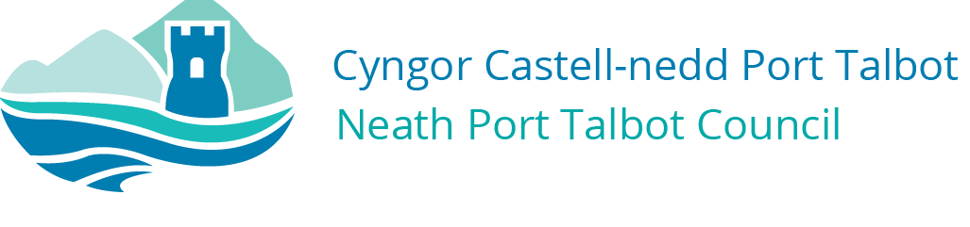
Safety Advisory Group

POST-EVENT FEEDBACK FORM

Name of Event

Organiser

Full Address

Email Address

Telephone Number

Mobile Number

What do you feel went well with the event?
What do you feel did not go well with the event?

What do you feel could have been improved?

Were there any incidents, accidents or ‘near misses’ during the event?

Any other concerns?

Please email your completed form to: Specialevents@npt.gov.uk Or Alternatively send it to: Corporate Health & Safety Section, The Quays, Brunel Way, Baglan Energy Park, Neath, SA11 2GG

