Online interactive learning activities

I’ve sourced a number of online learning activities to support carers learning from home. The areas covered are vast and should meet varied needs. Each title carries a brief summary. Look at the websites for full details. All courses are free of charge.
Updated 2020
If you find a link in this booklet has been deactivated please let me know.
Lisa Davies
l.davies5@npt.gov.uk

National organisation on Foetal Alcohol Syndrome

http://www.nofas-uk.org/OnlineCourse/foetalalcohol.com.htm

An estimated 6,000 to 7,000 babies are born in Britain each year with alcohol related brain damage known as Foetal Alcohol Spectrum Disorder (FASD). This means that 1 in 100 children born, 1% of our population, may be affected by FASD.
FASD - The Course will give you more information about Foetal Alcohol Spectrum Disorder. Better knowledge will contribute to better prevention of FASD and better support for the people affected.

- Click on this link to open https://www.open.edu/openlearn/
- Type the course title into the search bar
- Click on the course
Examples of the courses available:
Interview with a social worker (K114_1)
Time: 1 hour
Level: Introductory
The focus of this unit is to explore the role of a support worker. It helps to identify what is expected within a working environment, and the skills and qualities they need in order to perform their roles effectively.

Social work learning practice (K111_1)
Time: 4 hours
Level: Introductory
This audio unit focuses on the importance of people's backgrounds and experiences in the field of social work. It identifies the diverse ways in which service users and social workers define themselves, helping you to understand how the two...

The meaning of crime (DD100_1)
Time: 8 hours
Level: Introductory
‘Tough on the causes of crime.’ A famous phrase, but what is crime? This unit examines how we as a ‘society’ define crime. You will look at the fear that is generated within communities and what evidence is available to support claims...

Understanding society: families (Y157_2)
Time: 5 hours
Level: Introductory
Here you will explore how different families have different ideas about how work in the home should be divided. You will also investigate the diversity of families. We will see how any discussion of the division of labour has to recognise that...

Children’s rights (D218_5)
Time: 1 hour
Level: Intermediate
How do children fit in to our society? This unit will help you to understand the issues surrounding children's rights as well as examining the implications of seeing children as citizens. You will also explore the meaning of childhood and analyse...

Racial violence: European perspectives (D315_5)
Time: 1 hour
Level: Intermediate
The material presented here focuses on the politics of racial violence in Britain. The material is an audio file, originally 30 minutes in length, and examines the issues around this subject. It was recorded in 1995.

Social Problems: who makes them? (D218_1)
Time: 20 hours
Level: Intermediate
Anti-social behaviour, homelessness, drugs, mental illness: all problems in today’s society. But what makes a problem social? This unit will help you to discover how these issues are identified, defined, given meaning and acted upon. You will...

The autistic spectrum: from theory to practice (DSE232_1)
Time: 20 hours
Level: Intermediate
Most of us have a very vague and narrow concept of what autism is, based mainly on such stereotypes as Dustin Hoffman's character in the film Rain Man. In this unit you will discover that there is a wide spectrum of disorders associated with...

The politics of racial violence in Britain (D315_4)
Time: 1 hour
Level: Intermediate
The material presented here focuses on the politics of racial violence in Britain. The material is an audio file, originally 30 minutes in length, and examines the issues around this subject. It was recorded in 1995.

The problem with crime (D315_1)
Time: 1 hour
Level: Intermediate
This unit looks at the issues of order and disorder. Can the way these issues are represented change your view of a city? Taking Glasgow as an example, you will look at the problem of crime and how misrepresentation can easily occur.

Understanding dyslexia (DSE212_1)
Time: 20 hours
Level: Intermediate
Dyslexia is a condition affecting literacy skills. This unit analyses how our image of normality affects the way we as a society define such conditions. You will learn how important it is to integrate the different psychological accounts of...

What do we mean by "family"? (D270_1)
Time: 4 hours
Level: Intermediate
The idea of ‘family’ is very powerful in contemporary UK culture and policy. Family lives have been the subject of many anxieties both at the personal and policy levels. How do public debates relate to people’s everyday experiences of...?

Sexuality, parenthood and population (DD305_1)
Time: 10 hours
Level: Advanced
Sexuality and parenthood encompass some of the most ordinary and yet most profound experiences that life has to offer. In this unit, we look at how attitudes to parenthood and sexuality and the links between the two have changed, with specific…

Working together for children: Stirling (KE312_1)
Time: 10 hours
Level: Advanced
The care of children, especially those with disabilities, is surrounded by complex issues. Learning to navigate these difficulties while helping children to lead a happy and fulfilling life is the focus of this unit. Video footage from the Plus...

Young people’s wellbeing (KE308_1)
Time: 16 hours
What do we mean by ‘wellbeing’ for young people? How is it shaped by social differences and inequalities, and how can we improve young people's mental and physical health? This unit will examine the range of factors affecting young people’s wellbeing, such as obesity, binge drinking, depression and behavioural problems.

Children's participation (KE312_2)
Time: 12 hours
Level: Advanced

Article 12 of the UN Convention on the Rights of the Child introduced the right of children to have a say in issues affecting them. Although historic accounts demonstrate some children’s willingness and ability to express an opinion pre dating the UNCRC, a more visible emphasis on children’s involvement and participation, particularly in the design and delivery of children’s services, has been identified in its wake. Theory, practice guidelines and practitioner accounts are used to help the learner reflect on values and develop knowledge and skills for effective engagement and communication with groups of children in different contexts.

Parenting (K204_2)
Time: 8 hours
Level: Intermediate

“I blame the parents!” How often is that phrase used to explain the ills of society and is it valid? This material will consider how important is quality parenting, who judges it, and is its provision the sole responsibility of parents – should parents just be left to get on with it? It explores what parenting actually means, what is meant by quality parenting and, how it can be enhanced and promoted. It is of interest to anyone who is, might become or works with parents.

Meeting minority needs (K202_2)
Time: 1 hour
Level: Intermediate

This unit will help you understand how it is possible to meet the needs of a particular minority community: the Chinese who live in Northern Ireland. The audio file outlines some of the problems that this community are facing as well as describing the differences experienced by older Chinese inhabitants who require care and support.

The meaning of home (K100_4)
Time: 4 hours
Level: Introductory

This unit looks at the way people identify and become attached to places, buildings and objects. It also analyses how this attachment can impact on personal well-being. Understanding this is important in assessing the care people of all ages need and how this care should be delivered.

Understanding children: babies being heard (Y156_2)
Time: 5 hours
Level: Introductory
Here you will find out some of the things very young babies can do. You will also discover how babies can contribute to family life and relationships from birth. You will look at what they need from other adults and children, and what they can learn.

Children living in different settings (K204_1)
Time: 8 hours
Level: Intermediate

Most children live with a parent or parents, with siblings and relatives and with family pets in the family home, but many children do not live with their parents or even with their families. They may live elsewhere through choice or necessity, but whatever the event that causes them to move away from their parents or families, the significance of moving in a child’s life can be considerable. This material will be of interest to anyone who supports children who live away from their families in any capacity.

Exploring children's learning (ED209_1)
Time: 20 hours
Level: Intermediate

How can you analyse children and their development? This unit allows the learner to analyse how children's cognitive shills develop over time. You will also learn about how various different investigative methods have developed over time and how different techniques can produce different results.

Alcohol and human health (SDK125_2)
Time: 6 hours
Level: Introductory
What impact does alcohol have on the body? From a ‘hangover’ to cirrhosis this unit
looks at the harmful effects of alcohol both in the short and long term.

Diversity and difference in communication (K205_1)
Time: 16 hours
Level: Introductory

Interpersonal communication in health and social care services is by its nature diverse. As a consequence, achieving good or effective communication – whether between service providers and service users, or among those working in a service – means taking account of diversity, rather than assuming that every interaction will be the same. This unit explores the ways in which difference and diversity impact on the nature of communication in health and social care services.

Introducing social work practice (K113_1)
Time: 24 hours
Level: Introductory
Social work is a vital element in how our society cares for those in need. This unit looks at the meaning of ‘social work values’ as well as the different approaches to social work and the skills involved.

Life stories (K100_6)
Time: 4 hours
Level: Introductory

This unit examines life stories. It looks at the way in which objects, trends, cultures or disabilities may contribute to a person's identity. This unit also considers the contribution that our own life stories make to who we are, and how remembering and revisiting our past may help us to move forward with our lives.

Working with young people: roles and responsibilities (E131_1)
Time: 12 hours
Level: Introductory

In this unit, we look at the roles that are taken when working with young people. We focus on what those working with young people actually do, starting with some analysis of roles. We show that, in the context of work with young people, the term is more than simply a statement about who does what: it also says something about the kinds of relationships we form with young people and the values we bring to our work. We then move on to discuss roles in relation to the ‘bigger picture’ of organisations and projects that are concerned with young people.

Play, learning and the brain (E500_10)
Time: 15 hours
Level: Intermediate

This unit examines the area of the brain based learning with a particular focus on the development of the young child's brain and is of particular relevance to those who work with young children. We begin by looking at the structure and functions of the brain, and the impact that sensory deprivation can have on these. We consider the implications of current understandings of brain development for teaching and learning, particularly in an early years setting, and finish by exploring the value of play (particularly outdoor play) in children's learning and the development of their brains.

The role of play in children's learning (E215_1)
Time: 15 hours
Level: Intermediate

Has the emphasis on raising educational standards in the UK led to adult-led learning replacing play? This unit will help teachers assess the importance of spontaneous play and socialising in the playground as well as looking at the value of play and the varying attitudes that adults have towards the activity.

Involving the family in supporting pupils' literacy learning (E801_2)
Time: 10 hours
Level: Advanced

Teaching children to read is one area where collaboration between teachers and parents/carers is of vital importance. You will examine how families and schools work together to establish the links that underpin childhood literacy development and the ways in which educational institutions respond to the diversity of needs amongst students.

Parents and toddlers: teaching and learning at home (ED840_1)
Time: 20 hours
Level: Advanced

How do young children learn? This unit looks at the way toddlers interact with their carer in the home environment. You will learn how adults use different methods of teaching to encourage a small child to expand their boundaries and develop new ways of thinking.
NEW

Attachment in the early years
Attachment in the early years, covers theory and research in the area of attachment in early childhood. In the 1950s, John Bowlby was the first person to develop a theory about the significance of early attachments between caregivers and very young children. His work has stimulated a massive and very productive field of research with important implications for childcare.

Care relationships
To set up a care relationship that works well is a delicate matter, whether you are at the giving or the receiving end. In this free course we explore the very varied meanings of care relationships and how these meanings arise.

Challenging ideas in mental health
Challenging ideas in mental health, invites you to think differently about life's dilemmas by taking account of the views of all concerned, especially people experiencing mental distress. It explores ideas and practice in mental health, and will appeal to a wide range of people.

Childhood in a digital age
The amount of technology available to children today is greater than in any previous generation, and it is more specifically designed to capture their imaginations. There is heated debate as to how the digital influx is shaping children's development and experience.
Exploring family health
Exploring family health, will provide an understanding of what is meant by socialisation. You will recognise how a family can learn and support good and poor health behaviours alongside government interventions, such as the 5 A DAY strategy.
Introduction to child psychology
Introduction to child psychology, you will be introduced to the discipline of child psychology and some of the key questions that guide the understanding of childhood. These questions include 'What influences children's development?' and 'How do psychologists study the physical and cognitive changes that occur during childhood?'
Motivation and factors affecting motivation
This course explores the term 'motivation' and factors affecting motivation. This includes looking at the most influential theories of motivation that contribute to understanding the causes of motivation.

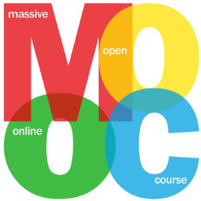
MOOCS
MOOCs are Massive Open Online Courses. They offer interactive step-by-step courses aimed at reaching an unlimited number of participants worldwide to create a community of lifelong learners. In addition to traditional course materials such as filmed lectures, readings, and problem sets, many MOOCs provide interactive user forums to support community interactions among students, professors, and teaching assistants.
MOOCS become available throughout the year. I suggest you register with providers and you’ll be updated when courses of interest to you become available.
Here are a few MOOC sites you can access with free courses
https://www.futurelearn.com/courses
Future learn runs courses such as
- Understanding drugs and addiction
- Caring for vulnerable children
- Logical and critical thinking
- Babies in mind: why parents minds matter
- Childhood in a digital age
- English in Early Childhood: Language Learning and Development
- Girls' Education: Teaching Strategies That Develop Confidence, Resilience and Collaboration
- Emergency and Urgent Care for Children: a Survival Guide
- Disability and a Good Life: Working with Disability
- The Right to Education: Breaking Down the Barriers
- Basic first aid
https://www.coursera.org/
Coursera- course availability changes from month to month. Listed below are examples sit Psychology: Well-being for life
- Foundations of Positive Psychology
- Psychological first aid
- Children's Human Rights - An Interdisciplinary Introduction
- The Brain and Space
- Learning Mind-sets & Skills
- Child Nutrition and Cooking
- Supporting children with difficulties in reading and writing
- Autism Spectrum Disorder
- ADHD: Everyday Strategies for Elementary Students
https://alison.com/
US based Alison (which stands for ‘Advance Learning Interactive Systems Online’) refers to itself as ‘A world of free certified learning’. You just need to register to access. ALISON provides over 750 free online courses in a range of different categories. Examples include:

- Psychology
- Parenting skills and tools
- Children's studies
- Educational psychology
- Mental health studies
- Caregiving
- Sociology
- Applied psychology
- Social work studies
- Suicide, violent behavior and substance abuse
- Understanding burnout and depression
- Health and safety for care giving

https://www.childtrauma.org/cta-library

A set of free resources for parents, caregivers, educators and professionals. Please select from the topics below:

Interventions

Abuse & Neglect

Brain Development & Neuroscience

Child Development & Early Childhood

Trauma & PTSD

Violence & Public Health

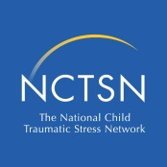
LEARNING CENTER FOR CHILD & ADOLESCENT TRAUMA HTTP://LEARN.NCTSN.ORG/

This learning centre is part of the US based National Child Traumatic Stress Network Center (NTCSN) it offers over 300 free trauma focused online courses. You just need to register to access. Examples of courses available include:

- Addressing transition issues for young foster children
- Developmental impact of childhood trauma
- Trauma and intellectual and developmental disabilities (idd) toolkit
- Optimizing visitation for young traumatized children and their parents/caregivers
- Psychological first aid online

HELMOPEN HTTP://WWW.NOTTINGHAM.AC.UK/HELMOPEN/

HelmOpen website is affiliated with the University of Nottingham and contains links to numerous health 'Reusable Learning Objects'. These are short courses designed specifically to be circulated widely and freely. All are health based but many overlap with social services work. Examples include
- Effectively communicating with children and young people following self harm
- Learning about self harm in children and young people
- Hand hygiene
- Home hazards.

HONOUR OUR VOICES HTTP://WWW.HONOROURVOICES.ORG/
Honour our voices is a unique online learning module providing you with the opportunity to see domestic abuse through the eyes and voices of children. Also contains audio modules.
https://www.acesonlinelearning.com/

EMERGING MINDS
HTTPS://EMERGINGMINDS.COM.AU/TRAINING/ONLINE-TRAINING/
This links to an Australian website that works in collaboration with Children of Parents with a Mental Illness (COPMI), promoting better outcomes for children and families where a parent experiences mental illness. It has resources targeted at the children, the parents themselves and professionals. This link takes you to the free elearning modules focused on professional interventions with children of parents with a mental illness including:
- The impact of trauma on the child
- Understanding child mental health
- The impact of parental substance misuse on children
- The impact of family and domestic abuse on a child
- Supporting infants and toddlers
- Building blocks for children’s social and emotional wellbeing

STRATEGIES FOR MANAGING ABUSE RELATED TRAUMA (SMART)
HTTP://WWW.CHILDHOOD.ORG.AU/FOR-PROFESSIONALS/SMART-ONLINE-TRAINING
Currently being updated – available soon
The SMART (Strategies for Managing Abuse Related Trauma) Program is an online learning course that focusses on supporting children and young people in a range of educational and other settings. The course is free and can be completed at your own pace. It has been developed by the Australian Childhood Foundation in partnership with the Child Abuse Prevention Research Australia and the Indigenous Health Unit at Monash University. The Smart Program consists of integrated professional development opportunities including knowledge and skill-building seminars and an interactive online learning package. Following the course are 20 discussion papers for further exploration.
Although targeted at enhancing the capacity of school and early childhood personnel to effectively respond to the needs of children and young people who have experienced abuse and trauma, it has much to offer carers and workers new to trauma understanding.
When you have completed the training, you will be able to download and print a certificate of completion

http://www.familylives.org.uk/advice/teenagers/
Parenting teenagers can be likened to a rollercoaster, with many ups and downs along the way. Some parents see changes in their teenager almost overnight whereas others may see a gradual change. Teenagers can also experience highs and lows through changes in their lives, both emotionally and physically. You may feel more anxious as your teen becomes more independent and it can become harder to give them advice. Parenting teenagers can be an enjoyable experience with a little bit of preparation Family lives offer a wealth of information on the different issues you might face. Including:
- Communicating with teen
- Drugs and alcohol
- Health and wellbeing
- Sex and relationships
- Online

Watch short videos for a wide range of instant parenting tips

https://www.familylives.org.uk/how-we-can-help/parentchannel-tv/
Parentchannel.tv is a free video service designed to support and encourage parents and carers of children from ages 0-19, with a collection of over 200 videos addressing day-to-day questions and concerns spanning wellbeing, behaviour and learning.

https://www.familylives.org.uk/how-we-can-help/leaflets/
Read a range of leaflets with further information and advice about topics including
- Bullying
- Moving to secondary school
- Gangs.
- Starting primary school
- Teenagers and risky behaviour
- Having a parent in prison
https://www.familylives.org.uk/how-we-can-help/online-parenting-courses/parents-together/
Six interactive blocks filled with helpful techniques and ideas that will help you become a more confident carer.

Modules on the course:
- Promoting wellbeing
- The power of communicating and being positive
- Understanding behaviour
- Managing and promoting positive behaviour in the family
- Play and what do children need
- Setting limits, boundaries and promoting co-operation
YouTube and TED Talks
Examples
Trauma and attachment
https://www.ted.com/talks/nadine_burke_harris_how_childhood_trauma_affects_health_across_a_lifetime?utm_source=tedcomshare&utm_medium=referral&utm_campaign=tedspread
https://youtu.be/FOCTxcaNHeg

Autism
https://www.ted.com/talks/temple_grandin_the_world_needs_all_kinds_of_minds?utm_campaign=tedspread&utm_medium=referral&utm_source=tedcomshare
https://www.ted.com/talks/stuart_duncan_how_i_use_minecraft_to_help_kids_with_autism?utm_campaign=tedspread&utm_medium=referral&utm_source=tedcomshare

Emotional first aid
www.ted.com/talks/guy_winch_the_case_for_emotional_hygiene

Dyslexia
https://youtu.be/L7cfD0PMV84?list=PLJVAb6pyqGfr3fgq2cAs9xuIq7IITKq64

Mental Health
https://youtu.be/oWe_ogA5YCU

Attending child protecting conference
https://youtu.be/EjRX38_P5HU

Social Care Institute of Excellence
Has lots of online learning. Some of the legislation spoken about is English but lots of the principles of the taught courses and films are valuable
http://www.scie.org.uk/socialcaretv/index.asp

http://www.scie.org.uk/publications/elearning/index.asp
examples :
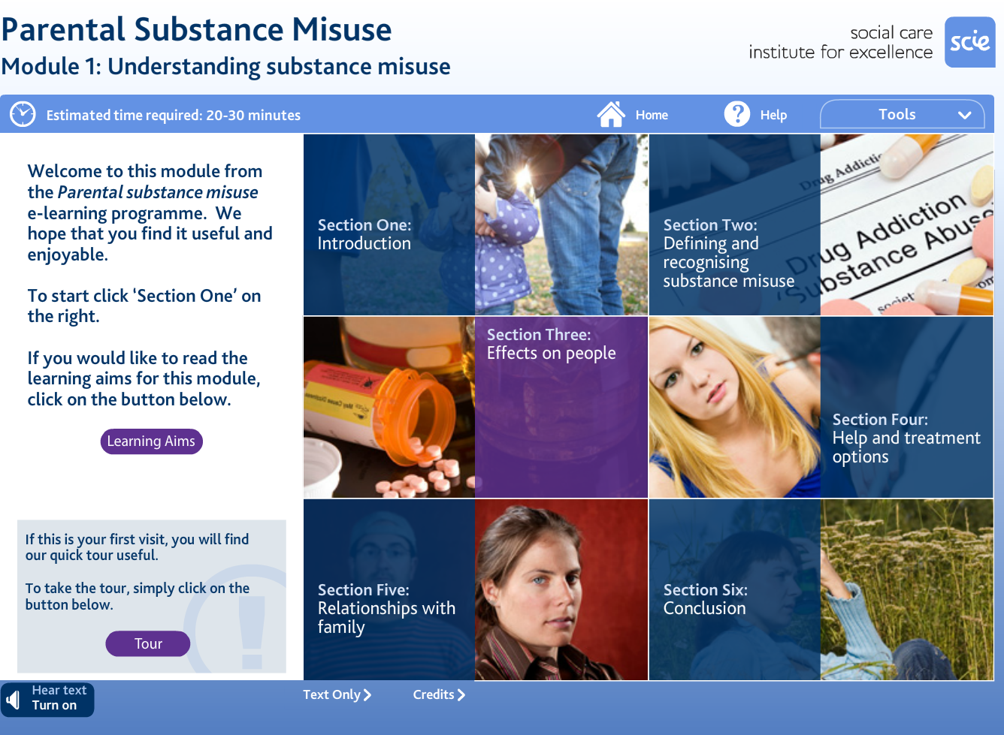
Examples:
- Parental substance misuse
- Parental substance misuse impact on children
- Parental substance misuse impact on social work practice
- Care planning and reviewing
- Communicating
- Working parents
- Working with professionals
- Introducing the family model
- Communicating in difficult situations
- Using play and creative arts to communicate with children
- Communicating across cultures

http://www.learndirect.com/maths-english-it
Improving your English and maths can boost your self esteem. As your skills improve so will your confidence. Improving your basic skills will help you support children and young people with their homework, enable you to write reports and recordings confidently an work out your finances.
Below are examples of the courses available

Courses
Brush up English
Grammar
Punctuation
Life skills
Reading
Spelling
Brush up maths
Money
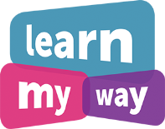

https://www.learnmyway.com/

This site teacher the basics of using your computer, table or mobile phone
Can you use your computer, phone or tablet as well as you’d like?
If you want to brush up on your skills to access the internet and keep up with the children and young people you care for please let us know

https://www.internetmatters.org/?gclid=EAIaIQobChMIsbvmm97B6AIVR7TtCh2PSQnqEAAYASAAEgKkI_D_BwE
Guides and information on safety settings on each device at home.
Learn Welsh
Learn Welsh online http://www.learn-welsh.net/
Say something in Welsh by audio clips
https://www.saysomethingin.com/welsh/course1/intro
Learn Welsh with this popular app.

This app brings together all lessons and vocabulary units (North and South versions) and all practice sessions.
This app allows you to download lessons so you can take the SaySomethinginWelsh online language course with you on your iPhone, iPad or Android device.

Useful Resources

Detailed below are useful contacts and websites:

Drug and alcohol advice
www.talktofrank.com

Ethnicity
www.cre.gov.uk
www.mewnswansea.org.uk

Foster Care
www.fostering.net
www.baaf.org.uk

Health
www.nhsdirect.nhs.uk
www.brook.org.uk
http://www.ox.ac.uk/news/2015-12-01-new-guide-parents-who-are-coping-their-childs-self-harm-you-are-not-alone
//spunout.ie/health/article/listening-is-helping

Internet safety
www.wisekids.org.uk
www.ceop.gov.uk
https://www.net-aware.org.uk/
smartsocial.com
www.internetmatters.org

Child development and parenting
www.bbc.co.uk/parenting
https://childdevelopment.com.au/areas-of-concern/what-is-child-development/

Health and social care information
www.communitycare.co.uk
www.nspcc.org.uk

Developmental disorders
Podcast
https://www.acamh.org/blog/neurodevelopmental-disorders-an-interview-with-dr-max-davie/?utm_source=Subscriber&utm_campaign=e0741eb284-EMAIL_CAMPAIGN_2019_05_03_01_39&utm_medium=email&utm_term=0_f59ca1eb20-e0741eb284-119277213

FGM and harmful practices
http://nationalfgmcentre.org.uk/knowledge-hub-resources/
https://www.virtual-college.co.uk/resources/free-courses/recognising-and-preventing-fgm

Child development
https://developingchild.harvard.edu/
Pay per course sites
http://www.tutorcare.co.uk/care-training-courses/child-care
Manual handling
https://www.a1risksolutions.co.uk/content/home

How to access Future Learn course
- Click on the link sent through the text service
- Click join and register
- Click join free
- Click save and go to course
- And enjoy your course
Never click the pay options
Always click the free options
Course are available for limited times only – so keep up the planned pace
- Complete your learning journal to evidence your personal development

