Corporate Risk Assessment

Activity being assessed:  Partial return to office working |  |  |  |  |  |  |  |  |  |  |  |  |  | Risk assessment reference number: Offices 1  Risk assessment created on: June 2020  Review date due: July 2020
Persons undertaking or affected by the activity
 | ☒ | Employees |  | ☒ | Contractor |  |  | ☐ |  | Public |  | ☐ | Service User |  | ☐ |  | Other
Hazard |  |  |  |  |  | Control measure |  |  |  |  |  |  |  |  |  |  |  |  |  | Likelihood  1. Very Unlikely  2. Unlikely  3. Likely  4. Very Likely  5. Certainty | Severity  1. Negligible  2. Minor  3. Medical Treatment  4. Major  5. Fatal |  |  |  | Risk Level  Likelihood x Severity = Risk Level
Exposure to Covid-19 |  |  |  |  |  | General  - This risk assessment has been developed in line with the Welsh Government’s Keep Wales Safe - at Work – Guidance for Employers and Employees.  - Employees should only work or enter Authority buildings if the work they are doing cannot be done from home. Staff must have received authorisation from their Manager to work or enter the building.  - Employees who are ‘shielding’ are not permitted to come into work under any circumstances.  - Special consideration must be given to whether employees who are considered to be in a higher risk category which make them more susceptible to Covid-19 as per Public Health Guidance should be permitted to come into work.  Important: For employees who are vulnerable and/or are Black and Minority Ethnic and are therefore considered to be in a higher risk category which make them more susceptible to Covid-19 and are concerned about returning to the workplace, a risk assessment tool has been developed by the Welsh Government which they can complete and share with their Manager. This can then be used as an aide in discussions with the employee to understand any concerns with returning to the workplace and to ensure appropriate control measures can be put in place for the employee to return to a safe environment.  The risk assessment tool can be accessed here.  - Any employee requiring a Personal Emergency Evacuation Plan (PEEP) will not be able to return to work at present.  - No members of the public are permitted to enter the building. Only authorised employees and maintenance contractors to be allowed to enter buildings. Any other visitors will only to be allowed entry with prior authorisation from the Head of Service.  - Main corridor doors are held open with magnetic devices which have been fitted to reduce the need to touch door handles (These devices will automatically close in the event of a fire alarm).  - First Aid kits are located on each floor.  Operational Times and entry to building  - The office opening hours are 7.30am to 5pm. This will enable cleaning staff to carry out their main cleaning duties and maintain social distancing from 5pm.  - Individuals to enter and leave the building by the main entrance where they must be signed in and out by the Concierge at the reception desk.  - A display board with key information for individuals in relation to the control of Covid-19 and a sanitation point is located inside the main entrance.  - A completed ‘Covid-19 Secure in 2020’ poster is displayed on entry demonstrating compliance with Government guidance.  - All exit points will be maintained in case of an emergency.  Hygiene – handwashing, sanitation facilities and toilets  - All individuals must use the hand sanitiser provided upon entering and leaving the building and wash/sanitise their hands regularly for the duration of the time they spend in the building eg. When leaving/returning to your workstation, before/after use of communal facilities/printer etc.  - Hand washing facilities are readily available with liquid soap and water in place and disposable paper towels for drying hands. Hand sanitiser dispensers are also located on each floor.  - All individuals are to be meticulous with their hand washing; washing thoroughly for at least 20 seconds on a regular basis.  - Signs and posters are displayed to build awareness of good handwashing technique, and the need to increase handwashing frequency.  - Cover your cough or sneeze with a flexed elbow or tissue; immediately dispose of the tissue safely and wash/sanitise your hands.  - Individuals to refrain from touching their eyes, nose, and mouth whilst at work.  - Only 2 employees are permitted to enter the communal toilets at a time in order that a 2 metre distance can be maintained. If there are already 2 people in the communal toilets when you enter you must leave the area and wait outside.  Cleaning  - The cleaning and disinfecting of offices by cleaning staff has been increased with particular attention being paid to ‘high touch’ areas.  - In addition, general cleaning wipes are available for employees who are encouraged to frequently clean their workstations and equipment.  - Employees must clear personal workspaces and remove waste and belongings from the work area at the end of a shift  - A ‘clear desk’ policy must be followed which will assist with the cleaning and disinfecting of workstations.  - Accountable Managers to liaise with staff where desks need to be cleared and can contact the Facilities section who can provide boxes for storing items and/or provide assistance if required.  Social Distancing  - Social Distancing - Reducing the number of persons in any work area to comply with the required 2 metre social distancing rule.  - Social distancing must be maintained at all times where it is possible, including when entering and leaving the building, in the car park and during lunchtimes, in order to avoid being coughed or sneezed upon and therefore reducing the risk of the spread of the Covid-19 virus.  - Information signs including 2 metre distancing signage, room/lift capacity limits, floor markings of areas to help employees ensure they keep 2 metres apart have been placed around the building.  - Protective screens have been positioned on reception desks and in the One Stop Shop.  - Plans have been done for Port Talbot Civic Centre, Neath Civic Centre and The Quays to show how employees are able to be seated at least 2 metres apart.  - The use of a rota system may be required in some sections to vary the times employees are in the office.  - The use of ‘hot desking’ is discouraged. Employees should use their own designated workstations where possible.  - If the Service dictates that hot desking is required, this should be kept to small Teams and additional cleaning and disinfecting measures will need to be carried out.  - Due to the size of some corridors within the building, it will sometimes be difficult to keep a distance of 2 metres when passing another employee. In order to help reduce this problem and to limit the amount of time employees are in contact with each other, employees should not congregate or have discussions in corridors.  - Employees to keep to the left hand side in the direction they are walking when moving around the building.  - One way systems may need to be introduced in buildings where a 2 metre distance cannot be achieved in most areas.  - Use of the stairs is encouraged rather than using the lift if possible.  - Only one person at a time is permitted when using the lift. Hands should be washed/sanitised prior to entering and upon leaving the lift.  - In order to avoid the use of shared fridges and taps in communal kitchen areas, employees are encouraged to bring in their own food and drinks. These could be brought in cool bags to keep food fresh for the duration of the time the employee is in work. Personal flasks could be brought in by employees for hot refreshments, again reducing the need to use communal facilities.  - Communal kitchen areas should only be used by one employee at a time.  - Avoid preparing drinks or other refreshments for colleagues. Any cups, mugs, crockery, cutlery used should be immediately washed up and put away after use. Do not leave any crockery or cutlery in the sink or on the draining board/worktop.  - No sweets/snacks to be brought into work for sharing within teams.  - Personal items should not be kept in communal areas eg. Coats, ppe etc.  - The coffee shop will be closed until further notice. One microwave will be available for employees to use within this area and seating provided (one person per table). General cleaning wipes are available to allow employees to wipe down the surfaces, microwave door handle, tables and other touch points.  - Use of kettles/toasters within individual offices is not permitted.  - Smoking only to be carried out outside, at least 10 metres away from the building maintaining a 2 metre social distance from others.  - Use of shared printers/photocopiers to be kept to a minimum. Only one person at a time should be within the printing/photocopying area. Wipes are available for employees to wipe down touch points on this equipment.  - Sharing of equipment such as staplers, stationery etc. must be avoided.  - Limit as far as possible shared use of items such as keys, petty cash box, etc. If multiple employees must use these then ensure they wash their hands before and after handling these items.  - The ventilation system at The Quays has been turned off temporarily as a control measure against Covid-19. Instead windows can be opened and fans, provided and tested by the Authority, used in warmer weather.  - Regular inspections and monitoring will take place to ensure rules are being adhered to (by Management and H&S section).  - Employees must follow any instructions and information related to controlling the virus.  - Any concerns in relation to control measures should be raised with your Manager.  - A separate risk assessment will need to be carried out for any activities carried out by individual sections where there are additional hazards and control measures required relating to those activities.  Meetings  - Face to face interaction should be reduced as much as possible. If a visit/meeting/work can be done via telephone/skype/teams etc. then this should be considered as the safest method. Otherwise consideration must be given to whether a 2 metre distance can be maintained.  - Avoid travel around the building eg. If you need to speak with someone in another part of the office or building, use the telephone, skype, ‘teams’ etc. to communicate with them rather than travelling to someone’s desk.  - All meeting rooms will be kept locked and if needed to be used must be booked via the Facilities section. This way arrangements can be made to ensure that the room is cleaned following its use.  - If meetings are necessary, only 2 people are permitted to enter meeting rooms and if the room has windows these should be opened to improve ventilation and employees must keep a 2 metre distance apart throughout the meeting.  - Greet people without physical contact eg. avoid handshakes.  Symptoms of Covid-19  - If an employees or members of their household are displaying any symptoms of Covid-19 they must not come into work and follow Public Health Guidance.  - If an employee develops/displays symptoms related to Covid-19 whilst in the workplace this should be reported and the employee should be sent home to self-isolate and must follow Public Health Guidance. The Manager must report this to the Facilities section (686253/facilities@npt.gov.uk) ideally by telephone so they can take appropriate action as soon as possible. This will include arranging for additional cleaning of the areas that have been used by the employee.  - If any employees or a member of their household are displaying any symptoms of Covid-19 then they can be tested by contacting the relevant Officer as detailed in Appendix 3 of the ‘Return to Workplaces Process’ document available on the HR page of the Intranet. Contact and tracing will also be arranged.  Mental Health and Wellbeing  - Management will promote mental health & wellbeing awareness to staff during the Coronavirus outbreak and will offer whatever support they can to help.  - Health and Wellbeing during COVID-19 information is available via the home screen on the NPTCBC intranet, which provides a wide variety of useful tools such as contact information for support services, online stress control classes, working from home guidance etc. |  |  |  |  |  |  |  |  |  |  |  |  |  | 2 | 3 |  |  |  | 6
Personal Protective Equipment
 |  |  |  |  |  |  | 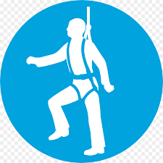 |  | 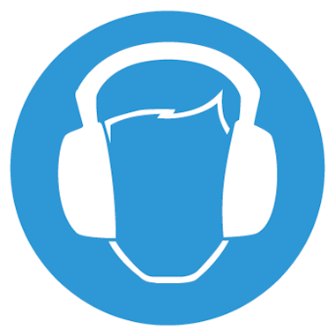 |  |  | 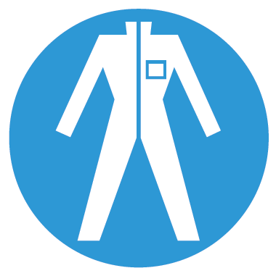 |  |  |  | 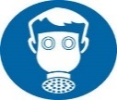 |  |  |  |  | 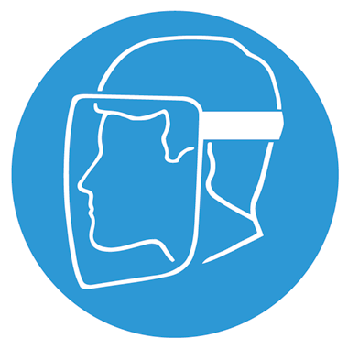 |  | Other
Aprons must be worn |  |  | Eye Protection must be worn | Head Protection must be worn |  |  | Safety Harness must be worn |  |  | Ear Protection must be worn |  | Safety overalls must be worn |  | Safety boots must be worn |  | Respiratory equipment must be worn |  | Hi Viz clothing must be worn |  | Protective  gloves must  be worn |  | Face Protection must be worn |  | ____________________________________________________________________
☐ |  |  | ☐ | ☐ |  |  | ☐ |  |  | ☐ |  | ☐ |  | ☐ |  | ☐ |  | ☐ |  | ☐ | ☐ |  | ☐
Additional risk information
In the event of an incident/accident, please contact your nearest first aider.
All incidents/accidents must be recorded on NPT’s Online Accident Reporting System.
Suitable information, instruction and training on how to use, store and maintain Personal Protective Equipment (PPE) correctly to be provided.
All staff to have regard for their and others health and safety at all times.

Please identify how this risk assessment has been communicated
Team brief / Team meeting | ☐
One to one | ☐
Email | ☒
Other (please specify: | ☐ |  | Risk Assessment published on Intranet

Emergency Procedures
Contact name:
Contact number:
Contact number (out of hours):

Name: | Position: | Date:

Risk assessments must be reviewed as a result of change in working practices / legislation or following an incident / accident
Reviews | Key
Review date : | Likelihood | Severity | Likelihood of Injury | 5 | 5Y | 10R |  | 15 | 20 |  | 25
Reviewed by: | - Very Unlikely - This will probably never happen/occur  - Unlikely - Do not expect it to happen/recur but it is possible it may do so  - Likely - Might happen or recur occasionally  - Very Likely - Will probably happen/recur, but it is not a persisting issue/circumstance  - Certainty - Will undoubtedly happen/recur, possibly frequently | - Negligible - Minor injuries or discomfort. No medical treatment or measurable physical effects.  - Minor - Injuries or illness requiring on site first aid. Temporary impairment.  - Medical Treatment - Injuries or illness requiring hospital treatment.  - Major - Injury or illness resulting in permanent impairment.  - Fatal - Fatality. |  | 4 | 4 | 8 |  | 12 | 16 |  | 20
Review date : |  |  |  | 3 | 3 | 6G |  | 9 | 12 |  | 15
Reviewed by: |  |  |  | 2 | 2 | 4 |  | 6Y | 8 |  | 10Y
Review date : |  |  |  | 1 | 1 | 2 |  | 3 | 4 |  | 5G
Reviewed by: |  |  |  | 0 | 1 | 2 |  | 3 | 4 |  | 5
Review date : |  |  |  | Severity of Injury
Reviewed by: |  |  |  |  | Low Risk |  | Medium Risk |  |  |  | High Risk

