Homeworking Guidance –
during COVID 19

Version | Date | Action
Version 1 | July 2020 | New Policy

- Introduction

Whilst lockdown is beginning to ease, the current Welsh Government guidance on working from home remains unchanged, i.e. that ‘all reasonable steps should be taken by employers to help people work from home’. This not only protects the workforce and provides business continuity it supports broader government measures to curb the outbreak.

The Council needs to implement a consistent approach to managing homeworking now that this arrangement has become more long-term during the coronavirus pandemic. This guidance provides a framework for both managers and employees during the current context and where the government continues to advise that employees must work from home where they are able to do so.

The guidance covers health and safety, managing performance, communication, work patterns, the provision of equipment and most importantly, supporting the employee’s mental health and well-being.

The guidance deals with the current circumstances and has been developed to take into account the flexibility needed at this time to enable employees to balance any new demands that have arisen due to the pandemic

Current homeworking arrangements are temporary therefore, this guidance will remain under review and will be amended as maybe necessary, dependent on government advice.

- Principles of Working from Home

Employers and employees should be practical, flexible and sensitive to each other’s situation when working from home.

In these unprecedented times, employees may be caring for children (due to school closures and normal childcare arrangements being disrupted), taking on caring responsibilities for vulnerable people and attempting to balance other needs. Allowing some flexibility, for example adapting working hours, will support employees to continue working while balancing these new but temporary demands.
To promote the flexibility needed to accommodate people’s different circumstances and whilst recognising the need to maintain a fair and consistent approach, the ‘Flexi-time Working Scheme’ will not be applied. This is a temporary arrangement, and it means that under the current homeworking arrangements, there will be no accrual of flexi-time. This decision however, will remain under review.

More information on this can be found in Section11.

Whilst employees will be expected to try their utmost to work their contracted hours, productivity and morale may be enhanced if hours can be worked in a more flexible way.

The manager should:

  - Consider the individual employee’s needs such as caring responsibilities as well as taking into account an employee’s own long-term health condition or disability.
  - Ensure a discussion takes place with the individual about their personal circumstances and agree how caring responsibilities or health needs can be supported whilst working from home.
  - For those with caring needs, the manager and employee may be able to agree a more flexible homeworking arrangement if this is necessary. This could include for instance, a temporary agreement to work different days or hours - maybe some work can be undertaken during the evenings or even over the weekend. In some circumstances, it may be appropriate to agree that the employee will work reduced hours or a reduced week for a short period of time, using annual leave, purchased additional annual leave or an agreement to work back hours at a later date. If longer term adjustments to working hours or patterns are required, refer to the Council’s Flexible Working Policy.
  - Consider whether work targets need to be reduced and be flexible about deadlines, where this is possible, and subject to the needs of the service.
  - If anyone has a long-term health condition or disability, consider for example, whether any specialist equipment needs to be provided or any reasonable adjustments are appropriate. Consider the role and which tasks can be undertaken from home as these might involve doing things differently.
  - Write down the arrangements that have been agreed so everyone is clear – this can be in an email.
  - When an employee is unable to work from home for example having no broadband access or not having the equipment required to carry out the role, consider that the only alternative option is for the employee to work from the office.

- Setting Clear Expectations

Managers:
Managers must ensure that employees understand what is expected of them. Working from home needs managers and employees to develop trusting relationships and adhere to certain principles and working practices.
A discussion should take place with employees and agreement reached on:
- when employees will be available to work;
- how they will keep in touch;
- safe home working practices, e.g. taking regular breaks;
- rules around storing information and data protection;
- how performance will be managed – taking into account employee’s personal circumstances where necessary;
- role expectations, what tasks need to be completed and what outputs are required from employees; and
- processes to monitor and review individual performance regularly and to address any individual concerns;
- Record the agreed arrangements so both parties have a mutual understanding of what is expected.
(This can be in any format you choose that best suits the team/service).

Please see Appendix 2 for a ‘Checklist for Managers’.

Employees
Employees are responsible for:
- keeping their manager regularly informed about their workload, progress and issues that require support;
- ensuring they are accessible to the manager and other work colleagues;
- ensuring they are accessible to the public, as well as all other customers, in the same way as required in the office; and
- complying with the Council’s policies regarding confidentiality, data security, use of equipment, and ensuring that no data protection principles are breached and the security of council equipment and property – refer to Section 8 of this guidance.

- Stay Connected – Keep in Touch

When working from home, it is important to continue to feel engaged and to stay connected with your manager as well as your team colleagues.

These are examples of how managers, employees and teams can keep in touch:

- continue with regular 1-2-1 supervisions.
- managers should schedule regular team meetings and employees should ensure they include themselves.
- employees can arrange informal chats with their colleagues in their own time. A chat messaging platform must not be used to do this as data protection reasons restrict this. Calls must be made via telephone or video.
- as a team, a weekly virtual lunch or a lunchtime quiz so everyone can take part could be arranged.
- take part in any training sessions or workshops delivered virtually.

- Dealing with employees who are reluctant to work from home

It is anticipated that our employees will continue to perform their duties to a high standard, and to work flexibly ensuring that services continue to be provided.

If difficulties do arise, where an employee refuses to carry out their role or certain duties, managers should start with finding out why the employee is refusing to do their job or part of their job. If there are specific concerns the manager should consider what, if anything, can be reasonably done to address the concerns and take action accordingly, to encourage the individual to work. The manager should consider the guidance provided in Section 2, taking into account the employees circumstances and in particular take account of any health issues or caring responsibilities.

If this has been done, but the individual still refuses to perform duties, this may constitute a conduct matter to be considered in line with the Council’s Disciplinary Policy and Procedure. The manager should explain the individual’s contractual obligations and the consequences of refusing to work. If there is still no change in the individual’s position, immediate advice should be sought from HR to ensure an appropriate and consistent approach can be taken.

- Health and Safety

By law, the Council is responsible for the health and safety of all employees, including those working from home.

Managers:
Managers should check that:
- each employee feels the work they are doing at home can be done safely;
- employees have the right equipment to work safely; and
- ‘reasonable adjustments’ are made for employees who have a disability.

Managers must ensure that all users of Display Screen Equipment (DSE) complete the new online DSE Assessment Application which is accessed via the Intranet (the link is provided in the next section).

The Manager will receive an auto email following their employees completion of the DSE assessment informing them whether the assessment has deemed their current arrangements as meeting the requirements of the DSE Regulations or not. If they do not, a summary of the issues will be provided and Managers will need to liaise with the employee in order to discuss what action is required to address the issues identified.

Managers may need to liaise with the Occupational Health and Safety Section and/or the Facilities Section in order to assist with some issues.

Employees:
Employees also have a responsibility to take care of their own health and safety including while working from home.

As you are likely to be working from home for a longer period, we recommend that you think carefully about your posture and how best to make your temporary workstation comfortable.

We appreciate that you may not have much choice of where you can work within your home. Here are some suggestions which will help make your workspace more comfortable:

- Work in a location with good natural or artificial lighting and ventilation.
- Ensure a safe electrical supply for equipment and avoid overloading sockets and trailing cables. Ensure equipment is switched off when not in use and not left on standby. Ensure cables are safe not to risk tripping over them, ensure children cannot drag laptops off desks etc.
- If possible, sit at a desk or table which is at the right height and use your laptop on a stable base.
- If you cannot connect your laptop to a larger screen, place your laptop on a screen riser if you have one to ensure it is at eye level. If you do not have a laptop riser then you could put your laptop on a sturdy box or some books.
- Take regular breaks away from your computer and ensure you are not sitting at your computer for long periods. Move around regularly throughout the day and have a stretch. If you are moving, there is a lot less stress on your muscles and joints
- Sit properly with lower back support and ensure any other equipment you need is within reach.

You will need to carry out an assessment of your work area by completing the new online Display Screen Equipment (DSE) Assessment Application which is available on the Intranet or via this link:
http://apexlive.neath-porttalbot.gov.uk/ords/live6/f?p=DSE_LIVE
The Application will generate a report which will be sent to your Manager, who should liaise with you in order to address any feedback.
The DSE Assessment Application also includes a short home working video and useful guidance from the Health and Safety Executive (HSE) which employees are advised to look at in order to assist with their home working arrangements.
Accidents/Incidents that occur within your ‘home workspace’ when working at home should be reported via our Online Accident Reporting System (OARS) which can be accessed via the Intranet.

- Equipment and technology

Outcome of the DSE Assessment

Following completion of the DSE assessment, if it is identified that an employee requires equipment (for example furniture including a desk or an adjustable chair, or ICT equipment, etc.) to work from home safely, the accountable manager can choose to authorise the loan of equipment from the workplace, including desks, chairs, etc.

The accountable manager should take into account the need to retain enough equipment in the workplace for those employees who continue to work in the workplace, or for those who are starting to return to the workplace. This may mean that there is not enough equipment for all employees who make a request to take it home.

Accountable managers should prioritise equipment for employees who have previously been provided with specialist equipment as a result of a previous workplace assessment and / or a disability.

Where items may be too large and impracticable to move, such as height adjustable desks, accountable managers may need to consider whether the employee can only be safely accommodated by working in the office – this would need to be considered via a risk assessment.

Note: if employees take equipment home, they will not be able to return to the office to work until the items have been returned, as the sharing of equipment is strongly discouraged.

Removal of Equipment
- If any equipment is removed from the office, this must be authorised beforehand by the accountable manager.
- The accountable manager must ensure that the employee completes a ‘loan agreement’ prior to removing any equipment and the loan agreement must be retained for audit purposes.
- This process can be done via email. The manager must then retain the email that the employee sends as well as the completed loan agreement.
Please refer to Appendix 1 for a template of the loan agreement.
Collection and Return of Equipment
- It will be the responsibility of the employee to arrange collection and return of the equipment unless the employee is shielding or has a disability. If this is the case, the employee should contact their accountable manager who will make alternative arrangements.
- If equipment is being removed from the Civic Centres (i.e. Port Talbot, Neath and The Quays), this must be agreed with prior arrangement with the Facilities Section.
- In all circumstances, the accountable manager must agree with the employee what equipment and technology is needed and provision will always be subject to management agreement.

- Security and Confidentiality

- The employee is responsible for the security of equipment, software and council information in their possession which is used or accessed whilst at home.
- This includes taking precautions against accidental loss, theft, damage and misuse.
- If any information is lost or stolen, the employee must report this immediately to the Data Protection Officer – dpo@npt.gov.uk
- The employee must ensure that all council information and data is kept secure and confidential. Paper documents should only be taken home when absolutely necessary. You must seek approval from your manager before visiting the office.
- Laptops must be shut down and stored in a safe place when not being worked on to ensure other household members cannot access them. The same applies to any paper documents in your possession.
- Personal devices and personal e mail accounts must never be used to transmit or store information or data related to Council business.
- Neither must Council information be transmitted to a personal email account for the purpose of printing this information.
- If printing documents is absolutely necessary, please contact the ICT team who will provide advice on this for example, using USB connected printers.
- Any confidential waste must not be disposed of with personal household recycling. This should be kept securely until a time when it can be disposed of in the normal way in council premises and when doing so, must be transported securely and confidentially.
- All relevant ICT policies must be complied with in relation to the access, use, storage, transportation and transmission of information.
- Further information can be found in the Information Security section on the intranet. http://umbraco.npt.gov.uk:700/4465

- Health and Well-Being of Employees working from home

Our employees’ health and well-being during this pandemic is of paramount importance. This is a very fast-moving issue. Managers and employees are asked to keep informed of the situation as it develops.

For information about the Coronavirus infection, please refer to Welsh Government and Public Health Wales guidance as follows:

https://www.nhs.uk/conditions/coronavirus-covid-19/
https://phw.nhs.wales/topics/latest-information-on-novel-coronavirus-covid-19/

- Managers should be aware of the potential mental health impact of COVID-19.
- It is important to communicate regularly on well-being and mental health support, wherever possible supported by activities that encourage physical, mental, financial and social wellbeing. This could include:-

  - Checking in regularly with employees – ideally face to face and at least weekly
  - Looking for possible signs and symptoms of poor mental health
  - Tackling unhealthy working habits
  - Raising concerns about poor mental health with the employee
  - Proactively reviewing workloads
  - Signposting to support services
  - Promoting wellbeing opportunities
  - Keeping in regular contact and review support where it is provided

Where a manager believes that an employee’s mental health is being affected adversely by working from home, they must discuss this with the employee and consider conducting a Stress Risk Assessment, and then, if it is appropriate, make a referral to the Occupational Health Unit.
The Council has developed a range of tools and resources to support the health and well-being of employees during the Covid-19 emergency which can be found here: https://www.npt.gov.uk/22793

A list of Helplines and Support Services can be found here: https://www.npt.gov.uk/22801

The NHS provides the ‘Wellbeing Through Work’ service which is available for anyone who works or lives in the Swansea Bay and Bridgend area:
http://www.wellbeingthroughwork.org.uk/individual-support/

10. Expenses
Any additional costs incurred by employees who are homeworking will not be reimbursed, including any utilities costs, the cost of any telephone land line or internet access. Employees can claim tax relief from Her Majesty’s Revenue and Customs.
Guidance on how to make a claim for homeworking expenses is included at Appendix 3.
The employee might wish to check with the mortgage provider, landlord and home insurer that there is nothing preventing them from working from home.

11. Employment Policies and Procedures
Flexi-Time Working Scheme
- As a result of the flexibility that the Council is affording to employees working from home, and to take account of the current extraordinary circumstances, there will be no accrual of flexi.
- Employees will not be expected to work within the usual band widths or core hours as defined in the ‘Flexi-time Working Scheme’.
- As mentioned previously, the employee and manager can agree a more flexible approach where working hours can be adapted to enable the employee to work their contracted hours and carry out their role (without suffering any detriment to their pay).
- However, there might be times where the service is facing significant pressures and the manager requires employees to work additional hours to meet such demands.
Employees who work additional hours or overtime will be compensated in line with time off in lieu (TOIL)/overtime arrangements but, such arrangements must be authorised, as appropriate, by the manager.

It is the manager who determines whether working additional hours/overtime is necessary and not the employee. No accumulation of TOIL will be made unless management approval has been granted.
(TOIL should be recorded separately from flexi-time).

Travel and Subsistence Claims
- Expenses will be paid in accordance with the Council’s ‘Travel and Subsistence policy’.
- The fixed work location (fixed centre) remains the same as that stated on the employee’s employment contract. This location will apply when any travel and/or subsistence payments are claimed.
- When claiming mileage incurred, the normal home to work and work to home (commuting mileage) must be deducted ONCE from the total mileage travelled on that day. Only excess mileage can be claimed.

In other words, the employee claims the total mileage travelled during the day minus the normal daily commuting mileage. The commuting mileage must only be deducted once from each day’s total mileage. Any mileage travelled in excess of the normal travel to and from work mileage can be claimed.
As employees would normally need to travel to and from their work location each day, they are not in any detriment when deducting the commuting mileage from their claim.
- Shortest route, shortest time rules must be applied therefore, the employee must efficiently plan their day accordingly to minimise distance travelled and costs incurred.
- The manager is responsible for monitoring that all journeys are planned in the most cost-effective way and should review the employee’s travel time and mileage incurred on a regular basis.

12. Terms and conditions of employment
Employees will receive the same pay when working from home, if they are working their usual hours.
All the Council’s terms and conditions apply other than having to work from home on a temporary basis.

APPENDIX 1
Checklist for Managers for Homeworking Arrangements
 |  | YES/NO/N/A | NOTES
1. | Have you agreed when employees will be available for work and working arrangements?
2. | Have you agreed how and when you will keep in touch?
3. | Have you considered the role and what tasks can be undertaken?
4. | Have employees been told they need to take regular breaks from the computer and move around regularly?
5. | Have employees been told about the rules of data protection and to store their laptop and other council information securely?
6. | Have you told them how to dispose of confidential information?
7. | Has the employee completed an online DSE assessment?
8. | If equipment is being loaned from the office, has the loan agreement been signed?
9. | Have you retained the completed loan agreement and e mail?
10. | Have you provided specialist equipment to those with a disability or long-term health condition? Have you considered making ‘reasonable adjustments’?
11. | Have you agreed how performance will be managed - Have you arranged 121 /supervision meetings? Have you agreed tasks and outputs?
12. | Have you arranged regular contact to review the current arrangements and check the well-being of the employee?
13. | Have you made a record of all the arrangements agreed above and shared with the employee?

Manager Name: __________________________
Date/s completed: __________________________
APPENDIX 2
Loan Agreement Letter

Re: Loan of Council Equipment
I write in respect of the above matter and set out below the terms and reference for your use of the equipment. .
Use of Equipment
The Council will provide to INSERT EMPLOYEE NAME the following equipment:
INSERT EQUIPMENT (the Equipment) from the date of this letter until further written notification to you by the Council] (the Term)
Terms and Conditions
In order to carry for you to use the aforementioned equipment, the following terms and conditions are to be complied with. For the avoidance of doubt the Accountable Manager detailed below is to be [INSERT ACCOUNTABLE MANAGER NAME] or any colleague nominated by him/her.
1. The Agreement and all its provisions shall be considered as a contract made in the United Kingdom and shall be construed in accordance with English and Welsh Law as it applies in Wales.
2. The Equipment will remain the Council’s property at all times.
3. You will not make any modifications to or seek to modify the Equipment without first obtaining the Council’s written approval and you must use the Equipment in any case or other equipment supplied for its use and for the use prescribed above only.

4. Upon receipt of the Equipment, you will be responsible for ensuring that the Equipment is kept safe (and secure when not in use), in good condition and repair (fair wear and tear excepted) and used properly at all times throughout the Term.

5. You will provide access to the Equipment at any time following a request from the Council to ensure it is being used for the purposes of this Agreement

6. Risk of any loss or damage in respect of accidental damage to the Equipment will become the responsibility of you upon delivery to you and this liability will remain with you until the Equipment has been returned to the Council or is no longer required by you. The Council will retain responsibility for any other damages or loss of the Equipment.

7. You agree to inform the Council immediately about any loss or damage to any part of the Equipment.

8. Either you or the Council may terminate this Agreement with immediate effect and for any reason by giving written notice to you or the Council.

9. If this Agreement is terminated in line with clause 8 above, your right to use the Equipment, will come to an end on the expiry of the Term.

10. Within 7 days after the termination or expiry of this Agreement you will, return the Equipment in good working order to the Council at the address the Council notifies to you for that purpose.

11. For the avoidance of doubt the Council accepts no liability for any misuse of the Equipment and for use other than for the purposes of this Agreement.
12. The terms of this Agreement may be changed only by the written
agreement of you and the Council.

Conclusion
I would be grateful if you would print your full name below, date and return to myself by e mailing me the full agreement and using your work e mail address, thereby confirming your acceptance of the above.
Should you require any clarification on the above terms please do not hesitate to contact me.

Yours sincerely

Signature of Accountable Manager
Print full name of Accountable Manager

EMPLOYEE TO COMPLETE:
I hereby, confirm that I accept the contents of this letter.

EMPLOYEE’S FULL NAME ……………………………………………………………….

DATE AGREEMENT SIGNED…………………………………………………………….

APPENDIX 3
Guidance on claiming tax relief from HMRC when working at home

As a result of the Coronavirus pandemic, many of our employees are now working from home and Welsh Government guidance is that employees should continue to work from home wherever possible.

Employees are therefore able to claim tax relief on £6.00 per week (worth £1.20 per week at 20% tax, or £2.40 per week at higher rate tax.). There is no need for employees to provide any receipts or provide any information in order to claim this tax relief, the amount is deducted from your taxable income.
It is only if you believe you have higher increased costs then you can claim more, but you will need to provide evidence to HMRC of the cost increases.

How to claim the tax relief

You can claim the tax relief via an online P87 form through your Government Gateway account or by filling out a postal P87 form or via the telephone.

Some employees may have already set up a Government Gateway account to apply for a passport, driving licence or to access tax free childcare vouchers. If you cannot remember your account ID or password or both, you can reset these easily on the site (in the same way as you would for any other secure site like a bank or building society). If you do not already have a Government Gateway Account, you will have to register for one.

Once you have accessed your Government Gateway account / registered for a Government Gateway account, you'll be asked for your employer's name and PAYE reference and your job title:-

Employers Name: Neath Port Talbot Council
Employers PAYE reference: 615/N108

You may also need other information to verify your identity such as:-

- National Insurance Number
- Passport Number and Passport Expiry Date or P60 information or financial information from a credit card account

Once you have accessed the Gateway, the key section you require is entitled 'Using your home as an office' (pictured below). You will need to click ‘no’ for the other expenses screen until you get to this one.

(If you are eligible for tax relief on other work-related expenses, like uniform tax rebates, or professional subscriptions, you can complete these at the same time)

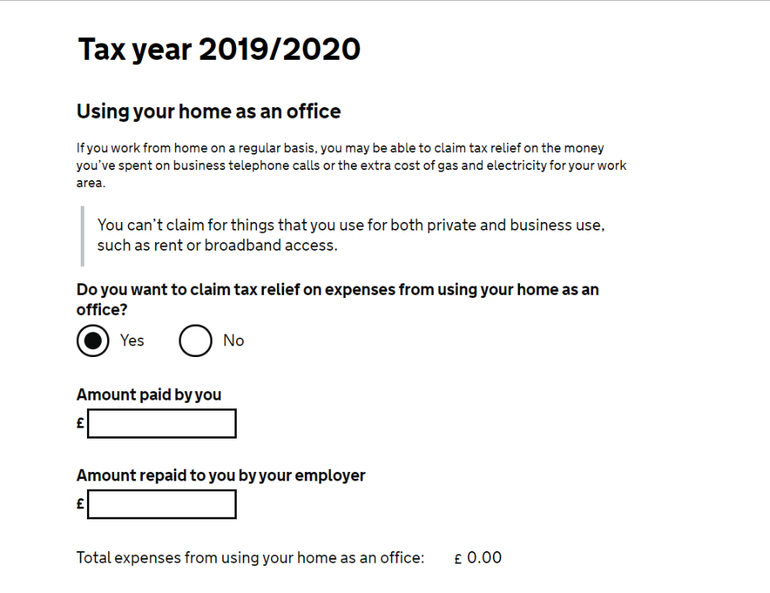

In the online form, there are two boxes:

- 'Amount paid by you'. HMRC has told us that provided you've had increased costs, just put a total amount that's equivalent to £6/wk for the period you've been working from home and that's fine, you won't need to show receipts.

- 'Amount paid to you by your employer' put £0.

If you're claiming through the postal form, you'll need to add a 'Using your home as an office' expense manually in the 'Other expenses' section.

To claim via telephone you call 0300 200 3300, this line is open Monday to Friday 8am – 4pm. There are some questions you will be required to answer via voice recognition to verify your identity (see above). When prompted for the reason for your call, you should say “home working expenses”. You will also need to provide the amount you want to claim. When determining this, in line with HMRC guidance, you should calculate as £6 per week multiplied by the number of weeks your claim is for.
You claim retrospectively on expenses incurred so it’s best to wait a few months before submitting a claim, or even until you are back in the office working then make the whole claim at once. Your tax code will likely be adjusted so you pay less tax over the year, as opposed to you getting a direct refund.

Once you've submitted the claim, you may hear back within a couple of weeks. However, obviously if HMRC is under pressure it may take longer.

If you need any help with this you can contact the Council’s Digital Inclusion Ambassador, Carl Griffiths (e-mail c.s.griffiths@npt.gov.uk, telephone 07812 104715) or your line manager or trade union representative.

