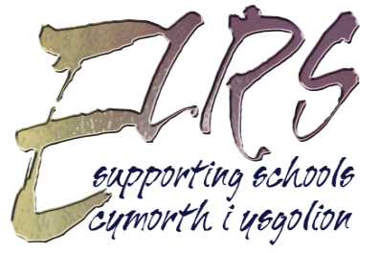 | TOPIC REQUEST FORM  TERM: Autumn/Spring/Summer  SCHOOL: |  |  |  |  | OFFICE USE ONLY  Rec:  Comp:
Prefer Welsh / English / mix?  Would you accept material not your preferred language if necessary? |  | TEACHER (full name):
 |  | Age or Year Group of Class |  | Ability of children  (as age equivalent) | English |  | Welsh
MAIN TOPICS (please indicate in brackets if being studied in a particular half term)

Additional / more specific areas you would be interested in.
If you gave a thematic topic above please explain what it includes here.

Non Book / Half Term Loan Resources
If available would you like?  Posters / Prints  Big Books  Multimedia  Museum Items  Toys |  |  |  | Office use only
Any specifics / restrictions relating to the above

If you would like to purchase role play packs or off-air broadcast DVD’s to support your topic please contact reprographics on (01639) 889900.
Please return this form by e-mail books.elrs@npt.gov.uk
You can also contact us by telephone on (01639) 889900.

