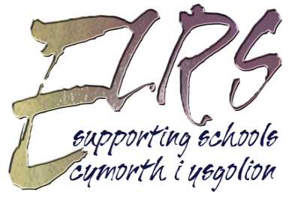 | PRIMARY FICTION REQUEST FORM  One form per school only  SCHOOL: |  | OFFICE USE ONLY  Rec:  Check:  Comp:
No. of FTE teachers: |  | Pupil No (approx.):
This information will be used to work out your allowances
CONTACT NAME:

TELEPHONE NO.: |  | E-MAIL:
Please fill in this side of the form if you prefer English language material. If you would also like Welsh language material please indicate here.

FICTION LEVELS / TYPES REQUIRED
 | PICTURE BOOKS |  | POETRY SELECTION
 | FIRST READERS |  | KS2 SEN SELECTION  Please specify age equivalent ability range
 | LOWER KS2
 | UPPER KS2

We can supply up to 1 box of more specific fiction per school, subject to stock, please give details of items or topics you would like below, not including guided reading or big books. Note that this is for the whole year.

GUIDED READING SETS
These can be exchanged approximately termly

 | PRE READING |  | LOWER KS2
 | FIRST READERS |  | UPPER KS2
 | KS1

Please return this form by e-mail books.elrs@npt.gov.uk or by telephone on (01639) 889900.

