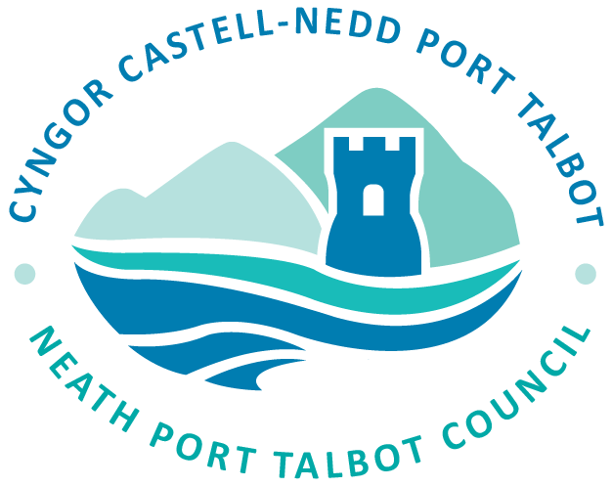

Easy Read Version
of
Neath Port Talbot Council’s Housing Support Programme Strategy

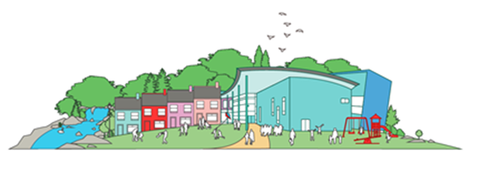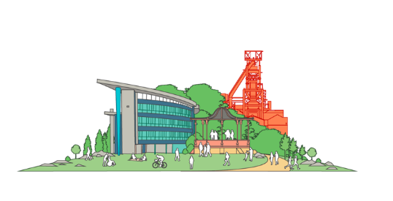
What is the Housing Support Programme Strategy?

The Strategy aims to make Neath Port Talbot a place where nobody is homeless and everyone has a safe place to live.

The Strategy shows how we will work with people and organisations to make sure we have the right numbers and types of housing.

We will ask people what they think of our Strategy, and look at how it can help stop people from becoming homeless or quickly help them to find somewhere to live.
We would like to know what you think of the Strategy.

How to take part

There are different ways for you to tell us what you think.

You can answer our online questionnaire www.npt.gov.uk/haveyoursay

You can email us CCU@npt.gov.uk

