Corporate Risk Assessment

Activity being assessed:  Working in Offices Post Pandemic and Onwards |  |  |  |  |  |  |  |  |  |  |  |  |  | Risk assessment reference number: Offices PP  Risk assessment created on: June 2022  Review date due: Ongoing
Persons undertaking or affected by the activity
 | ☒ | Employees |  | ☒ | Contractor |  |  | ☒ |  | Public |  | ☐ | Service User |  | ☐ |  | Other
Hazard |  |  |  |  |  | Control measure |  |  |  |  |  |  |  |  |  |  |  |  |  | Likelihood  1. Very Unlikely  2. Unlikely  3. Likely  4. Very Likely  5. Certainty | Severity  1. Negligible  2. Minor  3. Medical Treatment  4. Major  5. Fatal |  |  |  | Risk Level  Likelihood x Severity = Risk Level
Spread of Communicable diseases (including Flu, Norovirus and Covid) |  |  |  |  |  | This risk assessment has been prepared following Welsh Government’s removal of all Covid restrictions and has been replaced with 7 Control Measures as suggested by Public Health Wales.  These measures are intended to help mitigate against the most common communicable diseases (including Flu, Norovirus and Coronavirus) risks which we will face on an ongoing basis.  Staff are encouraged to consider these control measures and to use a common sense approach by implementing them where reasonably practicable to do so in order to keep each other as safe and well as possible in the workplace.  This risk assessment has been developed jointly with the Trade Unions based on the arrangements in place at the three Civic Centres. Managers in other buildings should consider and tailor this risk assessment to suit their location.  This risk assessment will be reviewed on an ongoing basis and reviewed in line with any changes to Public Health and Welsh Government guidance.  Ventilation  - Adequate ventilation must be provided in all areas of the workplace to help reduce the spread of communicable diseases. Natural ventilation indoors can be provided by opening doors and windows where this does not contravene fire safety requirements.  - It is important to identify and deal with areas that are not well ventilated. The occupation of a poorly ventilated area should be avoided. If such an area needs to be used, the number of people and time they spend in that area should be limited. This will help lower the risk of spread of any Communicable disease.  - If table or pedestal fans need to be used, ensure that air is not blown from one person to another by regularly bringing in air from outside by opening windows or doors. You should not use these fans if ventilation is inadequate.  - The ventilation system is on at The Quays, but the thermal wheel has been switched off so there is no cross contamination. The air conditioning system remains off.  - Use of Meeting Rooms – When booking and using meeting rooms, consider the size of the room, the means of ventilation in the room and the number of people who need to be at the meeting. If large numbers need to attend, consider whether some attendees can join via Microsoft Teams. You should also consider limiting the length of time needed to be in the room.  Cleaning and Personal Hygiene  - All individuals are encouraged to use the hand sanitiser provided upon entering and leaving the building and to wash hands with soap and water or regularly sanitise their hands throughout the day as this is one of the most important control measures in helping to reduce the spread of any communicable diseases.  - Effective and timely cleaning and disinfection is an important principle of infection prevention and control and will help minimise the onward transmission of communicable diseases.  - The cleaning and disinfecting of offices by cleaning staff is robust with particular attention being paid to hand contact surfaces. Hand contact surfaces such as door handles, taps, light switches and push pads and toilets which present a greater transmission risk are being cleaned and disinfected regularly by Cleaning staff.  - The cleaning of buildings is undertaken using anti-virucidal cleaning products including Premier Screen disinfectant, with strong anti-virus and anti-bacterial properties.  - A product called ‘Hi Q Viroblock’ is being used to coat surfaces at the three Civic buildings as an additional measure to help limit the spread of viruses.  - In addition general cleaning wipes are available for employees who are encouraged to frequently clean their workstations and equipment.  - Employees must clear workspaces and remove waste and belongings from the work area before leaving. A clear desk will assist with the cleaning and disinfecting of work areas by Cleaning staff.  Training  - All individuals are encouraged to watch the short video on the intranet which provides a simple guide to the control measures within this risk assessment that staff are encouraged to follow.  - Risk assessments will be displayed at the entry point to the building along with any other relevant signage and information.  Physical Distancing  - Physical distancing is particularly relevant to minimise the spread of respiratory illnesses like Flu and Coronavirus. Therefore, Public Health guidance still suggests that physical distancing should be encouraged where reasonably practicable to do so..  Working from Home  - The most effective way of minimising the risk of exposure to any communicable disease in workplaces is to enable some or all staff to work from home. Staff should follow the Hybrid Working arrangement in place for their section.  - Working from home should be considered particularly during high prevalence periods (such as Autumn/Winter).  Exclusion of Symptomatic Individuals  - The most effective way of preventing the spread of any communicable disease in the workplace is to prevent the virus being present in the first place.  - If an individual is displaying any symptoms of a communicable disease (such as Flu, Coronavirus or Norovirus) or have tested positive for Coronavirus, they should not come into their workplace and where possible, work from home.  Vaccinations  - According to Public Health advice, vaccination remains a critical part of our response to Coronavirus and is the most important thing an individual can do to protect themselves and others.  - All employees are encouraged to be vaccinated against Covid-19 and time off with pay is provided for all employees to attend vaccination appointments.  Other considerations  Vulnerable Employees  - People previously placed on the Shielding Patient List are no longer considered at substantially greater risk than the general population, and they are advised to follow the same guidance as everyone else on staying safe and preventing the spread of coronavirus as well as any further advice they may have received from their Doctor  - You should discuss any requirements, including reasonable adjustments that may be required for disabled workers and workers with health conditions to return to or remain safely in the workplace.  - Discussions with pregnant workers should take place at an early stage so you can co-produce the risk assessment, keeping it under review throughout the pregnancy to ensure appropriate mitigations are put in place in a timely manner.  Face Coverings  Face coverings may still be worn by individuals in buildings if they so wish but this is no longer a mandatory requirement in any part of any building.
Personal Protective Equipment
 |  |  |  |  |  |  | 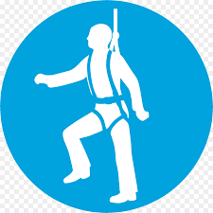 |  |  |  |  | 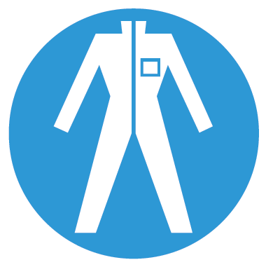 |  |  |  | 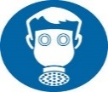 |  |  |  |  | 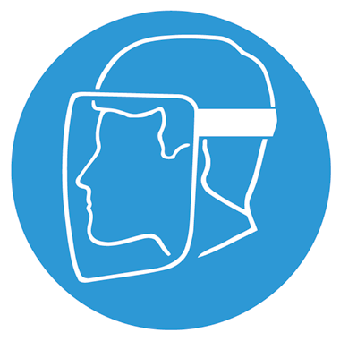 |  | Other
Aprons must be worn |  |  | Eye Protection must be worn | Head Protection must be worn |  |  | Safety Harness must be worn |  |  | Ear Protection must be worn |  | Safety overalls must be worn |  | Safety boots must be worn |  | Respiratory equipment must be worn |  | Hi Viz clothing must be worn |  | Protective  gloves must  be worn |  | Face Protection must be worn |  | ____________________________________________________________________
☐ |  |  | ☐ | ☐ |  |  | ☐ |  |  | ☐ |  | ☐ |  | ☐ |  | ☐ |  | ☐ |  | ☐ | ☐ |  | ☐
Additional risk information
In the event of an incident/accident, please contact your nearest first aider.
All incidents/accidents must be recorded on NPT’s Online Accident Reporting System.
Suitable information, instruction and training on how to use, store and maintain Personal Protective Equipment (PPE) correctly to be provided.
All staff to have regard for their and others health and safety at all times.

Please identify how this risk assessment has been communicated
Team brief / Team meeting | ☐
One to one | ☐
Email | ☐
Other (please specify: | ☐

Emergency Procedures
Contact name:
Contact number:
Contact number (out of hours):

Name: | Position: | Date:

Risk assessments must be reviewed as a result of change in working practices / legislation or following an incident / accident
Reviews | Key
Review date : | Likelihood | Severity | Likelihood of Injury | 5 | 5Y | 10R |  | 15 | 20 |  | 25
Reviewed by: | - Very Unlikely - This will probably never happen/occur  - Unlikely - Do not expect it to happen/recur but it is possible it may do so  - Likely - Might happen or recur occasionally  - Very Likely - Will probably happen/recur, but it is not a persisting issue/circumstance  - Certainty - Will undoubtedly happen/recur, possibly frequently | - Negligible - Minor injuries or discomfort. No medical treatment or measurable physical effects.  - Minor - Injuries or illness requiring on site first aid. Temporary impairment.  - Medical Treatment - Injuries or illness requiring hospital treatment.  - Major - Injury or illness resulting in permanent impairment.  - Fatal - Fatality. |  | 4 | 4 | 8 |  | 12 | 16 |  | 20
Review date : |  |  |  | 3 | 3 | 6G |  | 9 | 12 |  | 15
Reviewed by: |  |  |  | 2 | 2 | 4 |  | 6Y | 8 |  | 10Y
Review date : |  |  |  | 1 | 1 | 2 |  | 3 | 4 |  | 5G
Reviewed by: |  |  |  | 0 | 1 | 2 |  | 3 | 4 |  | 5
Review date : |  |  |  | Severity of Injury
Reviewed by: |  |  |  |  | Low Risk |  | Medium Risk |  |  |  | High Risk

