

**FREE CYCLE STANDS**

Application Form



**This project is funded by Welsh Government with support from Transport for Wales**

To help encourage more people to cycle, Neath Port Talbot Council is giving away up to four free cycle stands to organisations in locations where cycle parking is needed – workplaces, leisure facilities or amenities used by the public.

Under this scheme eligible organisations can apply for up to 4 cycle stands for free. The Council will purchase stands whilst the cost of installing them is met by the applicant**.**

The stands provided under the scheme are for installation within land or premises owned by the applicant (i.e. not on public space or highways owned by the Council). **Arrangements for installing stands provided under the scheme must therefore be made by the applicant(s),**

**Please read all the information below before completing this application form.**

If you need advice or help in completing your application, please contact NPT at [greener@npt.gov.uk](mailto:greener@npt.gov.uk)

Please return the completed application form to

Active Travel

Neath Port Talbot County Borough Council

The Quays

Brunel Way

Baglan Energy Park

SA11 2GG

Or email to [greener@npt.gov.uk](mailto:greener@npt.gov.uk)

APPLICATION FORM FOR FREE CYCLE STANDS

1. **Your Organisation**

Please complete the following:

|  |  |
| --- | --- |
| **Contact Name** |  |
| **Name of Organisation** |  |
| **Email address** |  |
| **Telephone Number** |  |
| **Address** |  |

Please indicate how many (full time equivalent) employees/volunteers you have.

Please indicate what type of organisation you are:

* Community group or voluntary sector
* Church or place of worship
* Small business or co-op
* Larger organisation (more than 50 employees)
* Other (please provide details)

1. **Planning Permission**

The scheme is not open to organisations that are required to install cycle parking as part of a planning permission.

Planning consent may be required in some situations to install cycle stands (e.g. listed building consent). It is the applicants responsibility to determine if planning permission is required.

Please indicate below:

* We do not have to install cycle parking as a planning requirement.
* Ours is not a listed building.

For any queries, please contact NPT’s Development Control on:

Tel: 01639 686868  
Email: [planning@npt.gov.uk](mailto:planning@npt.gov.uk)

1. **Free Cycle Stands**

The scheme provides ‘Sheffield’ type cycle stands. Each stand holds up to two bikes. Cyclists lean their bikes against the stand and secure them using their own D-lock or cable lock.

There are two types of fixing for the stands we have available, they are:

* **Sink-in fixing**:

Two holes are dug and the posts of the stand are concreted into position, or,

* **Bolt-down fixing**: Suitable for all surfaces above.

4 bolts are needed as stands have baseplates (2 bolts per baseplate).

**If you require further advice on this, please email** [**greener@npt.gov.uk**](mailto:greener@npt.gov.uk)

How many stands do you require?

Sink in fixing:-

* one
* two
* three
* four

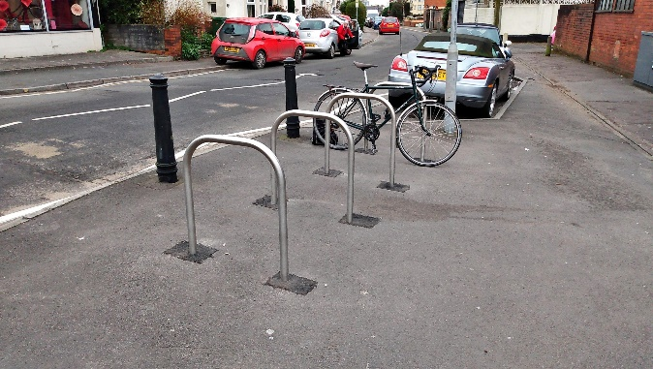

Photo showing sink in type

Bolt-down fixing:-

* one
* two
* three
* four

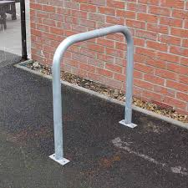

Photo showing bolt down type

Where do you propose to site your stands? (*Please refer to the guidelines below and provide a diagram and/or as much information as possible*)

Please explain why you have chosen this location:

1. **I understand the criteria for this application and confirm that the information supplied in this application is accurate.**

Name

Signature

Position in organisation

(Senior Manager or equivalent)

Date

It is essential that cycle storage is installed and spaced correctly. Please follow these guidelines. Bolt down cycle stands are suitable for use only on solid concrete surfaces and should be secured with suitable bolts – not provided.

Bolt down stands are 800mm high x 715mm wide.

Sink in type stands are 800mm high x 715mm wide. They also have a concrete base that is sunk 300mm below ground level

BOLT DOWN TYPE SINK IN TYPE

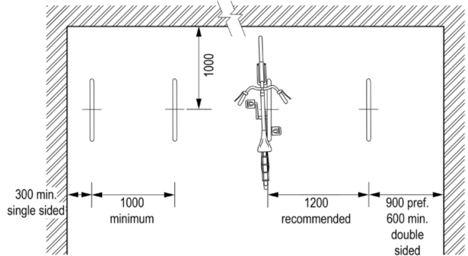

ARRANGEMENT PARALLEL TO WALL (VIEWED FROM ABOVE)

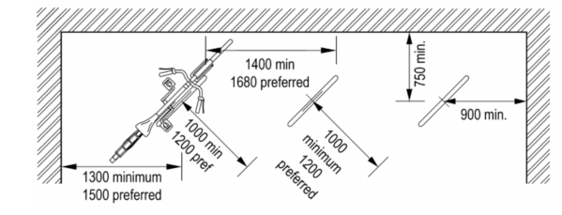

ARRANGEMENT 45 DEGREES TO WALL (VIEWED FROM ABOVE)