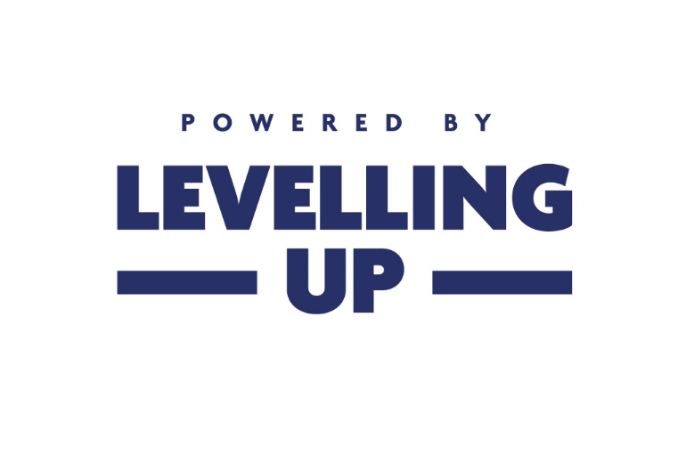

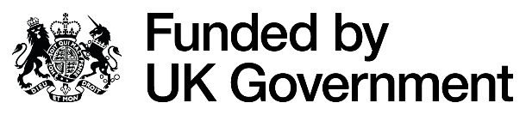

UK Shared Prosperity Fund
Neath Port Talbot
Match Funding Form

This form asks you to confirm that match funding is in place where projects rely on match as part of the funding package. Match funding must be confirmed (with the exception of SME contributions) prior to the issuing of any Funding Agreement.
One form should be completed by each organisation providing funding to the lead applicant. Each organisation should complete a separate copy, filling in the relevant sections, and inserting a signature. The information should include a breakdown of match funding to be provided and be signed by someone in a position of authority in that organisation.
The lead applicant must submit these with the application, by the submission date.
Project name:
Name of lead applicant organisation:
Name of participating organisation:
Company or charity registration number:
Registered address:
Confirm:
- £ value to be provided:
- the type (cash only):
- the status (secured or date to be provided):
If the funding has not yet been secured, explain when it is expected to be secured and what the impact would be if it is not secured:
If the project will require income from beneficiaries, the lead applicant should explain how you have ensured that the level of demand for the service is sufficient to generate the expected contributions:
By completing and signing this form, I confirm support for this bid, noting any outstanding requirements and/or conditions that need to be met below:
Conditions:
Name: | Job role:
Date: | Signed:

