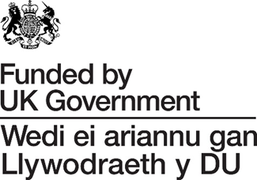

TATA STEEL UK TRANSITION
ECONOMIC GROWTH & INVESTMENT FUND

SCORING GUIDANCE & CRITERIA

Administered and delivered by Neath Port Talbot Council (NPTC) on behalf of UK Government (UKG) Tata Steel UK (TSUK)

This project is funded by UKG and TSUK

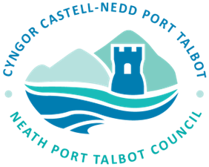
Introduction
The following scoring criteria, that focuses on maximizing public value, economic growth and deliverability will be used to evaluate, score and rank Applications for funding from the Tata Economic Growth & Investment Fund.
Process
All Applications received will be reviewed (as per the criteria outlined below), scored and ranked in order of % scored.
Minimum Threshold: Applications must achieve a minimum overall score of at least 60% to progress to the next stage. However, as this Fund will operate via an Open Call and there is a “Total Fund Value” that cannot be exceeded, there is no guarantee that Applications that score more than 60%, will be shortlisted to proceed to full application.
In addition, Applications that score zero on any of the 5 key areas listed below, will be declined.
Shortlisted Applications will proceed to the next stage, where further due diligence checks, i.e. financial; legal status, capacity to deliver, any necessary licensing or planning requirements, etc., will be undertaken.
Feedback will be given to any unsuccessful applicants.
Please Note: Before submitting an Application for funding, please read the Criteria and Guidance for Applicants for the Economic Growth & Investment Fund which will be provided alongside this document to all applicants.
Scoring Criteria (Total 100%)
1. Strategic Fit and Alignment (15%)
- Clear alignment to one of the Objectives of the Fund and potential impact within the targeted local authority areas. Projects that meet at least 80% of the objectives of the fund will score higher.
- Evidence of need of grant (additionality) and clear explanation as to why public funding is required.
- Projects MUST operate within the business sectors outlined in the Guidance Notes for this Fund
2. Economic Impact and Growth Potential (25%)
- Job Creation & Retention – details of any new or safeguarded jobs (e.g., Full-Time Equivalents – FTEs; apprenticeships, etc) must be included in the Application. Projects creating and safeguarding high-value, sustainable, or specialized roles rather than temporary or low-skilled jobs will be favoured.
- Evidence that the project will help the company achieve significant growth (e.g., we would expect to see a year-on-year increase in turnover over the next 5 years).
- Projects that demonstrate Innovation, i.e. introduction of new products, processes, or services to the market, etc., and can evidence indirect economic benefits to the supply chain within their sector or other sectors will score higher.
3. Deliverability and Project Management (25%)
- Applications will be scored against a realistic, SMART (Specific, Measurable, Achievable, Relevant, Time-bound) project plan with clear milestones including a clear strategy for transition and ongoing operation.
- Clear evidence that the management team have the necessary skills, expertise, and capacity to deliver the project.
- Any risks (financial, technical, legal) must be identified, and robust mitigation strategies should be in place.
- All projects must evidence a timeline for making the expenditure and the submission of claims to draw down the grant funding.
NB: All projects must be:
- Compliant with the criteria of the Fund including the procurement process for quotes.
- Transparent as to how the project will be funded and identifying any potential conflicts of interest relating to delivery of the project.
- Efficient in providing timescales for delivery of the project that can be met and a schedule for claims that can be achieved.
4. Value for Money (VfM) and Financial Viability (25%)
- Strong track record of trading and growth, including how this has been achieved.
- A justification of costs to ensure they are reasonable and comparable to market rates.
- Evidence of mandatory match funding i.e. 30% of the total project costs net of VAT and financial standing.
- Projects that demonstrate a high ratio of private investment to public grant will be scored higher.
NB: If shortlisted to proceed, further financial due diligence checks will be undertaken.

5. Sustainability and Social Value (10%)
Projects that can evidence the following will score higher:
- Positive environmental impacts, i.e. net-zero contribution, decarbonization plans or general reduction in environmental impact.
- Equality, diversity or fair work practices.
- Commitment to supporting apprenticeships or training opportunities to underrepresented groups.
- Wider tangible benefits to the community as part of the delivery of the project, including supporting local supply chains.

Scoring Matrix
The following will be used to score Applications:
Excellent – 3 points Clear, relevant response that goes beyond expectation and provides detailed examples.
Good - 2 points Well thought through, addresses all requirements and provides evidence.
Satisfactory - 1 point Addresses most requirements with sufficient evidence.
Unsatisfactory – 0 points No/Insufficient evidence provided.

Scoring Criteria | Points Awarded | Weighting  %
Strategic Fit and Alignment |  | 15%
Economic Impact and Growth Potential |  | 25%
Deliverability and Project Management |  | 25%
Value for Money (VfM) and Financial Viability |  | 25%
Sustainability and Social Value |  | 10%

