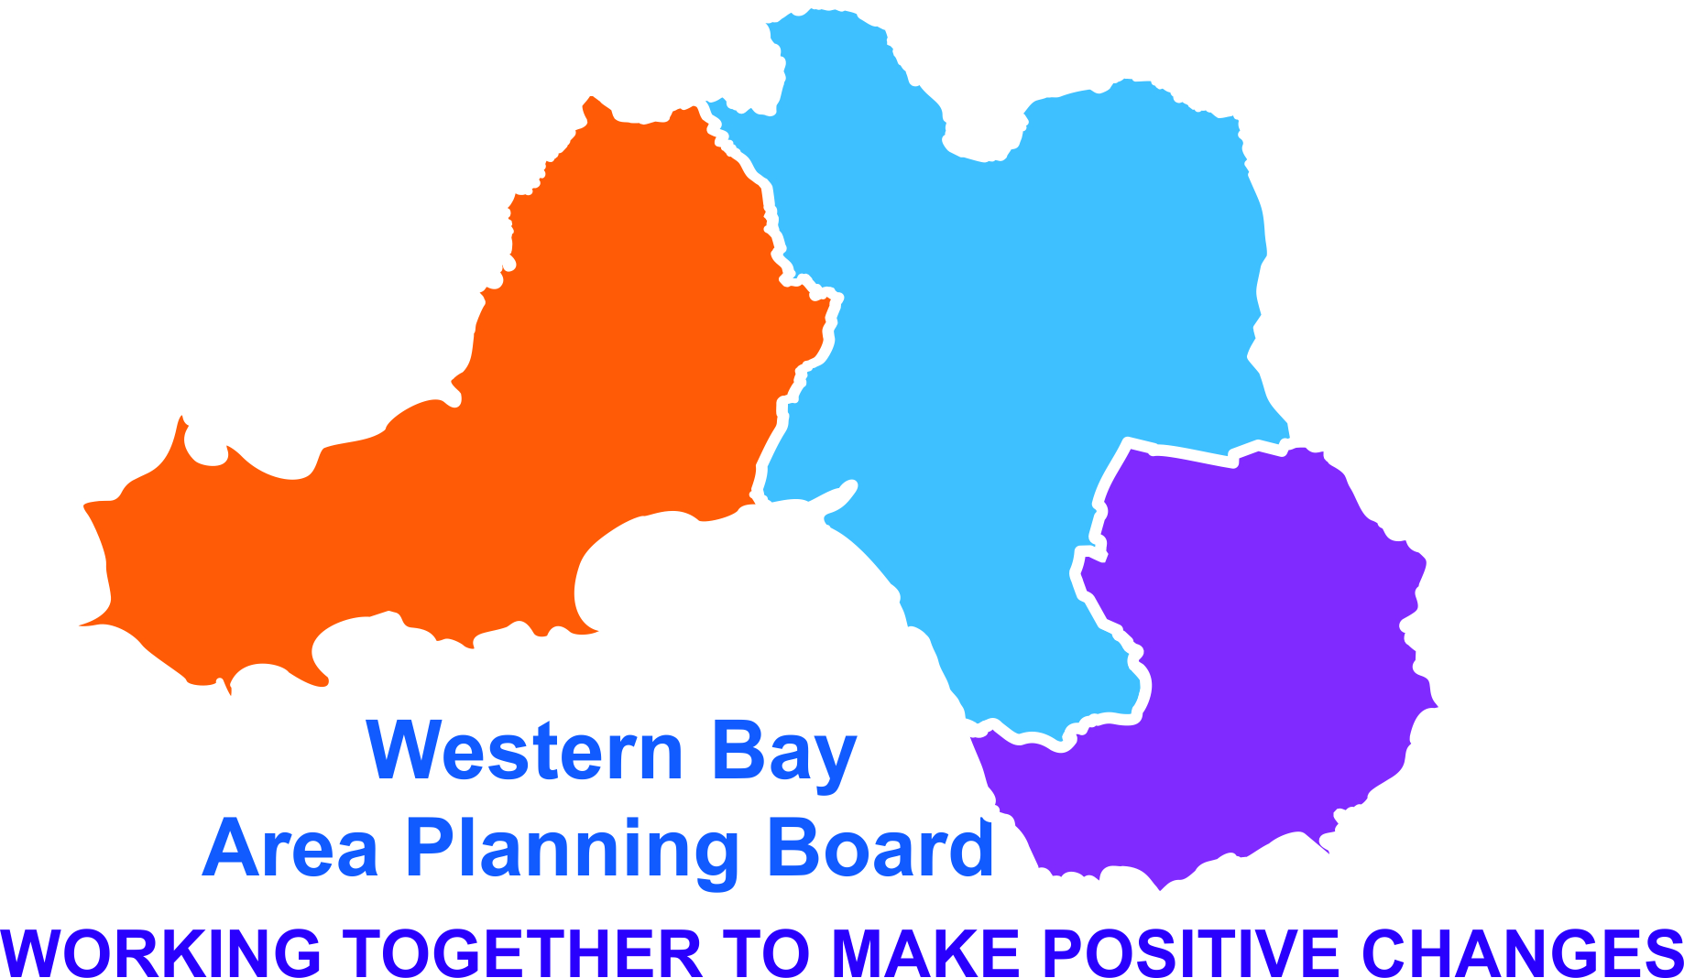
PREVENTION AND EDUCATION SUB GROUP
14 Jun 2016 9.30 – 11.30
Neath Civic Centre

Present
Mike Catling - PHW (MC) Chair
Emma Griffiths - PHW (EG)
Jamie Harris - Drug Aid (JH)
Jay Carroll- Drug Aid (JC)
Claire Fauvel - PHW (CF)
Lisa Shipton - WCADA (LS)
Apologies
Becky Hancock-WCADA
Kay Harris – BAVO
Melanie Perry-HWW
Paula Davies – ABMU -
Angela Cronin – BCBC
Anne Saunders – ABMU

Julie Powell – SWP (JP)
Lisa Warlow-NPTCBC
Julia Jenkins-NPTCBC
Corrine Fry-NPTCBC

- Introductions and Apologies.
Introductions and apologies took place.

- Minutes of previous meeting and Action Log.
The minutes from the last meeting were found to be correct and the Action log was updated with the following comments:

- Andy Edwards from Youth Worker for Swansea attended the meeting.
- CF updated the group regarding what work was being undertaken in other areas around Working Age Adults. It was decided that a dedicated discussion would take place at the next meeting. Action: LW to add Working Age Adults to the agenda for a dedicated discussion to take place.
- JJ will follow up safeguarding representation for the meeting. Action: JJ to follow up the safeguarding representation
- CF queried who the BCBC rep was for this meeting and other meetings as Mark Wilkinson had queried this. LW to clarify who the BCBC rep is for the next meeting.

Action Log from 14 Jun 16

Action | Status | Lead | Deadline | Comments
LW to add Working Age Adults to the agenda for a dedicated discussion to take place. | Green | Lisa Warlow | 20 Sep
Research for questions for young people NPS Strategy - decisions to be emailed to CF before 15 April. | Red | ALL | 20 Sep
LW to clarify who the BCBC Rep is for this meeting | Amber |  | 20 Sep | To be discussed at the next meeting.
JJ to follow up the safeguarding representation | Amber | Julia Jenkins | 20 Sep | To be discussed at the next meeting.
CF LS CFR will meet to put together a proposal for the next APB to use some of the underspend to develop an app for the survey and for comments to be invited. | Red | Claire Fauvel Lisa Shipton Corrine Frey | 20 Sep
Early Years to be added to the agenda for the next meeting | Green | Lisa Warlow | 20 Sep
JJ to compile a response to WG for the DD training Delivery Plan | Green | Julia Jenkins | 20 Sep | This forms part of the joint Delivery Plan that has been developed by the DD DIG & sent to WG.
JC and EG to draft a report on the reduction of the Police CRC role and to circulate to the group form comments and endorsements before the submitting to the APB for agreement. | Green | Jay Carrol Emma Griffiths | 20 Sep | This no longer applies.

- Draft NPS Prevention Strategy

- Consultation with Young People Update
CF gave a background for new members of the group and a verbal update. The PID was attached to the agenda for information. Discussions took place as to how to implement and make best use of this across the region. A survey is currently being developed using survey monkey and is due to be implemented in the 2nd week of September 16 within schools and a range of youth settings. All participants will have the opportunity to be entered into a draw for an ‘iPod’. A general discussion took place as to how to circulate the survey across the region. The results are intended to provide baseline information on young people’s perceptions and perspectives which added to service/agencies data can inform the prevention strategy and our recommendations for action across Western Bay. It was suggested that this work could fit well with the idea of a Conference/Workshop on the topic of Prevention with a showcase focussing on Early Intervention. There was a suggestion that an App could be developed for the use of the survey. Action: CFr, LS and CF will meet to put together a proposal for the next APB to use some of the underspend to develop an App for the survey and for comments to be invited.

- Feedback on and Discussion Of Next Steps for Work Plan
At the last meeting it was requested for feedback on the work plan so that it could be completed. Only a response from Drug Aid and BAVO was sent. It was highlighted that it currently does not reflect the work that is being done. Discussions took place around Early Years and Working Age and it was decided that the next meeting would be dedicated to these to two topics. Apologies from WCADA were given for not responding due to staff restrictions. Action: Two items to be on the agenda for the next meeting on the 20 September- Early Years and Working Age Adults.

- Dual Diagnosis training Delivery Plan
A strategy has been developed along with a pathways and a plan for implementation. Unfortunately this has not been carried forward. WG have requested an update on the Dual Diagnosis strategy which is to include a framework on delivery, training plan and how many people have been trained. JJ explained that a small working group has been established led by ABMU Mental Health Directorate and a framework has been drafted which will be signed off at the next meeting. It was put to the group on how to source a training programme. Group members expressed a willingness to consider the development of a training programme if invited through their organisations. However, it was suggested that the working group first identify the training needs and CPD requirements for dual diagnosis before establishing a training programme. JJ to feedback to the working group with a view to compiling a response to WG. Action: JJ to compile a response to WG.

- Prevention and education Sub Group work Plan Update:
- Early years, Parents and Carers Mapping Exercise
This was discussed under Agenda Item 4.

- Young People Task & Finish Group
An update was given and the following changes were highlighted.
- CF stated that it appears that lessons from the Police Core Programme will be reduced particularly at primary school level. CF stated that this would seriously undermine the quality of the provision.
- The Police Core Programme Coordinator post is currently being reviewed due to WG funding reductions and could be reduced by up to 50%. However, the partners have not been consulted about the rationalisation of the programme. It was proposed that it may help to raise the matter for the APB to consider submitting an official response. Action: CJ and EG to draft a report on the reduction of the Police Core Programme education provision and to circulate to the group for comments and endorsements before submitting to the APB for agreement.

- Older Adults – findings of the APSOM research on substance misuse in older people.
This was not discussed due to time restrictions.

- School Policy Implementation Review.
This will be discussed as part of the Work Plan.

- Drug Scratch Cards
CF handed some Drug Scratch Cards out and requested any feedback to be sent to her.
- Key points to be raised to the APB on behalf of subgroup
Due to time restrictions, MC will forward these to the group at a later date.

- AOB
Due to time restrictions this was not discussed.

- Time and Date of Next Meeting

20 Sept 16 – 9.30 – 11.30 am WCADA Port Talbot

