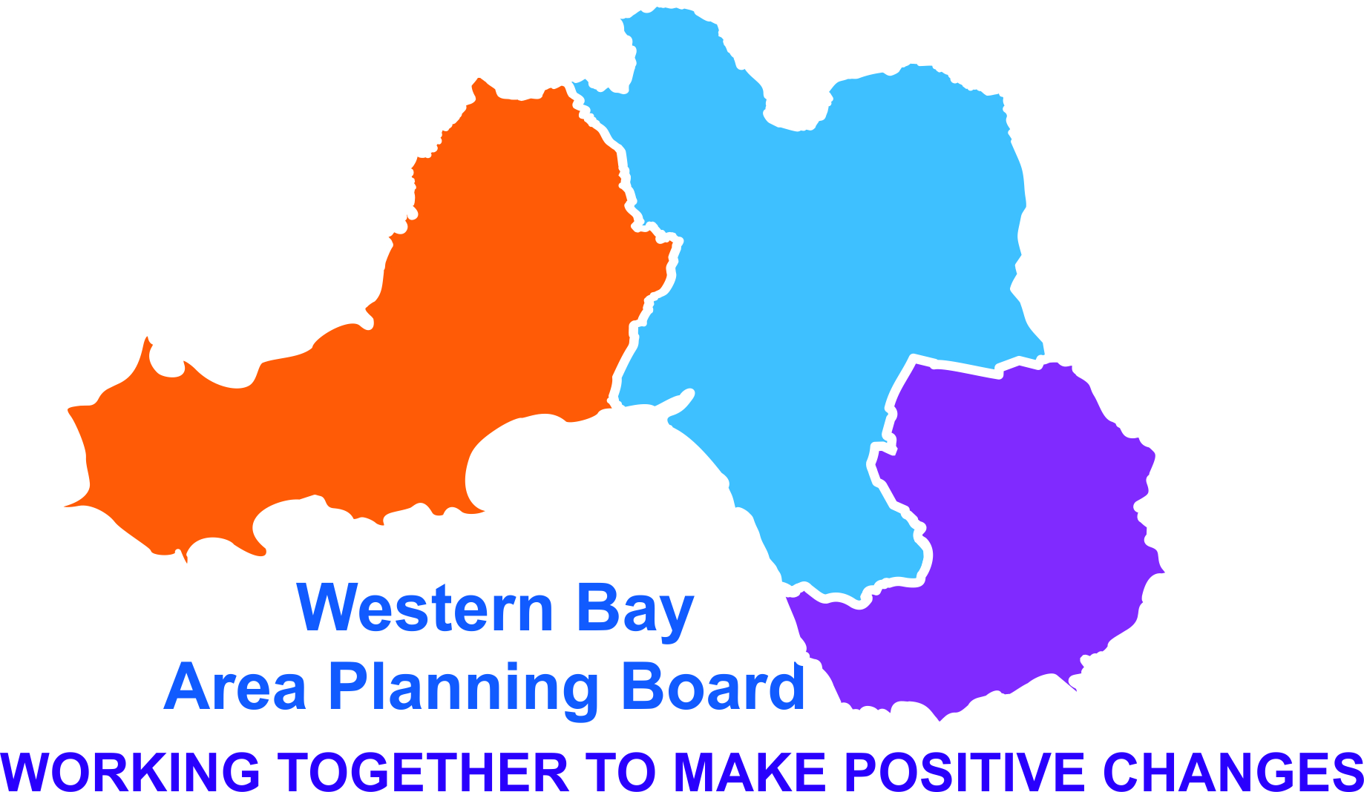
PREVENTION AND EDUCATION SUB GROUP
20 Sep 16 9.30 – 11.30
WCADA Port Talbot

Present
Mike Catling - PHW (MC) Chair
Emma Griffiths - PHW (EG)
Claire Fauvel - PHW (CFv)
Julie Powell – SWP (JP)
Julie Powell-Jones – PHW Prac (JP)
Lisa Warlow-NPTCBC (LW)
Julia Jenkins-NPTCBC (JJ)
Corrine Fry-NPTCBC (CFr)
Steve Adie – NPTCBC (SA)
Lucas Williams – Trading Standards (LuW)
Paula Davies – Flying Start- ABMU (PD)
Becky Hancock-WCADA (BH)
Clare Price – DASH (CP)
Kay Harris – BAVO (KH)

Apologies
Melanie Perry-HWW
Jamie Harris - Drug Aid
Angela Cronin – BCBC
Anne Saunders – ABMU
Jay Carroll- Drug Aid
Lisa Shipton - WCADA
Phil Thomas - SWP
- Introductions and Apologies.
Introductions and apologies took place.

- Minutes of previous meeting and Action Log.
The Minutes were found to be correct; the actions from the last meeting were discussed and the following comments were made:
- JJ is going to follow up with BCBC Safeguarding Representative Training Board which would cover both BCBC representatives as well.
Action: JJ to invite Claire Holt to represent the Safeguarding and BCBC rep for this meeting.
- It was corrected that CF and EG were to draft a report on the reduction of the Police Core Programme but there is not going to be a reduction in delivering the Education Programme just potentially the role of the coordinator.

Action Log from 20 Sep 16

Action | Status | Lead | Deadline | Comments
JJ to invite Claire Holt to represent the Safeguarding & BCBC for this group. | RED | Julia Jenkins | 6 Dec 16
CF, BH & JJ to take the lead with the scoping work of what is happening across the region regarding the Working Age Adults prevention services | RED | Claire Fauvel Becky Hancock Julia Jenkins | Ongoing
CF, SA, BH, CP to meet to develop the work plan | RED | Claire Fauvel Steve Adie  Becky Hancock  Clare Price | Ongoing
CF, BH, TOH, CP and EG to compile a report to be taken to the APB in Dec 16 regarding how to improve the access to services for schools. | RED | Claire Fauvel  Emma Griffiths  Becky Hancock  Clare Price  Toni OHara | 13 Dec 16
Early Years to be placed on the agenda for the next meeting for a dedicated discussion. | RED | Mike Catling Lisa Warlow | 6 Dec 16
PD to take the discussion of training for Health Visitors to the Safeguarding meeting on the 20 Sep and to feed back to the group at the next meeting. | RED | Paula Davies | 6 Dec 16

- Work Plan Update

- Overview of redrafted plan
CF has updated the Work Plan and gave an overview of this with the main discussion being around Working Age Adults. CF also discussed potential indicators and data development needs. A small Working Group consisting of CF, SA, BH and CP will be meeting to move this forward.
Action: CF, SA, BH, CP to meet to develop the work plan.

- Working Age Adults – Main discussion
The paper that was provided was discussed and described some prevention interventions that were applicable to the working age. Within the group it appeared that there were no direct links with working age adults or with Domestic Violence and that this needs to be addressed. Discussions also took place around substance misuse within the workplace as more work places are undertaking testing more regularly. It was queried what then happens if employees’ were found to be positive and maybe this could be an area to be looked at in the future.
Discussions took place around the pilot that Cwmtaf are running with GP’s, they are contacting the over 40’s who have not presented themselves at their surgeries for a period of time and offering them a general check-up. Zoe Wallace is leading on a similar piece of work in the Bridgend area. It was decided that this group should scope as to what is happening across the region regarding the Working Age Adults prevention services and then for this to be taken to the APB in the future.
Action: CF, BH & JJ to take the lead with the scoping work of what is happening across the region regarding the Working Age Adults prevention services.

- Children & Young People
  - SM Education Update
A brief update on the scoping exercise of what education services schools are able to access was given and which resulted in the Police Core Programme being the only service readily available. Beyond this it was mainly WCADA, DrugAid and DASH. The SBAR report provided a summary the findings and recommendations and a further report will be compiled by CF and EG which will be taken to the APB in Dec 16. The role of the PET Group would then take this work forward.
Action: CF, BH, CP, TOH and EG to compile a report to be taken to the APB in Dec 16 regarding how to improve the access to services for schools.

  - Children Young People – School Policy Update
Meetings have been held and the funding proposal will be going to the APB in Oct for the translation, editing and publishing of the first Draft. The Director’s will then confirm the first draft and decisions will be made as to which schools will trial it.

  - Children Young People – NPS Prevention Strategy Update
The NPS survey is going to be launched on Oct 3rd and the reason for the delay has been due to having the survey translated into Welsh and to have a branding, which has been decided as being “not so legal, not so high’. There will be separate surveys in Welsh and English with a view to this starting in January 2017.

  - Early Years.
The SBAR document that was provided was discussed. The Healthy Child’s Programmed will be launched on 26 October 2016 and this will be an all Wales programme. Recommendations include training for Health Visitors to ensure competency, and Flying Start Childcare facilities should have access to this training. It was requested for this to be placed on the agenda for the next meeting for a dedicated discussion.
Action: for Early Years to be placed on the agenda for the next meeting for a dedicated discussion.
It was also suggested for training around Substance Misuse to be taken back to the Safeguarding Meeting this afternoon where health visitors from across the region will attend.
Action: for PD to take the discussion of training for Health Visitors to the Safeguarding meeting on the 20 Sep and to feed back to the group at the next meeting.

- Drug Scratch Cards
Due to time restrictions this was not discussed.

- Safeguarding
An outline was given why this has been put on the agenda of relative subgroups. It is also going to be included in monitoring meetings and if anything needs to be escalated then this would be fed back to the Safeguarding Board. It was decided that this was not a key priority for this group but a consideration in all PET activities.

- Key points to be raised to the APB on behalf of subgroup
- A small working group will be looking at developing the Work Plan in detail.
- A Discussion on the Working Age Adults has been held and a small group will be formed to carry this forward.
- Progress has been made with the Substance Misuse Secondary Education School Policy.
- A dedicated discussion around Early Years will be held at the next meeting.

The group was updated with the new way of reporting back in the APB meetings and this will be through a quarterly report which in turn will become an annual report.

- AOB
- Drink Aware, which is an independent charity, has been launched in Cardiff. It aims to reduce alcohol related harm and the initiative is to have a number of Drink Aware Club Crew who will be specially trained to work in bars and clubs to help reduce antisocial behaviour. They will also be working in conjunction with Swansea Help Point and ATC in Cardiff.
- The CYP&F Group raised the topic of peer mentoring and the idea of producing a scheme to help standardize this across the region; and they are looking for cross representation from the PET Group.
- The CYP&F Group also had a discussion around the messages about accessing services for younger people and that perhaps the messages could represent a more helpful approach instead of giving the impression of being told what to do.
- It was requested for future agendas to include feedback from the Training Standards and Police.

- Time and Date of Next Meeting

6 Dec 16, 9.30 – 11.30 am WCADA Port Talbot

