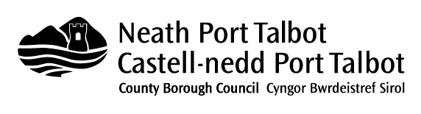
Document 4
THIRD SECTOR GRANT AGREEMENT (UNDER £1,000)
Activity:
Organisation:
Date of Approval:
Amount of Grant:
Grant Conditions
- The grant must not be used for any purpose other than those stated in the application
- Any publicity regarding the activity must acknowledge the financial assistance being given by the Council. The Council itself may wish to publicise its contribution to the activity and the organisation will agree to any reasonable request from the Council for co-operation in this respect.
- The grant monies must be deposited in a bank account specifically related to the activity or the organisation carrying out the activity.
- The activity must be completed within 12 months of notification of the approval of the grant. Any outstanding monies at the end of this period must be repaid to the Council.
- Within one month of completion of the activity the following information must be provided:
  - A financial statement showing how the grant was spent supported by invoices, receipts and any other relevant proof of expenditure if so required by the Council
  - A short report on the success, or otherwise, of the activity including:
    - A description of the activity
    - How the grant monies were spent
    - The amount and source of any matched funding
    - The achievement / non-achievement of the outputs and outcomes included in your original application
- If so requested by the Council you shall be responsible for populating and maintaining the system established by the Council to discharge the information, advice and assistance requirements contained within the Social Services and Well-Being (Wales) Act 2014.

The above conditions are accepted by the undersigned on behalf of the organisation carrying out the activity.

Signed:

Print Name:

Position:

Date:

Please sign one copy and return to Ms D Weaver, 1st Floor, The Quays, ICT Department, Neath Port Talbot County Borough Council, Brunel Way, Baglan Energy Park, Neath SA11 2GG and retain another copy for your records.

