Ground Instability in the Pant-teg area, Ystalyfera
- The Pant-teg landslip is part of a wider landslip system present on the slopes of Mynydd Allt-y-grug. Historical ground movements have occurred above and below a slope toe that follows the main road through the village (Cyfyng Road).
- The approximate boundary of the Pant-teg landslip is shown in green below (Figure 1) and the photo shows an old landslip opposite Pant-teg chapel and now demolished properties to the left of the image (Figure 2):
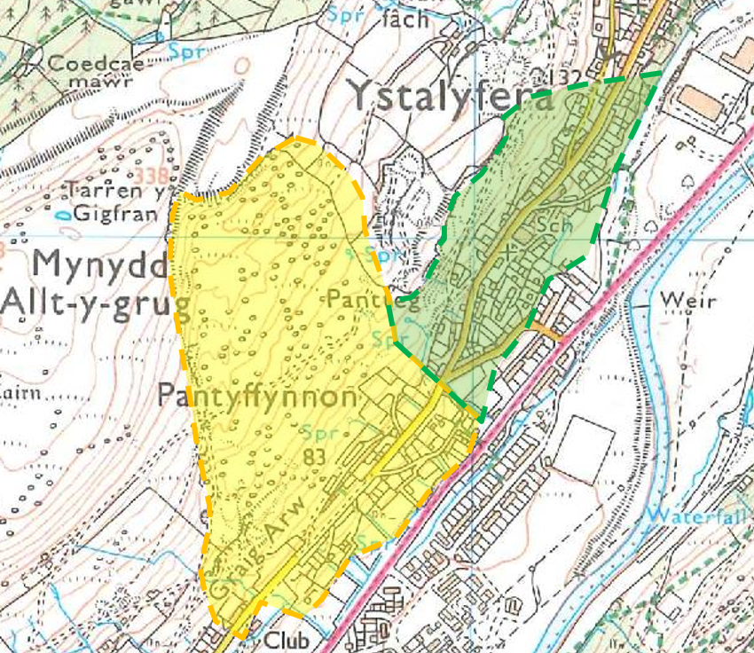
Figure 1: Extract from the 1:25,000 Ordnance Survey Map showing the approximate extents of the Pant-teg (green) and Godre'rgraig (yellow) landslips (OS licence 0100015788). Not to scale.

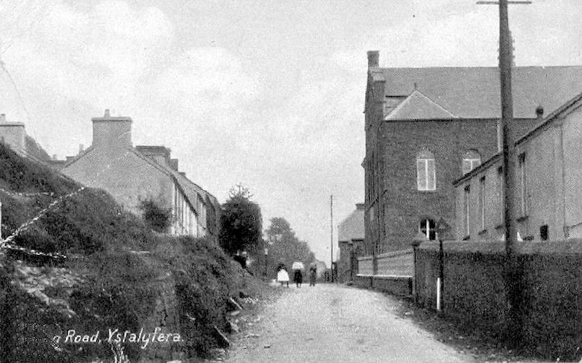
Figure 2: Undated Postcard of Pant-teg Chapel (Ball, 2015)
- The village and neighbouring areas were built on the steep valley sides and are unstable due to:
- Natural geological and surface conditions present since the end of the last ice age (common in Wales) and;
- Historical mining and development activity.
- Instability has been recorded at least twenty-six times since 1897, seven of which were sizeable events. Parts of the neighbouring village of Godre’rgraig have been gradually abandoned since the 1950’s and 1960’s due to ground instability. At the present time, material appears to be falling from the crest of the slope which was regraded following the 2012 landslide.
- In terms of the terrace of 10 properties affected at Cyfyng Road, based on our site reconnaissance, knowledge of the wider landslip, geomorphology of the slopes to the east of Cyfyng Road and recent groundwater monitoring, we consider it likely that additional ground movement and slope regression will occur, possibly de-stabilising the structures and adjacent areas.
- To predict when this will occur is almost impossible given the resolution we currently have on the landslip, so we are limited to being able to say that it is more likely than not to happen in the short to medium term. Because of the proximity of the failures to people and property, we consider there to be an immediate risk to those receptors.
- At present, it is not possible to accurately predict when or where a landslip will take place at Pantteg and our ongoing work will improve the understanding. Since 2012 NPTCBC have, in addition to installing monitoring equipment, carried out re-profiling of the failure slope, tree clearance and the construction of a block stone road defence. It is unlikely that there is a viable overall engineering solution to stop further landslides from occurring.
- Since 2015, Earth Science Partnership have been working with NPTCBC to implement a strategy to understand the existing geological conditions better and have formulated a monitoring regime for the landslip area. This comprises a series of borehole installations and land surveys; you may have seen some of this activity recently. The aim of this work is to update the historical Hazard and Risk Map based on current engineering geological practice, which has evolved over the last decades, to develop an understanding of where instability is likely to occur in the future, and give us a better understanding of likely impact on roads, land and properties in the area.

