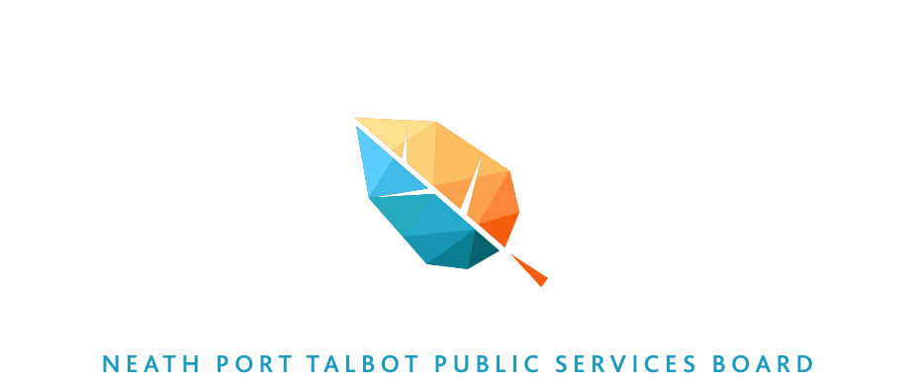

Local Well-being Plan

Draft – November 2017

Contents

1. Vision for Neath Port Talbot (page 3)
2. The Well-being of Future Generations (Wales) Act 2015 (page 4)
3. How this Plan has been developed (page 9)
4. The Partnership Structure (page 12)
5. Draft Cross-cutting priorities (page 13)
6. Local draft priorities (page 20)
7. Delivering and Monitoring Progress (page 34)

1. Vision for Neath Port Talbot
We want Neath Port Talbot to be a vibrant and healthy place where people have an equal chance to get on in life - a place where people want to live, learn, invest and visit for many generations to come.

We want local public services, which includes the Third Sector, to be effective and value for money, easy for people to use, offering quality employment where people are valued and appreciated for the work they do. Together with citizens, we will build on our strong and cohesive communities where the rights of everyone will be respected and protected.

We want our public services to be focused on enabling people and communities to be resilient and it will be the norm for citizens to experience seamless, personalized high quality services. Public service delivery will create the right conditions for investment that will enable the county borough to attract and sustain quality sustainable employment for local people.

Our communities will be well connected through a first class digital and transport infrastructure and our natural Environment will be protected but also developed to support healthy living and investment.

We will have achieved our vision if all children and young people have the best start in life; if all young people and adults have the skills and resilience to be healthy and prosperous; if people are safe and feel safe; if all of our communities are thriving and supporting the people who live there and where people can draw on the support of neighbours and well developed social networks.

2. The Well-being of Future Generations (Wales) Act 2015
This local Well-being Plan has been developed to meet statutory requirements contained in the Well-being of Future Generations (Wales) Act 2015. The Act applies to 44 public bodies in Wales which includes Welsh Government, local authorities, local health boards, Fire and Rescue Services, National Parks, National Resources Wales and the National Museum of Wales.
The Act is about improving the social, economic, environmental and cultural well-being of Wales and the Welsh Government has produced a short animation which is a very useful introduction to the meaning and intention of the Act.
The Act puts into place a “sustainable development principle” which means every one of the 44 public bodies listed in the Act must act in a manner which seeks to ensure that the needs of the present are met without compromising the ability of future generations to meet their own needs. There are 5 things those public bodies need to think about to show that they have applied the sustainable development principle
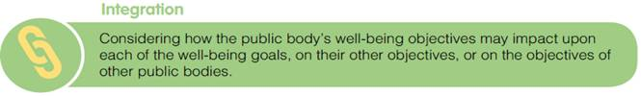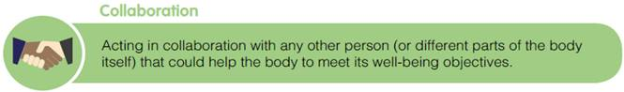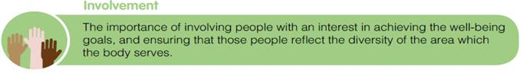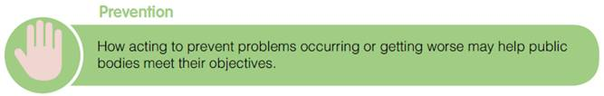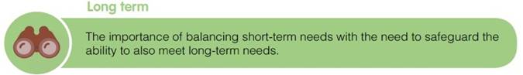
The Act contains seven well-being goals which together provide a shared vision for the public bodies listed in the Act to work towards. These seven goals were developed following an extensive national conversation facilitated by the Welsh Government and reflect what many people said they wanted to achieve for their children and grandchildren.
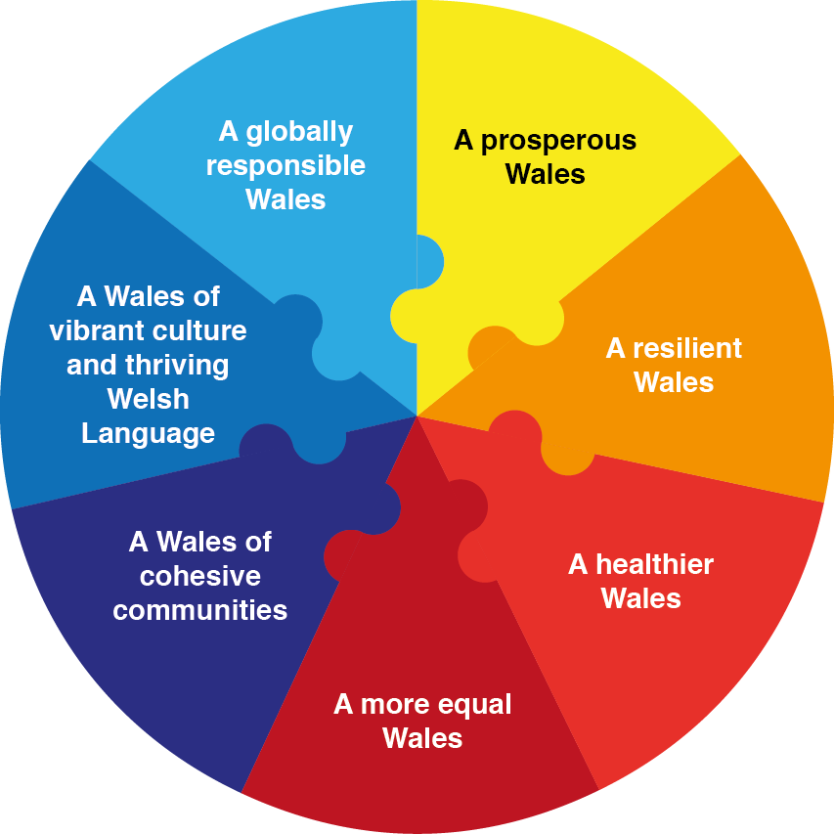

A prosperous Wales: An innovative, productive and low carbon society which recognises the limits of the global environment and therefore uses resources efficiently and proportionately (including acting on climate change); and which develops a skilled and well-educated population in an economy which generates wealth and provides employment opportunities, allowing people to take advantage of the wealth generated through securing decent work.
A resilient Wales: A nation which maintains and enhances a bio diverse natural environment with healthy functioning ecosystems that support social, economic and ecological resilience and the capacity to adapt to change (for example climate change).
A healthier Wales: A society in which people’s physical and mental well-being is maximised and in which choices and behaviours that benefit future health are understood.
A more equal Wales: A society that enables people to fulfil their potential no matter what their background or circumstances (including their socio-economic background and circumstances).
A Wales of cohesive communities: Attractive, viable, safe and well-connected communities.
A Wales of vibrant culture and thriving Welsh language: A society that promotes and protects culture, heritage and the Welsh language, and which encourages people to participate in the arts, and sports and recreation.
A globally responsible Wales: A globally responsible Wales. A nation which, when doing anything to improve the economic, social, environmental and cultural well-being of Wales, takes account of whether doing such a thing may make a positive contribution to global well-being and the capacity to adapt to change (for example climate change).

Public Services Boards

The Well-being of Future Generations (Wales) Act 2015 establishes a statutory board, known as a public services board, in each local authority area in Wales. The boards are made up of both statutory members and invited participants and there are four statutory members of each board. (The public services boards replace the previous local service boards).

The Neath Port Talbot Public Services Board was established in May 2016 and the statutory members of the Neath Port Talbot Public Services Board are:

- Neath Port Talbot County Borough Council
- Abertawe Bro Morgannwg University Health Board
- Mid and West Wales Fire and Rescue Service
- National Resources Wales

The invited participants of the Neath Port Talbot Public Services Board are:

- NPT Council for Voluntary Service
- South Wales Police
- Tai Tarian
- National Probation Service
- Wales Community Rehabilitation Company
- Job Centre Plus
- NPT Group of Colleges
- Police & Crime Commissioner
- Higher Education Funding Council for Wales
- University of Wales Trinity St David
- Welsh Government
- Public Health Wales
- Community Councils & Town Councils

3. How this Plan has been developed
To meet the requirements of the Well-being of Future Generations (Wales) Act 2015, the first piece of work for the Neath Port Talbot Public Services Board to do was to prepare and publish an Assessment of Local Well-being. This assessment is an assessment of the state of economic, social, environmental and cultural well-being in Neath Port Talbot and was published by the Public Services Board on 2nd May 2016 (available here).
The assessment was informed by extensive engagement and survey work with residents and stakeholders, and consideration of relevant information such as existing data, evidence and research.
The published assessment captures the strengths and assets of people and communities across Neath and Port Talbot and describes the challenges and opportunities Neath Port Talbot faces now and in the future.
The second piece of work required by the Act is the preparation and publication of a local well-being plan which sets out how each board intends to improve the economic, social, environmental and cultural well-being of its area by setting local well-being objectives which will maximise the contribution made by each individual board to achieving the 7 well-being goals outlined earlier.
To inform this draft Local Well-being Plan for Neath Port Talbot, the challenges and opportunities (65 in total) identified in the local Assessment of Well-being were further explored by the Public Services Board in a workshop (June 2016) which informed the setting of the following draft priorities. It is these draft priorities, the Public Services Board agreed could benefit from collective action that will have a positive impact on the state of well-being in the area:
- Support children in their early years, especially children at risk of adverse childhood experiences.
- Create safe, confident and resilient communities
- Encourage ageing well
- Promote well-being through the workplace
The group discussions at the workshop also led to the identification and development of a cross-cutting theme:

- Recognise and promote green infrastructure, how the green infrastructure can promote well-being, in particular for those groups of people identified in the above priority themes.

Individual members of the Public Services Board volunteered to lead the work on the priorities and themes which involved the establishment of multi-agency working groups made up of representatives from the organisations represented on the Public Services Board (see diagram overleaf). The work undertaken by the groups includes:
- co-ordinating the mapping of issues and assets;
- adopting an Asset Based approach to focus on identifying, building on and mobilising personal, local assets and resources;
- ensuring sufficient data sharing protocols are in place to facilitate relevant, safe and timely data sharing between agencies;
- identifying local knowledge and experience to build supportive groups and networks to develop opportunities for meaningful engagement with the community

Consultation

At their meeting on the 21st September the Public Services Board agreed to adopt a two tier approach to the consultation:
Tier 1: using the Citizen Engagement Scheme we will design a general public consultation to give a wide range of interested bodies and the general public the opportunity to comment on the draft Vision and the draft priorities identified by the PSB. The key messages of this consultation were developed and disseminated through partners existing networks using a range of channels (e.g. online questionnaire, social media, paper questionnaires and community engagement events).

Tier 2: again, with reference to the Citizen Engagement Scheme lead officers will undertake focused consultation/engagement on their particular work-streams. This will enable lead officers to identify the people that could be involved in developing and delivering the project in line with the sustainable development principle.

We plan to hold a multi-agency stakeholder event in December 2017. The event will focus on whether by taking a narrow and deep approach to the well-being plan this leaves a gap in partnership planning arrangements. The output of this workshop will then inform the final version of the well-being plan.

4. The Partnership Structure
Neath Port Talbot
Public Services Board

Children in their early years

Lead:
Aled Evans
Neath Port Talbot County Borough Council

Safe, confident and resilient communities

Lead:
Martin Jones
South Wales Police

Ageing Well

Lead:
Roger Thomas
Mid and West Wales Fire and Rescue Service
Well-being
(through the workplace)

Lead:
Andrew Davies
AMBU Health Board

Multi-agency Task and Finish Group
Fire
Police
Public Health Wales
NPTCBC
NPT CVS
NRW
FGC Office

Multi-agency Task and Finish Group
Police
NPTCBC
Tai Tarian
NPT CVS
DWP
Police and Crime Commissioner’s Office
FGC Office

Multi-agency Task and Finish Group
NPTCBC
Police
Fire
Public Health Wales
NPTC Colleges
Tai Tarian
NPT CVS
NRW
WB Subs Misuse
Swansea Uni
FGC Office

Multi-agency Task and Finish Group
Tai Tarian
Police
Fire
NPTCBC
Public Health Wales
FGC Office

Green Infrastructure

Green Infrastructure

5. Draft Cross-cutting Priority: Recognise and promote green infrastructure, how green infrastructure can support the economic, social and cultural well-being of the people of Neath Port Talbot
Why is this important?
The European Commission defines green infrastructure as:
“…the use of ecosystems, green spaces and water in strategic land use planning to deliver environmental and quality of life benefits.”
Green infrastructure (GI) refers to the combined structure, position, connectivity and types of green (and blue) spaces, including parks, open spaces, playing fields, woodlands, wetlands, road verges, allotments and private gardens.
The feedback from the public engagement on the NPT Well-being Assessment shows that these green and blue spaces are highly-valued by individuals and communities. They provide us with direct benefits by offering space for relaxation, play, physical activity, learning and connection with nature. More than this, they provide a wealth of other benefits on which our existence and quality of life depends - from the regulation of climate to food production, energy provision, lowered flood risk and improved air quality.
A network of healthy and connected green spaces are essential for well-being and yet the provision and maintenance of good quality green space is challenged by conflicting issues – from agriculture, industry, development, energy production, climate change and anti-social behaviour issues such as dog-fouling, off-roading, litter and fly-tipping. There is no strategic over-arching approach to the provision of green space in the county borough and a lack of recognition of the myriad direct and indirect well-being benefits that a well-maintained network of green spaces can provide – or the potential for the green space resource to enable and deliver even greater benefits in the future.
There is a substantial body of evidence to suggest that investing in green spaces can deliver multiple benefits for environmental, social, economic and cultural well-being. These benefits link directly to the other priority topic areas identified by the NPT Public Services Board. For example:
Physical activity: Those living closer to green space are more likely to use it and more frequently. (POSTNOTE) At a population level, higher levels of exposure to natural environments are associated with lower all-case mortality, rates of type 2 diabetes, cardiovascular and respiratory disease, and more positive maternal and pregnancy outcomes (EIN020).
Mental health: People visiting the outdoors report higher feelings of well-being, and lower feelings of stress and anxiety, than those doing the same exercise indoors (POSTNOTE). Self-esteem levels are significantly improved and feelings of anger, confusion, depression and tension all significantly prove after activity outdoors (NEF)
Inequality: Evidence shows that socioeconomic inequalities in health may be narrower in places with better access to green spaces, compared to those with poorer access (NRW ACEs briefing)
Early years: Exposure to greenspace during pregnancy has been linked to better maternal health and pregnancy outcomes, such as healthy birth weight (EIN020). In early years, green spaces allow for natural and creative play, and enable children to learn to take risks and adopt healthy/active lifestyles that they continue into adulthood.
Community safety: Evidence points to lower levels of crime in residential areas with more green space (great outdoors). However, poorly maintained green spaces contribute to a feeling of vulnerability and fear of crime.
Adverse childhood experiences: Green spaces make an important contribution to improving the physical and mental well-being of individuals, supporting personal and emotional resilience.
Skills, jobs & economy: Local businesses and property developers benefit from additional green space through job creation, visitor spending and house prices (POSTNOTE). Managing and improving green spaces provides multiple opportunities for training and employment.
Climate change: Green infrastructure can reduce the risks associated with heat stress. Improving green infrastructure can lead to increased connectivity and condition of ecosystems and improved resilience to changing conditions.
Exposure to pollutants: Green infrastructure (such as urban trees) contributes directly to reducing people’s exposure to air pollution.
Good quality homes & places: Green infrastructure is a vital component of good place design, allowing for active travel, greater community, reduced anti-social behaviour and benefits for physical and mental health. Trees and green space can also reduce harmful noise pollution and contribute to urban tranquillity which is important when creating quiet areas in towns covered by the Environmental Noise Directive such as Neath and Port Talbot.
Green spaces make a contribution across the 7 well-being goals:
The Seven National Well-being Goals | The contribution this Objective will make to each goal
A prosperous Wales | Green spaces are a vital component of a low carbon society, providing the natural resources on which we all depend for our quality of life. Green and Blue spaces can attract tourism and investment to the area.
A resilient Wales | Green infrastructure is critical in helping us and our surroundings adapt and respond to the future challenges we face, by increasing resilience of our ecosystems. GI helps us feel more connected to the natural world and can encourage us to live more sustainable lifestyles.
A healthier Wales | Areas with more accessible green space are associated with better mental and physical health
A more equal Wales | Evidence shows that socioeconomic inequalities in health may be narrower in places with better access to green spaces, compared to those with poorer access.
A Wales of cohesive communities | Green spaces for socialising, interaction and events enhances community cohesion and social ties, especially in disadvantaged communities.
A Wales of vibrant culture and thriving Welsh language | Green spaces are an important component of connection to place and personal identity.
A globally responsible Wales | By looking after our environment and the range of natural resources, we also respect the global environment.

There are some high quality green spaces in NPT which represent a huge asset to the county - but their current contribution to well-being, along with their potential to deliver greater benefits in future, often goes unrecognised. There is also opportunity to create new green spaces whilst improving the management and health of others. These natural resources underpin our existence and our quality of life - from physical activity, mental well-being and opportunities for social interaction, to climate regulation, food production and economic investment. The provision, maintenance and use of these natural assets is challenged by conflicting issues – from agriculture, industry, development and climate change, to anti-social behaviour issues such as dog-fouling, off-roading, wildfires, litter and fly-tipping.
Whilst green space services are under pressure financially and staff are stretched, there is still a high-quality resource within the County’s boundaries upon which we can build to deliver against all of the well-being goals.
There are numerous examples of existing or past projects/initiatives working with NPT’s green spaces to deliver well-being. However, these have tended to be either pilots or short-term funded.
Mainstreaming has proved challenging and projects tend to be carried out in isolation meaning that the overall impact is fragmented. There is much past and current good practice in involving people and communities in their green spaces and there could be enormous benefit from working with greater collaborative effort to address common objectives, greater involvement of people and longer-term interventions focussed on prevention.
We need to adopt a different approach to this resource, one that looks at the whole picture and understands how a healthy and resilient environment supports economic and social prosperity. Some past initiatives have gone some way to supporting this but more could be done with appropriate resources. It will need to involve working at scale to join things together and develop collective solutions and to focus on behaviour change approaches to encourage communities to use green spaces. Such approaches have worked elsewhere around the world and in the UK.
Public engagement in NPT shows that green spaces are really important to people:
- They provide cross-cutting benefits across all response analysis topic areas and all well-being goals
- NPT’s green spaces are a huge asset that few places have and much of the land is in public ownership. The potential to enhance well-being is considerable.
- Green spaces provide a cost-effective way to improve the physical and mental health of everyone in NPT
- A network of green spaces is critical in helping us adapt and respond to the future challenges we face, helping us to become more resilient
- Green spaces are a vital component of good place design, enabling active travel, greater community cohesion and encouraging inward investment
- If austerity measures continue then publicly accessible green spaces are under threat without alternative sources of funding.

What steps will we take?
Whilst all services are under pressure financially and staff are stretched, there is still a high-quality greenspace resource within the County’s boundaries upon which we can build upon to deliver against all the well-being goals.
We need a different approach, one that looks at the whole picture and understands how a healthy and resilient environment supports economic and social prosperity. It will have to involve working at scale to join things together and develop collective solutions. There will need to be a focus on a large scale behaviour change approach to encouraging communities to access green spaces.

Key opportunities:

Environmental and community resilience: There is opportunity to reconnect habitats, and improve connectivity for the resilience of both people and nature. Involving people and communities in their local green spaces is key – for example, NPT Council’s Working with Nature project, provides health and well-being benefits for its participants, whilst improving quality of local greenspace. Improving green space provision and connectivity will also enable us to better adapt and improve resilience to future climate change (e.g. flood risk, tree shading/cooling in urban areas), e.g. Water Sensitive Urban Design in Llanelli.

Regeneration with an environment focus: NPT has benefitted from extensive recent regeneration (e.g. Vibrant and Viable Places) and more is in the pipeline. There is a need to feature GI and sustainability considerations into such projects making the area an attractive place to live and work at the same time as optimising the benefits for both people and wildlife.

Afan Forest Partnership – NPTCBC and NRW group has been formed to review the opportunities at Afan Forest Park as a visitor destination.

Using environment for physical and mental health: People are healthier and happier if they have contact with nature. There is untapped potential to link the green space resource to primary care, social care and community development – making connections and systemic links between and those who manage greenspace and/or outdoor activity providers, and those who work with people who would most benefit from getting outdoors. Use of green space is an important component of social prescribing, as happens elsewhere in Wales and the UK (for example, the Actif Woods Project, run by Coed Lleol). There is evidence that the return on spending on “parks services” is significant (primarily in terms of health benefits and corresponding savings to health services providers) and therefore opportunities exist for partnership working to inform parks management strategies to better target beneficiaries.

In order to realise these opportunities we will first have to undertake a number of investigatory steps:
Set up a Green infrastructure Working Group to include relevant parties who have a role in the provision and management of Green Spaces (e.g. NPT Countryside Team, the Economic Development/Regeneration Team, Planning Development Team, Estates) as well as representatives from users of these assets, e.g. the Local health Board, social prescribers, recreational interests). Key actions for the Group will be to:

 | Steps
1 | Understand the extent and condition of existing assets, including for example:  a. Map the extent of current assets – building upon the work already completed for the Local Development Plan (LDP) and Supplementary Planning Guidance (SPG).  b. Review against socio-economic factors (e.g. using the good for people toolkit) to identify potential areas for future attention and investment.
2 | Review opportunities for developing the asset base:  a. Understand future development proposed by public and private sector in the county.  b. Better management practices on public estate.  c. Retrofitting of Sustainable urban Drainage Systems (SuDS), green corridors, active travel routes, community gardens, tree planting to tackle air quality etc.
3 | Promote multiple benefits from the use of our assets to achieve the PSBs wellbeing objectives , including for example:  a. Evaluation of past and current work in relation to use of Green Space to understand what is already going on/what has worked well etc.  b. Develop a toolkit for community involvement (building on action 3)  c. Identify barriers to use of Greenspace.

6. Local draft priorities
This chapter provides more detail on each of the draft priorities the Neath Port Talbot Public Services Board has identified that will improve the well-being of the area.
For each of the draft priorities we have set out:
- why we think each draft priority is important having regard to the analysis of the state of well-being in the Neath Port Talbot Well-being Assessment and the discussions and work undertaken both within the Public Service Board and the multi-agency working groups.
- the steps we propose to take meet the draft priorities, who is responsible for undertaking those steps and the periods of time within which we expect to meet the draft priorities
- how the above steps have been developed in accordance with the sustainable development principle. In drafting this Plan, we sought the advice of the Future Generations Commissioner on how the steps we propose to undertake are consistent with the sustainable development principle.
- how the draft priorities will contribute to achieving the Welsh Government’s 7 well-being goals

Draft Priority: Support children in their early years, especially children at risk of adverse childhood experiences.
Contribution to well-being goals: A prosperous Wales, a resilient Wales, a healthier Wales, a more equal Wales, a Wales of cohesive communities and a Wales of vibrant culture and thriving Welsh language
Why is this important?
It is obvious that not all children get an equal start in life and many are adversely affected by adverse childhood experiences or ACEs. These children come into contact with the Education Service, Social Services, Health Service, Police and Voluntary Services during their childhood, as bigger cracks appear in their mental and physical wellbeing, manifested often in increasingly challenging and risky behaviour. As a result services begin to struggle to meet the increasingly complex demands caused by these vulnerable children.

Intervening earlier in the lives of these children has been the ambition of service providers for many years, not only is there a moral imperative, there is also very much a business imperative for intervening earlier. Education, Social Services, Health and the Police are increasingly struggling to manage both the volume and complexity of demand emanating from inadequate parenting, inter-family abuse, drug and alcohol abuse, mental health and domestic abuse.

The Welsh Adverse Childhood Experience (ACE) study has shown suffering four or more harmful experiences in childhood increases the chances of high-risk in many areas of lives. Data revealed that 14% of adults in Wales had experienced four or more Adverse Childhood Experiences during their childhood, making four times more likely to alcohol problems, six times more likely to smoke and 14 times more likely to being involved in violence in the last year. The report highlighted the short medium and long term benefits of early intervention to support children and their families at the earliest point, illustrating that this methodology is also more cost effective as less cases progress to acute and chronic states.

Through more effective integrated agency action we may stop abuse, neglect and other harmful experiences faced by children, and break the link between poor physical and mental health, chronic disease, lower educational achievement and lower economic success in adulthood.
The Welsh Adverse Childhood Experience (ACE) study report refers to Welsh surveys and research data linking adverse childhood experiences and poor health, low academic achievement and links to criminal behaviour.
All services will have information about families and people who regularly come into contact with services, they will also have high level data concerning the rate of service usage in various areas, the risk here is as the service tap is turned off due to volume, all too often the individuals with real needs fall between “thresholds” and agencies.
Many of our existing services and resources are focused on long term chronic needs. This negative risk based model fails to capitalise on the benefits of wide spread, low level, lower cost interventions on the root causes of the chronic needs. Several areas across Wales have started to structure locality based multiagency integrated teams to prioritise such low level inventions and embed this philosophy early on in service delivery. It is recognised that all organisations, agencies, third sector and the private sector should be involved to provide a sustainable fully integrate solution.
Most agencies practice a risk based management model which is focused on delivering intensive treatment of symptoms of acute and chronic needs of individuals in society such as mental health, drug and alcohol misuse, child neglect and behavioural issues leading to school exclusions. These current models favour addressing symptoms rather than causes and lack the deep integration of all agencies to provide sustainable low level resourced interventions focused on prevention.
However, this early intervention through an “ACE” informed lens, will necessitate, long term, integrated, sustainable solutions, fully focused on prevention. This will bring together services to identify and deliver evidence based “protective” factors, so families and individuals can contribute to the prosperity and wellbeing on Neath/Port Talbot and not as a drain from generation to generation.
What steps are we going to take?
Neath Port Talbot County Borough Council are in the process of developing children’s zones which are geographically based models of intervention. Discussions have already taken place between the police and Education and it has been agreed that the development of this work through an “ACE” informed lens could add real value. By developing and piloting a Children’s Community in Sandfields West will allow the local authority and its partners to secure more coordinated ways of delivering preventative and early intervention strategies in a specific locality by bringing funding streams together, reducing duplication of resource and ensuring a relentless focus on breaking the cycle of deprivation.
We need to be able to provide the children of Sandfields West with the same opportunities as those in more advantaged areas.
The pilot will allow us to:
- trial the benefits of tailoring services to support the needs of the child rather than focusing on a single problem that presents itself at a particular time in childhood;
- move away from disconnected approaches led by individual institutions to a strategy uniting partners in the interests of the community’s children; and
- evaluate the impact of this work.
The pilot will be predicated on connecting both children and their parents to the existing network of services available in the county borough, as well as bringing services closer to the community when appropriate and exploring where improvements can be made.
By adopting a whole family approach, services will be managed by project co-ordinators which will mean there will no longer be a whole host of services and professionals involved with the family, each with their own assessments, service thresholds and appointments. To do this successfully, we will:
- develop more intensive family support services aimed at increasing educational aspiration and participation;
- ensure early identification and support for mental illness;
- build on current support mechanisms relating to domestic violence; and
- establish clear and proactive interventions to deal with alcohol and drug abuse.
The Children’s Community Pilot will be formed around three, distinct points where interventions will be most effective:
- Early years and primary school
- Secondary school and transition into adulthood
- Support for parents/carers
There will also be three main phases of work although it is expected that these will overlap.
- Phase 1 – mapping and shaping;
- Phase 2 – starting to work together;
- Phase 3 – working better together.
The proposed actions relating to each work-stream are outlined below. In order to initiate and co-ordinate these actions, to secure clear and timely communication and ensure momentum of activity it is proposed that a co-ordinator is seconded from the Think Family Partnership Team to fulfil this role supported by the current administrative resource.
Key to the success of the model is the need to secure high quality leadership that requires different and high level skills, notably influencing and negotiation, which take account of professional and organisational boundaries, to facilitate cross-cultural working. This leadership will be the responsibility of project coordinators who will engage in multiple operational and strategic tasks, such as project planning, governance, and resource management, to help them grow into leadership roles.
Staff training in partnership and team working will improve collaboration and reduce the impact of professional boundaries, Community involvement is also critically important in ensuring success. Involving and training individuals from community groups will also strengthen relationships, embed changes and encourage sustainability of these changes. Building on the findings of the Local Well-being Assessment we need to continue to make good use of available data and evidence to inform decision making and to monitor and evaluate progress. Community groups and professionals will gain skills and insights from shared data collection, analysis and interpretation.
 | Actions
1 | Map all early years and primary school provision in Sandfields West
2 | Map all secondary school and transition to adulthood provision in the area
3 | Map all support for parents in the area
4 | Identify any gaps in provision
5 | Map all community assets
6 | Agree co-ordination and communication protocols (include data sharing)
7 | Agree criteria to identify ‘vulnerable’ families
8 | Agree key threats and presenting issues
9 | Liaise with community leaders/key stakeholders to discuss and develop pilot
10 | Identify and agree which vulnerable families to support
11 | Agree key principles of the Children’s Community
12 | Agree a shared vision based on early intervention and prevention
13 | Develop a joined-up strategy based on an understanding of barriers, assets and opportunities to improve life chances
14 | Agree and establish a governance and management model
15 | Establish a local reference group (include children and young people)
16 | Road test current analysis and strategy
17 | Identify and agree an appropriate range of outcomes that will be improved by collaborative working
18 | Agree monitoring arrangements to assess and evaluate progress
19 | Agree actions to further develop provision and support
20 | Senior representatives from all key agencies commit to regular (fortnightly) meetings to discuss the project and agree interventions
Draft Priority: Create safe, confident and resilient communities, focussing on vulnerable people
Contribution to well-being goals: A resilient Wales, a healthier Wales, a more equal Wales and a Wales of cohesive communities
Why is this important?
A person is vulnerable if, as a result of a situation or circumstances, they are unable to take care of or protect themselves from harm or exploitation.
Harm may be constituted by a single traumatic event such as a violent assault, or a complication of significant events, which interrupt change or damage a person’s physical and psychological well-being. Harm may also arise as a result of abuse. Exploitation is the deliberate maltreatment, manipulation or abuse of power and control over another person. It is taking advantage or another person or situation usually, but not always, for personal gain. However, there is also a final element to risk and for some vulnerable people this will include the risk that they pose to third parties, either through their behaviour or, on occasions, criminality. In this definition situation or circumstances may include but is not limited to:
Personal Circumstances | Personal Characteristics | Health and Disability | Economic Circumstances
Social isolation  Poor social/communication skills  Bereavement  Living conditions  Self-neglect  Repeat victim  History of offending | Gender/Transgender  Sexual orientation  Ethnic background  Age  Disability  Religion | Learning disability  Physical disability or illness  Mental health needs  Drug/alcohol misuse or dependency | Financial  Unemployment  Housing

Vulnerable people by definition require an enhanced response from relevant services and agencies to ensure that their needs are met. These needs are often complex and presently all too often demand-led. This demand coupled with the complexity is causing service pressures and often wasted opportunities. With regard to the individual, their families and the communities in which they reside, their well-being adversely suffers as opportunities for safeguarding are prioritised, but enhanced resilience through self-help and integrated agency support are not always identified and implemented.

The local Assessment of Well-being identified a number of vulnerabilities in the area:
- We have an ageing population;
- The comorbidity of mental health issues, alcohol and substance misuse;
- The vulnerability of offenders; and,
- The vulnerability of identified communities as a result of matters relating to poverty.
In addition, there is a wealth of data held by Public Services Board partners that identifies present and future trends with regard to vulnerability to evidence the need to implement new ways of working. However, more work is required to map our assets and processes, identify our strengths whilst identifying gaps in services and areas where more work is required. Using evidence to focus on prevention and integrated case management, with the full involvement of key partners, we will implement long term solutions to tackle the issues of vulnerability more effectively. This will provide community resilience and cohesion whilst enhancing the goal of creating a more equal and prosperous Wales.
Although existing services are coming under increasing pressure to meet the needs of the vulnerable within our communities, there are many pieces of work ongoing locally, regionally and nationally with regard to vulnerability. Through this work we will develop and coordinate the use of existing data and information around vulnerability to ensure it is prioritised with regard to the seven wellbeing goals. The work will hopefully reduce organisational silos across all agencies, both internally and externally with regard to vulnerability and importantly enhance the delivery of services working with communities to increase wellbeing.

By adopting an asset based approach to identify and build on the human, social and physical capital that exists in Sandfields West we will be able to help: individuals, families and the community maintain and improve their well-being, even when faced with adverse life experiences.
- Make individual issues community issues, build around identified needs and aspirations, build supportive groups and networks, whilst developing opportunities for meaningful engagement.
- Identify, building on and mobilising personal, local assets and resources – such as people, time, skills, experience – mapping the capacities and assets of individuals, associations and local organisations.
- Build on and use local knowledge and experience to influence change, engaging people in decision making and local governance, building a community vision and plan and defining local priorities
- Empower the workforces in key organisations, change the relationships between service users and providers and between providers to share and re-allocate resources
- Focus on facilitating, enabling and empowering rather than delivering services in the usual way
The objectives of this pilot fall within the bigger ambition to reduce the risk of poor outcomes for individuals and families. This pilot offers the potential of targeting support to families in ways that build their resilience, life chances and independence in advance of problems escalating. In the longer term, this approach offers the opportunity to reduce the number of families requiring more specialist interventions, ensure services are working together to respond to vulnerability in a timely and appropriate manner. The ultimate aim would be that future generations have equal access to life opportunities.
The actions set out here are simply steps towards achieving these benefits, creating a multi-agency platform to enhance evidence to support early intervention and prevention with vulnerable people in our communities.

What are we going to do?
 | Actions
1 | Collate and analyse quantitative data from a number of partner agencies to build a picture of life in Sandfields West
2 | Use the Wales Accord on Sharing Public Information as the framework for sharing personal information between relevant partners
3 | Through the neighbourhood policing team, Local Area Co-ordinators and other partners we will strengthen existing relationships with the community
4 | Conduct a visual audit of the area
5 | Collate and share the contact details of all key community stakeholders/partners with all partners
6 | Map assets in the community (the positive capacity, skills, knowledge and connections) and ensure the use of these assets is maximised
7 | Conduct a survey of all pupils attending schools in Sandfields West (Ysgol Bae Baglan, YGG Rhosafan and St. Therese’s Primary)
8 | Using headline issues from a range of partners we will identify 20 vulnerable families to trial new ways of multi-agency working
9 | Develop and test a training and support model for key partners to raise awareness of different kinds of vulnerability. This will equip them with the knowledge, skills and tools to identify and respond to these vulnerabilities appropriately and in a timely manner.
10. | Build on our learning from work in the Sandfields West area we will identify and scale up opportunities across Neath Port Talbot.

Draft Priority: Encourage Ageing Well
Contribution to well-being goals: A prosperous Wales, a healthier Wales, a more equal Wales and a Wales of cohesive communities.
Why is this important?
As specified in the local Assessment of Well-being, people living in Neath Port Talbot (NPT) are living longer and the average life expectancy for people living in the borough is now 77.0 years for men and 81.2 years for women. However, this is low when compared to 78.3 and 82.3 years for men and women respectively across Wales and there is also substantial variation in life expectancy across the County Borough area.
The difference in life expectancy between males living in the least deprived and most deprived areas of NPT is 6.2 years and the gap in healthy life expectancy is even larger at 16.9 years; however, unlike Wales as a whole, these gaps have noticeably narrowed since the 2005-2009 period. The difference in life expectancy between males living in the least deprived and most deprived areas of NPT is 7.4 years, with a healthy life expectancy gap of 18.4 years. Unfortunately, for women the gap between those living in the most and least deprived areas appears to have increased over recent years.
The ageing population has more of a chance of having health-related issues including dementia (expected to increase by 31% between 2011 and 2021) and immobility (which is projected to increase by 50%). Poverty among older people remains an issue which can lead to cold-related deaths. Conversely, the older population increase should also be considered in a positive light as more older people would be available for working, caring or volunteering within our communities.
Since the launch of the Strategy for Older People in 2003 there have been efforts by all sectors to improve the well-being of those over the age of 50 in NPT. To improve the wellbeing of these residents the PSB has introduced their
‘Ageing Well’ in Neath Port Talbot work stream.

What steps are we going to take?
At the Public Services Board meeting on 2nd August the following key themes were identified:
- Develop age-friendly and dementia supportive communities
- Reduce the number of falls
- Reduce the prevalence of loneliness and unwanted social isolation
- Provide positive learning, employment and volunteering opportunities
- Reduce poverty including fuel poverty and cold-related deaths
- Increase awareness and reporting of crimes that target older people
For each of these themes a lead officer volunteered to take the responsibility for identifying key partners, co-ordinating the mapping of issues and assets in the community and making recommendations based on these findings. This investigatory work is necessary to determine what steps we will need to take to ensure people are ‘Ageing Well’ in Neath Port Talbot.
 | Actions
1 | Evaluate local dementia supportive pilot project and consider the criteria for dementia friendly and age friendly accreditation
2 | Health Board to consider existing work to prevent falls, how this can be developed and how partnerships can be strengthened
3 | Consider and map current initiatives addressing loneliness and isolation and explore opportunities for improving effectiveness
4 | Working with the Neath Port Talbot Learning Partnership and CVS we will map existing provision and community assets and assess need.
5 | Assessing what support is currently available to maximise income. Map need to identify where it is with the support of the Welfare Reform Groups
6 | Liaise with the Community Safety Partnership to assess current levels of reported crime amongst older people and how future safety can be improved
Draft Priority: Promote well-being through and in the workplace
Contribution to well-being goals: A prosperous Wales, a resilient Wales, a healthier Wales, a more equal Wales, a Wales of cohesive communities, a Wales of vibrant culture and thriving Welsh language and a globally responsible Wales.
Why is this important?
Work is important for health: people who work tend to have better physical and mental health than those who don’t. At the same time, work and the workplace environment can have a positive or negative impact on workers’ health. Keeping people healthy during their working lives will significantly reduce the burden of ill health in our population in later life – also contributing to achieving our ageing well objective. The Neath Port Talbot Public Services Board partners employ a considerable number of people that live in Neath Port Talbot. We understand that health behaviours in the workplace have an impact on the individual, their family and the wider community. We will support our staff to adopt healthy behaviours by creating healthy workplaces.
The increasing age of the population will be reflected in the health and disabilities of public service staff that we, as employers, will have to address.
Encouraging and supporting staff to adopt healthy lifestyles as individuals will impact positively on the health of the individual and influence others in their wider social network. Creating the workplace environments (both social and physical) that enable healthy behaviour will be crucial to enable this.
The former Local Service Board encouraged public sector partners to embrace the Corporate Health Standard which a number of partners attained at different levels.

What steps will we take?
- We will engage local people, both employees and residents to gain an understanding of the key workplace and work-related issues that they think are important for protecting and improving their health.
- We will hold a learn and share event with a cross-section of public sector employers and employees to:
- Review existing policies and programmes to identify good practice and to gain an insight into employees’ experiences
- Identify any opportunities to work collaboratively
- Learn from good practice and innovation in other areas
- Explore how workforce planning can mitigate the challenges presented by an ageing workforce and identify different approaches to managing the transition from work to retirement.
- We will co-produce our approach to improving workplace health with employees and partners – going beyond the awards to developing health promoting workplaces, effective and mutually supportive relationships – in and out of work and between individuals and organisations – and considering how to support those with long-term conditions back into work.

7. Delivering and Monitoring Progress
Monitoring our progress – The delivery of this Plan will be monitored by the Public Services Board supported by the development of a fit for purpose performance management framework which will clearly demonstrate accountability for the delivery of the Plan and the impact on the well-being of the area.

Annual Report - As required by the Act, an annual report will be prepared and published no later than 14 months after the publication of this Plan to enable the Public Services Board to report on a full year’s activity to improve the well-being of the area.

Scrutiny - The Neath Port Talbot County Borough Council’s Policy & Resources Scrutiny Committee is responsible for reviewing or scrutinising the decisions made or actions taken by the Public Services Board. The Scrutiny Committee is also responsible for reviewing or scrutinising the board’s governance arrangements; making reports or recommendations to the board regarding its functions or governance arrangements; considering matters relating to the board as the Welsh Ministers may refer to it and report to the Welsh Ministers accordingly; and carry out other functions in relation to the board that are imposed on it by Act.

