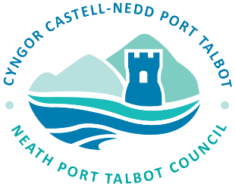
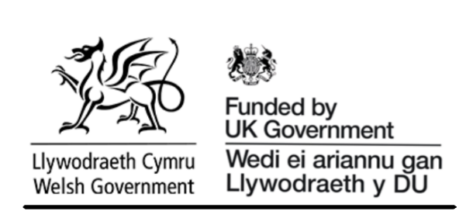

Neath Port Talbot County Borough Council
Workways NPT Local Growth Fund (LGF)
Privacy Notice

Please read the following statement.
Workways NPT is an employability support programme funded by UK Government under The Local Growth Fund (LGF) Wales. Neath Port Talbot County Borough Council (NPTCBC) delivers the services of the Workways NPT programme and is the Data Controller for the personal information you provide as part of your enrolment and participation in the programme.
We process your personal information in pursuance of our public task and the official authority vested in us to provide employability support services and contribute to improving employment, skills, training, and economic outcomes for individuals across Neath Port Talbot. Without this information, your enrolment and participation in the programme may not be possible.

Data Controller and Lawful Basis for Processing
In providing us with your personal information, you hereby acknowledge that Neath Port Talbot County Borough Council (NPTCBC) is the Data Controller for all personal information you provide for the purposes of the UK General Data Protection Regulation (UK GDPR) and the Data Protection Act 2018 (DPA 2018).
As a Data Controller, the Council is required under UK GDPR to inform you which of the Article 6 UK GDPR lawful bases it is relying upon to process your personal data.
In respect of the personal information collected and processed as part of the Workways NPT Local Growth Fund Wales programme, Neath Port Talbot County Borough Council relies upon the following lawful basis:
Article 6(1)(e) UK GDPR – "Processing is necessary for the performance of a task carried out in the public interest or in the exercise of official authority vested in the controller."
Your personal information is processed for the purposes of delivering employability support services, assessing eligibility, administering programme participation, monitoring outcomes, fulfilling funding requirements, and supporting the Council's responsibilities in improving employment, skills, and economic wellbeing within Neath Port Talbot

What will your information be used for?
Neath Port Talbot County Borough Council will use your information for:
- Delivering employability support services and managing your participation in the Workways NPT programme.
- Assessing eligibility for support and identifying appropriate interventions.
- Funding, planning, monitoring, reporting, and policy development purposes.
- Recording and monitoring programme outcomes, including progression into employment, education, training, volunteering, or qualifications.
- Administration, verification, quality assurance, compliance, and audit purposes.
- Generating statistical information about the programme. Any statistics published will be anonymised so that individuals cannot be identified.
- Promoting and publicising the positive impact of the programme through case studies and success stories. Unless you provide specific consent, your identity will remain anonymous.

Special Category Data

Under Article 9(2)(a) of the UK General Data Protection Regulation (UK GDPR), Workways NPT, UK Government, Welsh Government, and approved evaluation partners will only process special category personal data where you have provided your explicit consent.

As part of the Local Growth Fund programme, funded by the UK Government, your information may be shared with appointed evaluation organisation’s to assess the effectiveness and impact of the support provided through Workways NPT. Participation in any evaluation activities is entirely voluntary.

The special category data that may be collected and processed includes:
- Long-term physical or mental health conditions or impairments
- Disability status
- Gender
- Ethnicity

This information will only be used for monitoring, reporting, and evaluation purposes to help improve programme delivery, measure outcomes, and ensure services are meeting the needs of participants. All data will be processed securely and in accordance with applicable data protection legislation.

Who may your information be shared with?
We may share your information where necessary and lawful with:
- Funding bodies responsible for supporting or overseeing the Workways NPT programme.
- Organisations contracted to undertake monitoring, evaluation, research, or audit activities on behalf of the Council or funding body.
- Training providers, employers, educational establishments, and support organisations where this is necessary to help deliver services and support your progression, and where appropriate safeguards are in place.
- Regulatory, inspection, audit, or law enforcement bodies where we are required to do so by law.
Any organisation receiving your information will only use it for agreed purposes and in accordance with data protection legislation.

How will we keep your information safe?
The information collected about you will be stored securely within Neath Port Talbot County Borough Council's systems and databases. Access to personal information is restricted to authorised staff who require it to carry out their duties.
Where personal information is shared with third parties, appropriate Data Sharing Agreements or Data Processing Agreements will be in place to ensure your information remains secure and is processed lawfully.

What are my rights and choices?
Under the UK General Data Protection Regulation (UK GDPR) and the Data Protection Act 2018, you have the right to:
- Access the personal data held about you.
- Request correction of inaccurate or incomplete information.
- Request restriction of processing in certain circumstances.
- Object to processing where applicable.
- Request erasure of your data in certain circumstances.
- Request data portability where applicable.
- Lodge a complaint with the Information Commissioner's Office (ICO).

How long will we keep your information?
Your information will be retained only for as long as necessary to fulfil the purposes for which it was collected, including funding, audit, monitoring, and legal requirements.
Unless a longer retention period is required by law, contract, or the programme funding conditions, participant records will normally be retained for up to 10 years following the end of your participation in the programme, after which they will be securely destroyed.

Contacts
For further information about how Neath Port Talbot County Borough Council uses your personal information, or to exercise your data protection rights, please contact:
Data Protection Officer
Neath Port Talbot County Borough Council
Civic Centre
Port Talbot
SA13 1PJ
Email: data.protection@npt.gov.uk

Information Commissioner’s Office
If you are unhappy with how your information has been handled, you have the right to complain to the Information Commissioner's Office:
Information Commissioner's Office
Wycliffe House
Water Lane
Wilmslow
Cheshire
SK9 5AF
Telephone: 0303 123 1113
Website: https://ico.org.uk

