Cimla Byelaw Consultation Responses

Introduction
Transport for Wales (TfW) and Neath Port Talbot County Borough Council (NPTCBC) are working together to make it easier, safer and more convenient for people to walk and cycle from Neath to Cimla and vice versa and are committed to investing in the development of an enhanced network for active travel.
As part of the active travel enhancements the existing 1975 byelaw has to be amended to cycling through a section of the Gnoll grounds to provide a continuous route with no diversions or interruptions.
This report summarises the feedback received from the public during the consultation to amend the byelaw and explains how the comments will be considered moving forward.

Background
In 1975 a byelaw was implemented by the former Neath Borough Council setting out the rules of use of many of the pleasure grounds and public open spaces in the former Neath Borough including both the Gnoll Estate and The War Memorial Gardens. Section 7ii of the byelaw states “a person shall not except in the exercise of any lawful right or privilege ride any bicycle, tricycle or other similar machine in any part of the pleasure ground”.
In line with the Welsh Governments transport strategy, Llwybr Newydd, and the Active Travel (Wales) Act to create and encourage more sustainable modes of transport; a proposal is being considered to create a new active travel route between Neath and Cimla. The route will allow the residents of Cimla to access Neath town centre on foot or by bicycle. Improving access for all while encouraging a modal shift to help reduce carbon production.
The main transport route between Neath and Cimla is along the B4287 Cimla road & Afan Valley road. The existing active travel provision along this road is poor especially for cyclists, with cyclists having little alternative but to cycle on road with the traffic. Given the speeds and volume of traffic and the gradient of the road, walking and cycling this route is unsuitable and unsafe for many people wanting to walk and cycle between Neath and Cimla. Cimla road is often congested at the junction of Cimla road and Eastland road, and is an area being monitored for poor air quality. Encouraging a modal shift to active travel modes rather than private car could help alleviate some of the congestion in the area. In order to allow cycling on the proposed route above it will be necessary to amend the wording in the 1975 byelaw to permit cycling along the path at the War Memorial Gates and between the War Memorial Gates and Cimla Common.
At this time it is proposed that the byelaw remains as written for the remaining areas within the Gnoll Estate and for the other pleasure grounds and public open spaces listed in schedules 1 and 2 of the Byelaw.

Consultation
The Authority has formally advertised the amendment to the 1975 byelaw made under section 164 of the Public Health Act, 1875, with respect to the Pleasure Grounds in the Borough of Neath. The amendment will permit cycling on the path through the war memorial gardens, Neath and in the area of the Gnoll estate between the war memorial gates and Cimla common as shown on the below plans:
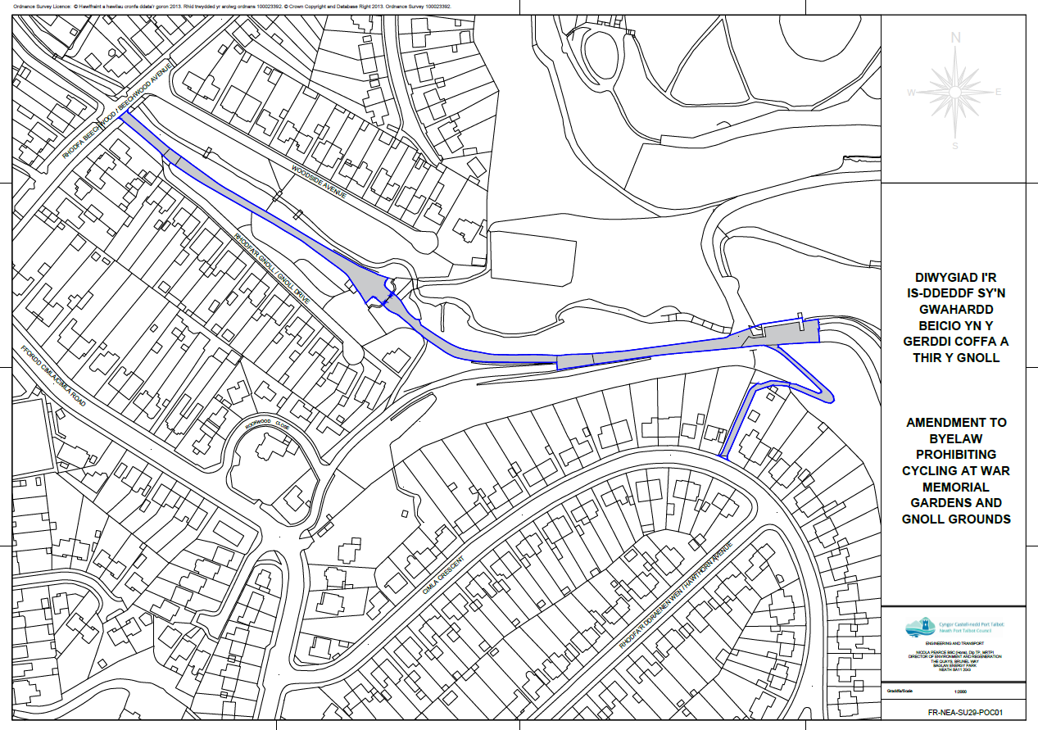

As part of amending the 1975 byelaw, the Authority undertook a public and stakeholder consultation for a period of 12 weeks from 2nd April 2024 to 25th June 2024. The consultation included stakeholder emails, social media post, letter drops, a webpage post and site notices which were done on 2nd April 2024. Examples of the consultation adverts are shown below:
Figure 1: Poster
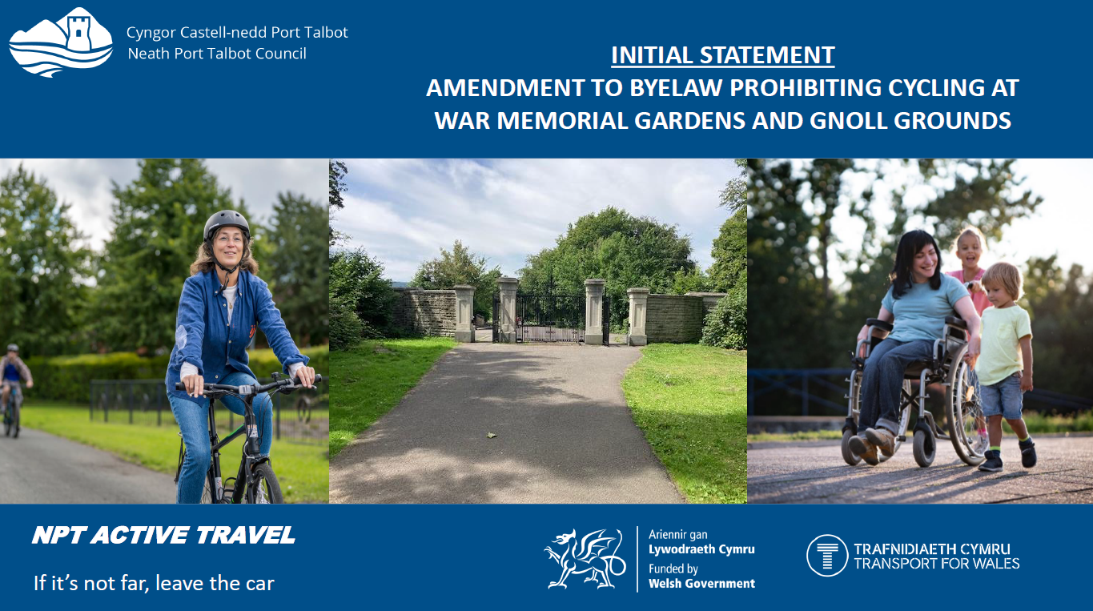

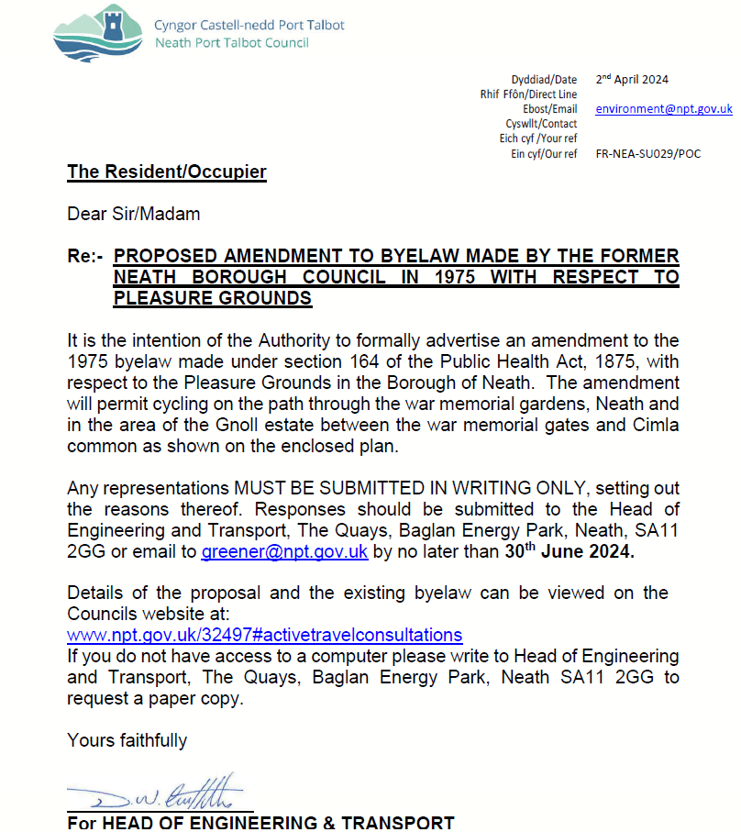
Figure 2: Letter to residents

Figure 3: Social media post

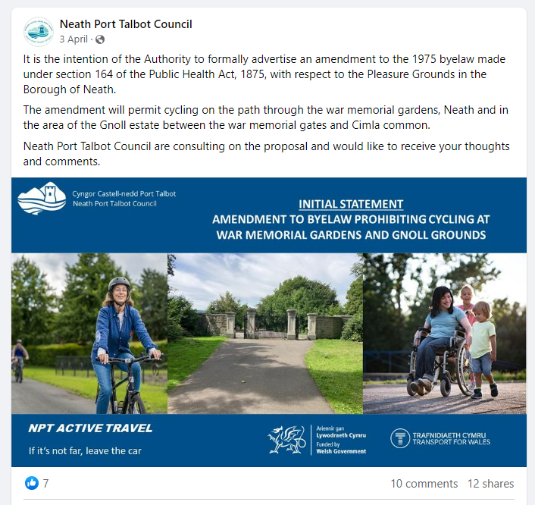

All information provided was bilingual and made fully accessible to assist blind and partially sighted people to engage with the process.

Responses
The Authority received a total of 14 responses to the consultation. Please see the below consultation responses and the council officer’s comments:
 | Comment | Council Officer Response
1 | I have no objection to the Byelaw regarding cycling through the War Memorial Gardens being amended as countless cyclists use this route each day anyway.  It is adjacent to my garden wall so I can definitely state that this Byelaw has not been enforced for many years.  However, if this amendment is a precursor to your previous plan to create and tarmac an additional cycle path around the Memorial Gates which would encroach on the actual War Memorial Garden, then I would most certainly object.  Both side gates of the Memorial Gates are used by cyclists, mobility scooters, wheelchairs, prams and buggies with no impediments whatsoever. Cyclists do not have to dismount or even reduce their speed.  The width of access through the side gates is currently 1.45 metres and your proposed plan required 1.5 metres. I hope that you will not even consider felling trees and digging up a section of the War Memorial Gardens in order to build a cycle track which is only 5 cm wider than the current access; which is obviously not needed and which would remove a section of The Memorial Gardens planted with trees and bulbs by volunteers such as myself who respect our War dead.  I look forward to hearing that no additional cycle route is still planned for the area around The Memorial Gates. | Thank you for confirming that you have no objection to the proposed amendment to the Byelaw to permit cycling through the War memorial gardens. I can confirm that the proposal to construct an additional cycle path around the memorial gates is no longer being considered.
2 | Regarding the proposal to allow cyclists access what safeguards are in place for pedestrians? In my experience cyclists and pedestrians (especially with dogs and young children) don't mix very well. | The proposal to create a shared use path would be in accordance with the Welsh Governments Active Travel Act guidance. Users of the path whether on foot or bike would need to use it with consideration of other users.
3 | I have resided in Gnoll Drive for some twenty five years and to my knowledge there has never been an enforcement of cycling restrictions on this path.  This path to the Memorial Gates is predominantly used by elderly Neath residents, parents with young children, and dog walkers. As of present this is a relatively safe thoroughfare for both the elderly and parents with children who are free to walk under their supervision. However there has been an increase in MOTORCYCLE and ELECTRIC SCOOTER TRAFFIC over the past twelve months. Motor cycles are prohibited on this path, electric scooters are illegal unless licensed and insured. What about electric bikes? I am given to understand that they are restricted to 15.5mph. This now poses the question "Who will police this pathway to ensure public safety"  Gnoll Drive has been designated an access only street by NPTC. However motorists park here to access their workplace on foot rather than take advantage of the multi storey car park in the town centre, likewise some dog walkers avoid the parking fee at the Gnoll Car park by parking here. Nobody seems to care!!  As a consequence, I have considerable reservations as to whether NPTC has the will to police this proposed amendment.  May i suggest a remote CCTV camera could "kill two birds with one stone"  Trust that due consideration will be given to pedestrians, family groups with young children, and dog walkers. | People should use all footways with consideration of other users.  Your concerns relating to parking on Gnoll Drive have been passed on to parking enforcement. Your suggestions of a remote CCTV camera have also been noted and will be passed on to the relevant department.
4 | I understand there is an intention to amend the said byelaw. Also considering the project that this amendment is related to, I must raise concern. Firstly before there is any amendment should there not be discussion about the original decisions to restrict cycles in this area. Then have consultation around the wider proposals of the related project. A more informed consideration around alternative routes from Cimla to Neath should be made available. Until more information is available I must object to any changes to the park byelaws | The byelaw was originally written in 1975 and doesn’t just cover the Gnoll but also the Neath town centre as well as other areas in the county.  Before discussing the wider scheme, NPT needs to have a consultation specifically about the byelaw, as it could affect the design and construction of the wider scheme.  Details about the full Neath to Cimla active travel route will be shared at a later time.
5 | I live in Cimla Crescent in Neath, close to where the proposed exit of the cycle route from the Gnoll Country Park meets Cimla Crescent. I have no dispute that providing cycle routes can encourage people of all ages to get outdoors and provide opportunities for improving health and reducing carbon emissions. However, formalising the proposed route from Neath to Cimla Common as a designated pedestrian/cycle path also provides danger. Combining pedestrians, cycles and cars is, in my opinion, a recipe for disaster.  The exit from the Gnoll Country Park onto Cimla Crescent sees a juxtaposition of vehicles required to travel at 20 miles per hour, pedestrians on foot, very often with dogs, parents, buggies and toddlers; and cyclists, some on very fast electric cycles and on occasion, motorcycles. All negotiating a difficult 90 degree turn left or right at the exit and entrance onto Cimla Crescent, made more difficult, especially in winter months when it gets dark earlier.  If traffic calming measurements such as speed bumps and parking bays were installed on Cimla Crescent these would exacerbate the problem, as well as being a source of damage to vehicles, in terms of suspension and tyres. Public service vehicles such as buses and refuse lorries would be susceptible as well. There would be unacceptable associated noise, and most importantly poorer air quality produced, instead of less.  From the side road (Cimla Road) entrance onto the main footpath/road through the park, leading to the hill climbing up to Cimla Crescent, there is a dangerous drainage gully/channel. This is a constant source of difficulty for cars passing one another. There is little space for this to happen anyway, without the added danger of larger numbers of cyclists competing with adults, toddlers, young children, buggies and dogs. This is again exacerbated by existing traffic calming measures which vehicles and cyclists strive to avoid. Again, once more, adding to poorer air quality for not only pedestrians and children, but also the cyclists themselves.  A previous Council plan to fill in the First Pond, foundered because the road from the Cimla Road entrance to dwellings in the Park had to remain open at all times for Council vehicles, farm machinery and emergency vehicles to use it; again a danger when all in the same vicinity.  I very much hope you will consider seriously, my response to the proposed change of use to the Gnoll Country Park footpath and associated problems and dangers. As a resident of Neath Port Talbot County Borough Council I request an opportunity to assess the Active Travel plan in detail and discuss this matter in a public forum before any decisions are made which could affect mine and my family's safety, together with our health. | Thank you for your comments on the wider Active Travel Scheme.  The proposal to create a shared use path will be in accordance with the Welsh Governments Active Travel Act Guidance. Users of the path whether on foot or bike would need to use it with consideration of other users.  Two options will be provided for Cimla Crescent as part of the wider scheme However this is outside of the area affected by the byelaw.  Alterations to the bottom entrance of the Gnoll are being considered to make this section safer and clearer for users.
6 | I am a resident of Cimla Crescent in Neath, close to where the proposed exit of the cycle route from the Gnoll Country Park meets Cimla Crescent. I write on behalf of a number of parents/grandparents that I have spoken to over recent weeks who share my concerns.  I am in favour of any plans that encourage people to remain fit and healthy and use the outdoors in our local area. However, as a mum of two small children I believe that this proposal may jeopardise the safety of them and many other children and carers who use this route regularly to walk safely to and from school. During these times (and throughout the day especially during fine weather) the lane is often a busy route for pedestrians many of which often have prams or dogs on leads which can already make the area quite congested so adding a cycling lane/area does not seem feasible given the small restrictions and the narrow hairpin bend. I would be concerned that this would compromise the safety of pedestrians.  Also, at the bottom of the footpath at the First Pond, there is already an area which causes vehicles, entering or leaving the small car park to have to dangerously navigate around inconsiderately parked vehicles on the opposite side. Adding cyclists to this area would be more ‘traffic’ for children to navigate. Whilst I appreciate that you propose that cyclists would be considerate to pedestrians, this isn’t always the case in other areas where cycling is permitted (Aberavon/Mumbles) as often young children are forced to ‘keep away’ from the cycle track due to the speed of some of the bikes despite the volume of people present. Also, whilst I have always taken safety measures when walking to school with my children, having the safe space away from the busy roads allows them the freedom to develop confidence and independence whilst walking through the Gnoll to school, I feel that should this become a cycle area they would feel vulnerable and less confident on their route to school.  I have read the plans and I try to remain informed about what further developments may be proposed for Cimla Crescent regarding options to widen the pavements and/or speed bumps and parking restrictions. I have been told that any changes would be discussed with residents in July and I would be grateful for any information regarding this. I am sure local residents would welcome the opportunity to express our concerns whilst listening to the proposals constructively rather than through social media channels that can often mislead and cause unnecessary anxiety.  Please let me know when the meeting date is confirmed. | The proposal to create a shared use path would be in accordance with the Welsh Governments Active Travel Act design guidance. Users of the path whether on foot or bike would need to use it with consideration of other users. We have other shared use paths in the County (Neath Canal towpath for example) that are used without conflict of users.  The path from Cimla Cresent to Gnoll Park is to be widened to 3m and all “pinch points” to be removed, which would create enough space for all users to pass each other comfortably. It must also be noted that no cars should currently be parking at the bottom pond of the Gnoll, the only vehicular access should be for the house and council vehicles. This parking issue will be passed on to parking enforcement.  The goal for the wider scheme is to provide more footway throughout to provide a more comfortable user experience when walking or cycling.  There will be a public consultation event in the Autumn to answer any questions and further explain the wider scheme. If you would like to be added to the consultation list please email greener@npt.gov.uk so you will be informed when the survey goes live.
7 | I refer to the above and proposals to amend the 1975 byelaw made under section 164 of the Public Health Act 1875 with respect to the Gnoll Country Park.  As a former journalist and advocate of sustainable safe routes and activity to improve health and well-being, I am a little alarmed at the proposals regarding the above, I only found out about the scale of the authority’s plans by accident, and I am sure you will be thorough in carrying out a full consultation exercise as many of the residents living along the main route (Cimla Crescent) were also not aware.  I am not aware of what evidence there is to support the proposals as the route including Cimla Crescent is a busy thorough fare with buses and lorries, delivery vans and many vehicles using the road every day. The driveways are directly on the road, some on a slope with blind spots so this would be of grave concern. There are cars parked on either side of the road with drivers having to stop to give way, and larger vehicles finding difficulty in getting through. The situation is not helped as visitors to the Gnoll Grounds also use the road to park to avoid paying the parking costs. Where are people supposed to park if these proposals go ahead? Added to this there are scores of people who use the route to exercise, walk and cycle, many of whom are children who use the footpath and pathway to and from the Gnoll Grounds to get to and from school. There are many pensioners, some on mobility scooter who also use the route. There are many children who also live on the Crescent.  I cannot see how the path would allow the safe passage of all if it was to be opened as a cycle way. There have already been several near misses as it is a blind spot on the approach from Cimla Crescent onto the path. Not only that, but motor cyclists also race down the path and use the walkway as a speeding run.  I also refer to the proposals to install speed bumps – research shows that this increases pollution and emissions from vehicles who brake and then accelerate to go over the bumps, which does not help the plight of the cyclists or residents.  The other concern is the opening up of the Memorial Gates to allow cyclists through. This area is used for quiet contemplation and not very respectful to those who regularly visit the memorial. Not only would that it allow the passage of even more motorcyclists to use the area as a race track.  I urge you to reconsider the plans. The route doesn’t need to be a designated active travel route as it’s already used in this way without the added safety risks that the proposals would bring. | There will be a full consultation for the wider scheme in due course.  The concerns regarding Cimla Crescent have been noted, however, the byelaw does not include Cimla Crescent.  Thank you for your response regarding the Memorial Gates. People should use all footways with consideration of other users.
8 | In regards to the proposal to amend the wording in the 1975 byelaw. Our understanding is that the following wording would be removed from the byelaws.  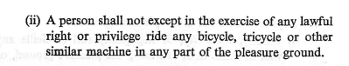  We also note that there is additional wording that governs the conduct of the behaviour of users of vehicles and bicycles and it appears that this should remain to ensure that an onus continues on anyone who does cycle within the premises to behave in a safe and considerate manner.  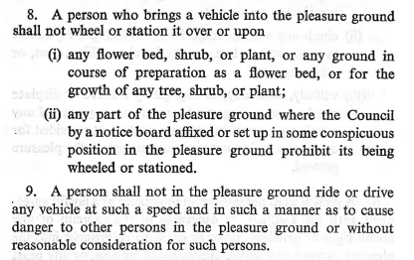  NPT links supports this proposal | Thank you for your support.
9 | I am pleased to see the proposal to allow cycling in the Gnoll park however I do have some concerns.  I am a supporter of cycling and most low powered transport. Will there be concessions for electric bikes, scooters, mobility scooters etc., and will there be conditions to regulate behaviour, e.g., speed which could affect walkers, dog walkers etc. | There will be no concession, users will be expected to use the route with consideration for other users.
10 | I must emphasise that my concerns do not relate to cyclists in general and specifically refer to the War Memorial Gardens. This particular area is part of NPTCBC’s proposal. Cyclists wishing to use the pleasure grounds of the Gnoll already have a number of other accesses which are well used by them e.g. from the Cimla Hill (the old main entrance to the Gnoll), Cimla Crescent, the top of the Glannant estate and from Fairyland (the main entrance) and the Llantwit side where a number of entry points exist and are well used.  The particular area of the War Memorial Gardens is part of NPTCBC’s proposal. We have in our town a magnificent memorial to the world wars of 1914-18 and 1939-45 with the names of those of Neath who fell in these wars listed, and more recent substantial memorials to those of Neath who fell in Burma and in post 1945 conflicts around the world. The pathway leading up to it makes up the War Memorial Gardens to which your letter and the proposed byelaw amendment refers. Signage has existed for years in this area indicating No ball games, which further enhances the solemnity and peace of this particular area which means so much to so many people. This particular area is the focus of Neath’s memorials to those who made the ultimate sacrifice at key dates and times through year, which are always well attended, to underline the, solemnity, importance and significance of the sanctity of the War Memorial Gardens. This is my concern and objection, which has motivated me to write to you.  It is unfortunate that in recent times, e- bicycles, e-scooters and motorbikes have started to use this place. Its purpose is to remember the sacrifices. Legitimising bicycles will send a message to the range of users of other transports that it is OK to do so. | Thank you for your response regarding the Memorial Gardens.  The purpose of opening the gates is to allow not only cyclists but also disabled people using adapted bikes, mobility scooters, or wheelchairs to access the area. The intention would be in no way to disturb the area.
11 | Firstly, is there a specific reason as to why the byelaw is only being lifted for this section as opposed to the park in its entirety?  Secondly, as a park we have a slight concern on the location. I worry about how the cycleway meets one of the main driveways into the Gnoll. I can see this becoming a health & safety risk, and quite a hazardous area due to the line of site etc. | The proposal is to amend the byelaw over this section only as the other paths throughout the Gnoll do not comply with the standards set out in the Active Travel Act Guidance.  This area will be designed to the Active Travel Act Guidance. All safety concerns such as widths, volume of traffic and line of sight will be looked at.  It is proposed that road markings are installed at the junction to advise motorists to give way to oncoming road users.
12 | Although we have no objection in principle to the proposed byelaw amendment, there is currently insufficient information to understand how the amendment will impact the historic park and garden. Alterations to the current footpath, including surfacing, lighting, signage, road markings and alterations to the war memorial gates will have an impact together with how the park is experienced by park users. Therefore, further information is required on these aspects before we can comment fully. We advise that a Heritage Impact Assessment is produced by a qualified heritage consultant with experience of working in historic parks, gardens and designed landscapes.  Finally, there may also be undesignated historic assets that could be affected by the proposed development and, if you have not already done so, we would advise that you consult the Historic Environment Record held by the Glamorgan-Gwent Archaeological Trust www.ggat.org.uk | A listed building consent application will be provided to yourselves. As well as any supporting documents, including a Heritage Impact Assessment.
13 | I wish to object most strongly to the proposal to change the current bylaws to allow cycle access through the Gnoll Memorial Gardens. Proposed access will destroy the peace and tranquillity of these gardens and inevitably invite greater use of other forms of transport, including the use of e-bikes, e-scooters and motor bikes, all of which have already and illegally accessed the Memorial Gardens on many occasions. The dangers to pedestrians, dog walkers and young families are, I believe, obvious.  Access for bicycles and their passengers already exists through a variety of other access points to the wider Gnoll Park and I feel the proposed amendment to include the Gnoll War Memorial Gardens is superfluous, potentially dangerous and wrong.  The ill-advised nature of this proposal also fundamentally overturns the original purpose of the Memorial Gardens, namely to ‘remember’ and to remember the sacrifices of hundreds of members of our wider community of Neath in both the wars of 1914-18 and 1939-45 and the post 1945 conflicts around the world. The overwhelming argument against the proposed amendment is surely a moral one. Remembering the ultimate sacrifice made by the hundreds of people of Neath in quiet, reflective memory in what is after all our town’s own collective ‘cemetery of the fallen’ must surely come before consideration of bicycle access.  I urge the council to abandon this proposal and instead continue to focus its efforts on the maintenance of this very precious space in its existing form. | The purpose of opening the gates would be to enable all users’ not just cyclists but mobility scooters, wheelchairs, etc. as well to pass through the access. The intention would be in no way to disturb the area. People should use all footways with consideration of other users.  The reason for this access is that it would provide a continuous, safe and undisturbed link for users from Neath to the Cefn Saeson at the top of Cimla. Allowing safe access for all users, of all capabilities.
14 | Before I list my objections I would like to note 2 things:  First of all I would like it to be noted that it does not only affect the Pleasure grounds at the Gnoll but has a huge impact on the War Memorial Gardens which is where we remember our fallen heroes of the 1st, 2nd World Wars and also other wars. Cycling through this area shows a total lack of disrespect.  Secondly changing this Byelaw has massive implications on the Health, Safety and wellbeing of the General Public and could even lead to loss of life if there was an accident.  Below are my objections in detail and the reasons why:  1. The volume of footfall where the proposed cycle path will go is already substantial including pushchairs, prams, toddlers walking with parents/grandparents, the elderly and dog walkers with their dogs. Pedestrians will therefore be put at greater risk especially in the area of the War Memorial Gardens due to the layout.  2. The proposed cycle path is at the entrance of both the War Memorial Gardens and Gnoll Drive. This entrance is already narrow and is often congested with vehicles leaving and entering Gnoll Drive all the time. There is not enough space as it is now without adding a large volume of cyclists as well, this will increase the risk of accidents.  3. A War Memorial Garden is surely a place where there should be peace and tranquillity to remember the fallen. A place where cycling is prohibited. The sensitivity of the War Memorial gardens appears to have been totally ignored. The historic nature of the byelaw is to preserve the sensitivity of this site. If the local council is unable to do this, how do expect the younger generations to do the same. How does the council plan to manage Remembrance Sunday, D Day celebrations which we have just had and other War Memorial Days. In all my travels in this country and Europe I have never seen a War Memorial area with a cycle track directly through the middle of it. If the Cycle Path was to go ahead the land at the War Memorial Gardens will be interfered with stopping the enjoyment and use of this land as it is now.  4. There is a steep slope to the rear of the War Memorial Gates/Gardens. There is a major Health & Safety Risk that Cyclists will approach the rear of the gates at high speed putting the general public at risk. The gates that the cyclists will have to go through are very narrow, if someone is already entering this area there is a major risk of an accident.  5. A cycling club like Port Talbot Wheelers can have up to 40 cyclists out at any one time, surely this amount of traffic seems excessive for a War Memorial and Residential Area with limited space. Even more concerning would be Cycling races for example the Dragon Ride which was actually this weekend. Hundreds and Hundreds of cyclists took part. Also what if there was a cycling race planned the same day as a memorial service, how would that work?  6. There is also a potential of an increase in anti-social behaviour at the War Memorial Gates. This is reported regularly and is already a serious problem for residents.  7. Teachers with their pupils from local Primary Schools are often seen walking through the War Memorial Gardens for educational visits at the Gnoll. Schools that will be affected are Alderman Davies Church Of Wales, Gnoll Primary and Castell Nedd Schools.  8. The War Memorial Gardens is also used as a through road to access the above said schools by young children and their parents and is very busy during school times.  9. Whilst the intention is to provide a cycle path there is clear anecdotal evidence that electric scooters and E Bikes will also use the path again posing a danger to pedestrians.  Finally the consultation does not set out whether alternative routes were considered for a comparison of the benefits and drawbacks of these alternative routes. Also the consultation does not state what Health & Safety risk assessments have been carried out in the area if any.  I would like it put on record that if the cycle path goes ahead that it is put on record of the high risk of potential accidents and if there is a fatality that Neath Port Talbot Council will take full responsibility as these risks have been identified to you before the change in the Byelaw. | The proposal to create a shared use path would be designed in accordance with the Welsh Governments Active Travel Act design guidance. Users of the path whether on foot or bike would need to use it with consideration of other users.  Provisions are to be designed to improve the surrounding footways as part of the wider scheme to allow a more comfortable experience for everyone not only cyclists but also disabled people using adapted bikes, mobility scooters, or wheelchairs to access the area.  The plans propose staggered bollards are to be provided to prevent users passing through the area at speed.  The path would be used as a public link from Neath to Cimla, there are currently no intentions for the proposed route to be used for sporting events.  The purpose of opening the gates would be to enable all users’ not just cyclists but mobility scooters, wheelchairs, etc. as well to pass through the access. The intention would be in no way to disturb the area. People should use all footways with consideration of other users.  One of the key reasons for improving active travel facilities is to promote walking, cycling, or wheeling, especially for families and young children traveling to and from school.  The intention is to provide a shared use path for all users of all capabilities, not just a cycle path.

Summary
The feedback received from the public will be used to help the Council in assessing the suitability of progressing the process of the 1975 byelaw amendment and detailed design drawings for the wider scheme of Neath to Cimla active travel.
The results of the engagement exercise will be considered alongside and balanced against wider considerations around deliverability, engineering feasibility and delivery timescales.
It is anticipated that further public engagement will be undertaken on the wider scheme of Neath to Cimla in due course so comments regarding that will be considered then.

