Neath Port Talbot Additional Learning Needs ‘Principles’ Document
January 2022

This document will be used to inform Local Authority and School’s decision making processes as set out within the Additional Learning Needs Code for Wales 2021

1.0 Introduction
This document has been produced to help with the decision making processes for schools and the Local Authority (LA) in relation to children and young people with Additional Learning Needs (ALN) under the new Statutory Framework for Wales (The Additional Learning Needs Code for Wales 2021).

The Additional Learning Needs and Education Tribunal Wales (ALNET) 2018 Act provides new legislation for supporting children and young people with ALN, and is accompanied by a mandatory Code. The aim of the new approach, as stated in the Code is as follows:

‘To support the creation of a fully inclusive education system where all children and young people are given the opportunity to succeed and have access to an education that meets their needs and enables them to participate in, benefit from, and enjoy learning.’

The new statutory framework is underpinned by the following key principles and aims:
A rights-based approach where the views, wishes and feelings of the child, young person and their parents / carers are central to the planning and provision of support; and the child, young person and their parents / carers are enabled to participate as fully as possible in the decision-making processes. This can be achieved through the implementation of Person-Centred Practice (PCP).

Early identification, intervention and effective transition planning where needs are identified and provision put in place at the earliest opportunity.

Collaboration where services work together to ensure ALN are identified early, and appropriate co-ordinated support is put in place to enable children and young people to achieve positive expectations, experiences and outcomes.
Inclusive education which supports full participation in mainstream education, wherever feasible, and a whole setting approach to meeting the needs of children and young people with ALN.

A bilingual system where all reasonable steps are taken to deliver Additional Learning Provision (ALP) in Welsh.

The starting point of the decision-making processes in Neath Port Talbot, in respect of Additional Learning Needs and Additional Learning Provision will be the aims and principles described above.

The ALN system is supported by a person-centred process of collaboration and co-production, which facilitates discussion about needs, outcomes and provision, with disputes and disagreements avoided, or resolved at an early stage.

Consequently, the decision-making process in respect of ALN in Neath Port Talbot will be determined by the extent to which schools have made sufficient efforts to apply these principles and Person Centred Practices.

2.0 Definition of ALN
For the purposes of the Act, the use of the term ALN relates to individual children and young persons who have “Additional Learning Needs” i.e. they have a learning difficulty or disability (whether the learning difficulty or disability arises from a medical condition or otherwise) which calls for Additional Learning Provision.

Many children and young people are likely at some point to experience short term issues with their learning, for example because of a period of absence from an education setting caused by a temporary illness, or because they have suffered a bereavement or some other trauma. In these circumstances, schools may need to take action to help the child or young person catch up and / or to prevent the issue from escalating. These situations would not ordinarily amount to ALN on their own; but it is possible that in some cases, this could result in a difficulty in learning which calls for ALP.

For those children and young people who do not have an identified disability, in the first instance, observing and assessing their progress will provide information about areas where they are not progressing satisfactorily (ALN Code 20.4).

On the basis of this evidence, including the data collected, it should be possible to identify learners making less than expected progress. This can be characterised as progress which:
• is significantly slower than that of their peers starting from the same baseline;
• fails to match or better the child’s or young person’s previous rate of progress; or
• fails to close, or widens, the attainment gap between the child or young person and their peers, despite the provision of support aimed at closing that gap (such as differentiated teaching) (ALN Code 20.8).

2.1 Definition of ALN – a 2 step approach
To establish whether a child of compulsory school age or young person has ALN, the following tests must be applied.

Test 1 - Does the child or young person have a learning difficulty or disability?
A child or young person of compulsory school age or above has a learning difficulty or disability if he or she—
(a) has a significantly greater difficulty in learning than the majority of others of the same age,
or
(b) has a disability for the purposes of the Equality Act 2010 which prevents or hinders him or her from making use of facilities for education or training of a kind generally provided for others of the same age in mainstream maintained schools or mainstream institutions in the further education sector.

If the answer to either (or both) question is ‘yes’, it is necessary to proceed to apply the second test. If the answer is ‘no’ to both questions, the child or young person does not have ALN.

Test 2 - Does the learning difficulty or disability call for ALP?
The second test is whether the child or young person’s learning difficulty or disability calls for ALP. ALP can take many forms; it might include any support that takes place inside or outside the mainstream classroom, where it is additional to, or different from, that made generally for others of the same age. ALP might also be delivered in settings outside of the school or in some circumstances and/or by external professionals.

“Additional Learning Provision” for a person aged three or over means educational or training provision that is additional to, or different from, that made generally for others of the same age in:
(a) mainstream maintained schools in Wales;
(b) mainstream institutions in the further education sector in Wales; or
(c) places in Wales at which nursery education is provided.

If the child or young person has a learning difficulty or disability which calls for ALP, the child or young person has ALN for the purposes of the Act. Where it has been agreed that a child or young person has ALN and ALP is to be secured, an Individual Development Plan (IDP) will be drafted and maintained.

In order to help with the decision making process in relation to whether a child or young person has ALN, Neath Port Talbot LA, in collaboration with the South West Region, have developed the following staged process which is based upon Person Centred Practices:

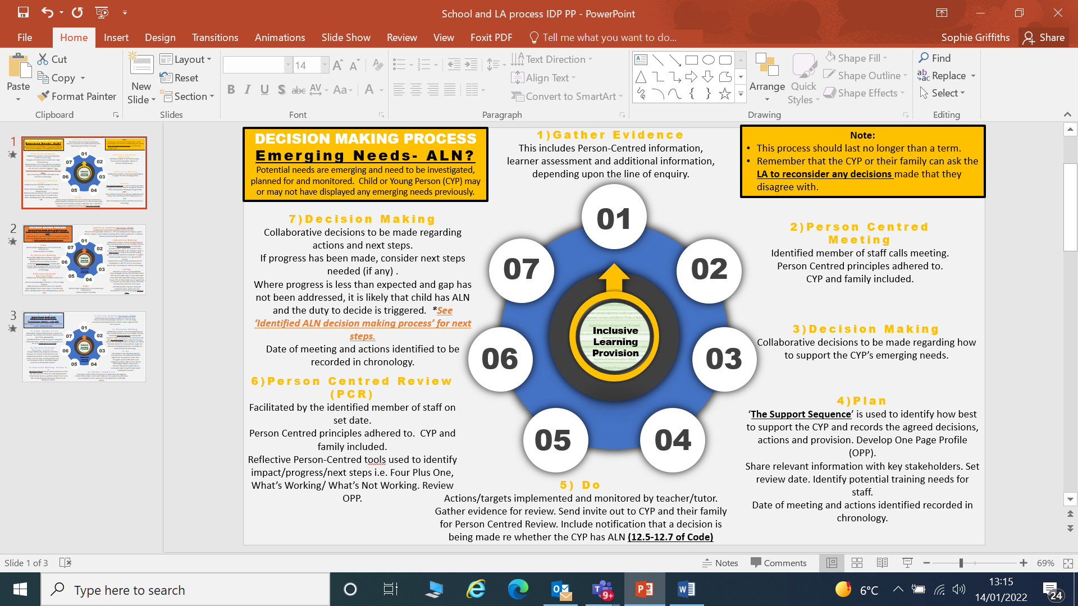
Figure 1 A diagram

3.0 Additional Learning Provision – LA or School Maintained IDP?

Section 12.44 of the Code states that:
Local Authorities should, in consultation with schools they maintain, and any other persons they consider appropriate, establish and publish a set of principles they will apply when determining whether it is reasonable for a school to secure the Additional Learning Provision (ALP) required by a pupil or whether the authority ought to do so. Principles should relate to:
- The extent and duration of advice from external specialists that is likely to be unreasonable for a school to secure;
- The equipment that it is likely to be unreasonable for a school to provide;
- The intensity and duration of support and scale of internal engagement of staff (including the ALNCo) at the school that it is likely to be unreasonable for a school to provide.

School Maintained IDP
If a decision has been made that a child or young person has ALN, then an Individual Development Plan (IDP) needs to be prepared. In most cases, the decision whether a pupil has ALN and for preparing and maintaining an IDP, is made by the maintained school through the delegated budget. Schools will also therefore be responsible for securing the Additional Learning Provision needed for the majority of learners with ALN. Any decision regarding whether a maintained school can be reasonably expected to secure the ALP will be based upon the principles outlined below.

In its decision making around whether a school or the LA should develop and maintain the IDP, the LA will be mindful of circumstances outlined in section 12.43 of the ALN Code, where it may be unreasonable for the school to secure ALP.

These include instances where the learner:
- Has a low incidence condition / rare condition which requires specialism that the school cannot provide (for example profound and multiple learning difficulties);
- Requires regular advice and support from external agencies which is over and above that which can be reasonably arranged and accessed by the school (for example weekly specialist input from a Braillist or Qualified Teacher of the Deaf);
- Requires equipment that can only be used by one pupil or cannot be re-used or is beyond the reasonable resources of the school; or
- Requires very intensive daily support which cannot be reasonably funded or secured by the school’s budget (25 hours TA support or above).

In order to help with the decision making in relation to whether a child or young person requires a School Maintained IDP, the LA has developed the following staged process.

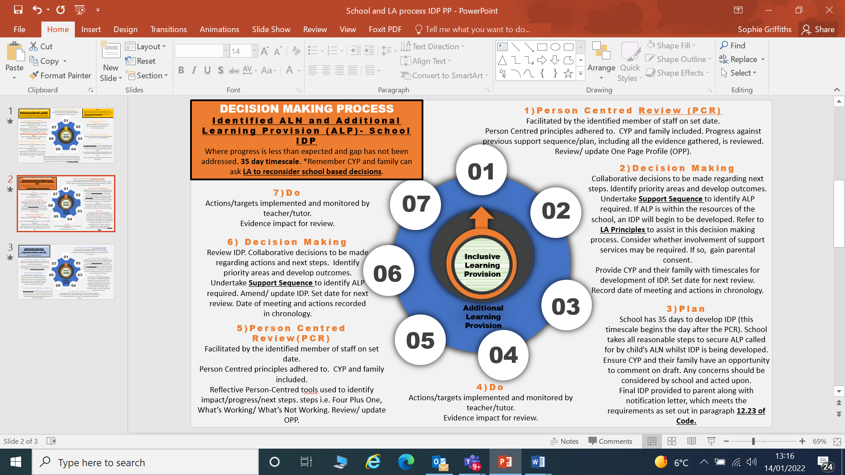
Figure 2 A diagram

Local Authority Maintained IDP
In some cases the decision whether a pupil has ALN and for preparing and maintaining an IDP is either referred and /or completed by the Local Authority. There are two instances in which a maintained school is required to refer a child’s case to a local authority rather than decide for itself whether the child has ALN:
- Where the pupil is dually registered (paragraph 12.37 of the ALN Code)
- If the child is looked after (chapter 14 of the ALN Code)

In these cases, Neath Port Talbot LA will have the duty to decide and develop the IDP and will maintain the IDP through the delegated resources to the school.

Chapter 12.39 of the ALN Code also states that a maintained school can choose to refer a child’s case to a local authority but should only do so if it considers that the child has ALN:
a) that may call for ALP it would not be reasonable for the school to secure;
b) the extent or nature of which it cannot adequately determine; or
c) for which it cannot adequately determine ALP.

Neath Port Talbot LA will maintain IDPs for those pupils who require 25 hours or above Teaching Assistant Support to deliver the ALP. The funding for the TA hours will be funded by the School’s Delegated Budget.
Neath Port Talbot LA will also maintain IDPs for those pupils who access a special school or learning support centre (LSC) placement.

The school should act promptly to consider whether to refer the child’s case and consequently make any referral. In most cases, the school ought to be able to make the referral within 20 school days (if not earlier) from the date on which it is brought to its attention, or otherwise appears to it, that the child has ALN which it cannot be reasonably expected to provide for from its own resources. For further information on making a referral to the Local Authority please see Chapter 12 of the ALN Code and the Neath Port Talbot Local Authority Maintained IDPs – Guidance for School Requests (2021) document.
In order to help with the decision making in relation to whether a child or young person meets the principles for a LA maintained IDP in Neath Port Talbot, the following staged process will be applied:

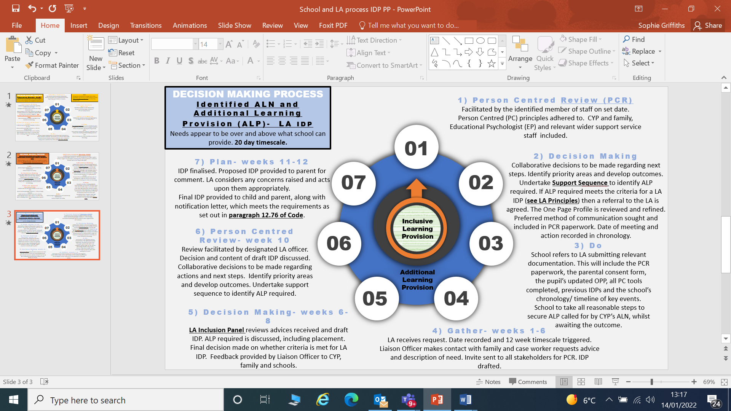
Figure 3 A diagram

4.0 Principles for determining whether a school or LA should secure ALP

The ALN Code recognises that the extent to which a school or other setting meets the needs of all children and young people will have a direct bearing on the nature of the Additional Learning Provision (ALP) likely to be required by learners with ALN, as well as the point when ALP is required.

The ALN Code places a duty upon Neath Port Talbot LA to review its arrangements for children and young people with ALN, as well as those of Governing Bodies (GBs) of maintained schools. This includes having regard to the level of ALP in place. The ALN Code (Chapter 7 para 7.10) requires each LA to gather evidence upon the extent that the following are available in maintained schools:
- high quality, differentiated teaching for individual children and young people;
- targeted intervention and support for children and young people with ALN;
- effective systems for monitoring the progress and achievement of children and young people with ALN and their inclusion in the everyday life of the school;
- arrangements for involving specialists in cases where it is appropriate to do so;
- arrangements for reviewing the effectiveness of interventions used to support children and young people with ALN and the skills and expertise of staff;
- arrangements for involving children, young people and parents at every stage.

Neath Port Talbot Inclusion Service in collaboration with Education Support Officers will work with schools to ensure that they are able to fulfil their statutory obligations in relation to the above expectations. Further information regarding this will be found in the Neath Port Talbot Additional Learning Needs Expectations Document (to be published). The LA will support schools, provide training and help to develop and embed systems and processes to secure the above. Funding mechanisms may need to be reviewed.

Inclusive Learning Provision (ILP)
All education settings are expected to put in place differentiated teaching strategies and /or other targeted interventions designed to address an attainment gap and therefore secure better progress for learners. These strategies and interventions form part of the high-quality teaching and learning provision made generally available to all learners within the setting and are termed ‘Inclusive Learning Provision’. Further information regarding the expectations on schools to provide Inclusive Learning Provision can be found in the Neath Port Talbot Additional Learning Needs Expectations Document.

Additional Learning Provision (ALP)
If a learner does not make appropriate progress in their learning and /or any barriers to learning are not addressed through Inclusive Learning Provision, or they present with significantly greater difficulties in their learning than the majority of others the same age, then an enhanced targeted package of support may be needed so that they can make progress and achieve their potential. This may include intervention and support using school-based expertise or through external agency support.

The process to determine whether a school or the LA should secure ALP, and subsequently will maintain the IDP, will be based upon the following evidence from school:
- evidence that it is not reasonable for ALP to be secured there; or
- that it is unable to determine nature or extent of a pupil’s ALN; or
- that there is an inability to adequately determine the ALP required to meet a learner’s needs.

In the event of receiving a referral from a school, Neath Port Talbot LA must decide whether or not the learner has ALN using the 2 step approach described in section 2.1.

In the event of Neath Port Talbot LA receiving a referral directly from a parent / carer or other professional, the LA will consider whether the school is best placed to decide whether or not the learner has ALN. In cases where this is determined, Neath Port Talbot LA will inform the school and the duty to decide rests with the school.

In addition to assessing evidence in respect of the inclusive learning provision, Neath Port Talbot LA will also take into account its arrangements to support schools, including the extent to which its delegated ALN budget is used for such support. It will also take into consideration the deployment of its own support services and those secured from improvement partners for learners with ALN.

Graduation of need and response
Maintained schools and local authorities should adopt a graduated response in relation to children and young people with ALN, making use of a wide range of strategies. “This means that the ALP made should be at the lowest level necessary to meet the child or young person’s identified needs” (ALN Code 20.23).

In particular, schools should make full use of their available resources before bringing specialist expertise to help support. In many cases the ALP initially made will mean that the child or young person’s needs are fully met or resolved. Only for those children or young people whose progress continues to cause concern, is increased or different ALP likely to be needed. Some children or young people may gradually require less rather than more ALP if the interventions are a success.

External agencies can support the process of deciding whether a person has ALN and determining the ALP required in a number of ways. They can offer advice and support staff with strategies or obtaining more information, undertake assessments and /or observations to provide more information about the child or young person’s needs, and suggest interventions and alternative forms of provision. External agencies might also be the appropriate body to directly provide the ALP required. ALNCos must secure relevant services that will support a pupil’s ALP as required. Some learners with ALN will need the support of external agencies and professionals. It will be the responsibility of the ALNCo to liaise with these specialist services and when there is agreement to provide such services, ensure that these are secured.

5.0 Funding
All Individual Development Plans (IDP’s) will be resourced from schools’ delegated budgets. As is the case currently, the expectation is for schools to meet the Additional Learning Provision (ALP) for all pupils who have an Additional Learning Need (ALN), from within their delegated budget. There is no additional funding for mainstream or special school / LSC pupils with ALN retained by the local authority.

The school’s ALNCO and those responsible for making decisions in relation to ALP, will need to have knowledge of the funding and resources available to them. Pupils with identified ALN will receive appropriate, targeted support at the right time. Schools are encouraged to utilise funding for specific interventions, or indeed longer term support, which will be specified in each pupil’s IDP. The use of teaching assistants may help in supporting pupils, and this may be delivered on a one to one, paired, shared or grouped basis, or a combination of these, dependent upon the ALP specified within the IDP.

6.0 Specialist Equipment
Under the Equality Act 2010, Schools and Local Authorities have a duty to provide reasonable adjustments for learners with disabilities. This duty includes the provision of ‘auxillary aids’, or to put it more simply, a piece of equipment which provides additional support to a learner with a disability. The majority of these aids are inexpensive and will be provided to learners from the school’s resources. For example, coloured overlays, pen grips, sloping desks, adapted key boards and computer software. However, other pieces of equipment may be more specialist and of a significant cost. These pieces of equipment will be bespoke to the individual learner’s needs and will have been identified through specialist assessment by a professional such as an Occupational Therapist, Physiotherapist or Specialist Teacher of the Visually or Hearing Impaired. Such specialist equipment will be the responsibility of the Local Authority to order and fund and will be recorded as part of the learner’s Additional Learning Provision (ALP) on their Individual Development Plan (IDP). (Equality and Human Rights Commission – Reasonable Adjustments for Disabled Pupils).

7.0 Disagreements and Appeals

It is likely that from time to time, there may be disagreements and differences of opinion regarding the requirement for an Individual Development Plan (IDP), or the level of support and provision set out in an IDP.

All educational settings should focus on providing children, young people and their parents an opportunity to raise concerns or questions at every stage of the process. In the majority of cases, early intervention and taking a person-centred approach will avoid disagreements and the potential escalation to a more formal disagreement resolution forum.

Children, young people and parents are therefore encouraged to seek to resolve issues with those who are directly involved with them in the education setting.

Chapter 32.3 of the Code specifies that Local Authorities must make arrangements for avoiding and resolving disagreements regarding exercising the education body’s functions under part 2 of the Act between:
- Maintained schools, FEIs or LAs
- Children and Young People for whom the LA is responsible for

Neath Port Talbot LA has a team of Liaison Officers who work collaboratively with all stakeholders, using a person-centred approach to seek to achieve the best outcomes for learners. The Liaison Officers will support pupils, parents and educational providers in working towards resolving differences. Additionally, Neath Port Talbot LA is providing training to all ALNCos and Newly Qualified Teachers on Dispute Prevention and Early Resolution.

A more formal disagreement resolution service is available through SNAP Cymru. Ultimately, disagreements can be resolved through referral to the SEN Tribunal for Wales (SENTW).

8.0 Closing Statement
The Local Authority is committed to maintaining a strong culture of collaboration with its schools, parents / carers and partner agencies, to ensure the best possible outcomes for the Children and Young People in Neath Port Talbot.

The Local Authority will support schools in fulfilling their statutory obligations under the new ALN legislative framework. The Local Authority, in collaboration with schools, will strive to create a fully inclusive education system where all children and young people are given the opportunity to succeed and have access to an education that meets their needs and enables them to participate in, benefit from, and enjoy learning.

