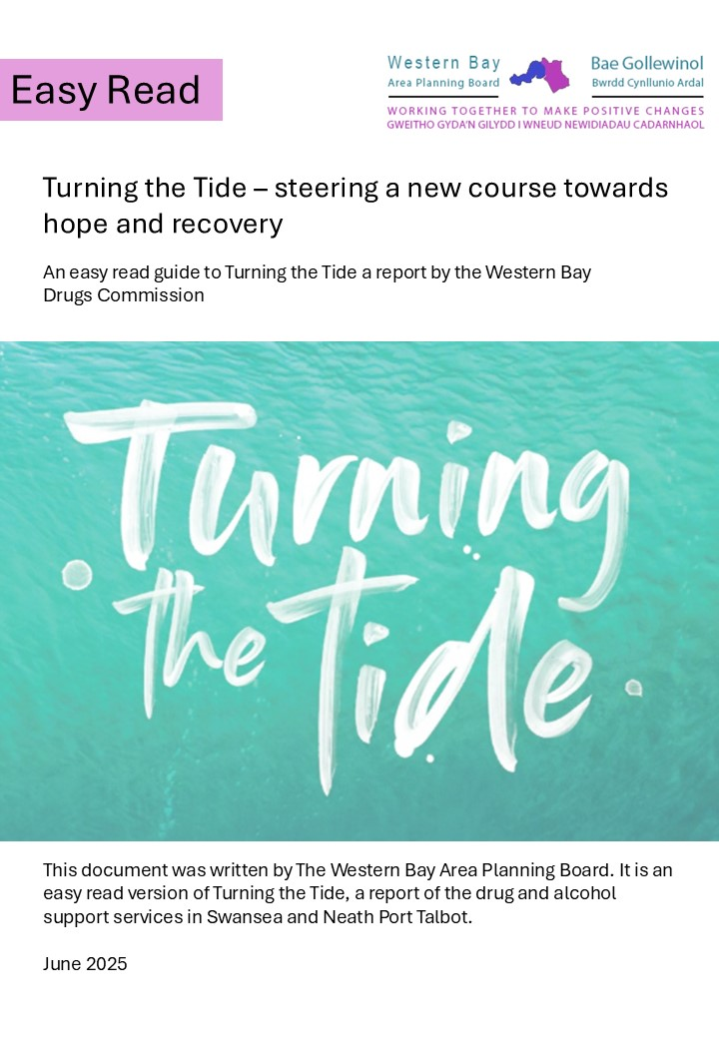

|  |  |
| --- | --- |
|  |  |
| Image of an owl sat in a tree with an open book. | This is an **Easy Read** document. But you may still want someone you trust to go through it with you. |
| A man smiling holding an open book. | Words in **bold blue** writing may be hard to understand. You can check what the words in blue mean on page |
| The Area Planning Board Logo which contains an image of Swansea, Neath and Port Talbot. | Where the document says we, this means **The Area Planning Board**. For more information contact: WBAPB@npt.gov.uk |

|  |  |
| --- | --- |
| Contents: |  |
| What is this report about? | 3 |
| What did they look at? | 4 |
| What did they find out? | 5 |
| What is the Western Bay Drugs Commission saying we should do? | 6 |
| Conclusion | 8 |
| Hard Words | 9 |

What is this report about?

|  |  |
| --- | --- |
| A blue water with waves crashing with the words Turning The Tide | This report is about the **Western Bay Drugs Commission** |
| A group of people including nurses, doctors, police and office workers | It was set up by the **Western Bay Area Planning Board.** That means people from local councils, health services, the police, and other organisations. |

What did they look at?

* Why people are dying from drugs in Neath Port Talbot and Swansea
* Why people use drugs
* What happens to people who use drugs
* How services can be better
* Ideas to help people who use drugs

What did they find out?

|  |  |
| --- | --- |
| An image of a triangle with a skull and cross bones | Lots of people are dying from drugs.  More than anywhere else in Wales.  Some people can’t get the help they need. |
| An image of a stopped cog with a red exclamation mark | 🔁 The current system doesn’t work. It needs to change in a big way with strong leadership. |
| A women sat down holder her knees looking upset. | People using drugs often also have problems with mental health and housing.  These need to be sorted at the same time as drug treatment. |
| A person holding a clipboard and pen | People who use drugs, their families and communities don’t have enough say in how services are planned. |
| a clock | They suit organisations more than people.  Support needs to be available outside regular hours and where people are. |

What is the Commission saying we should do?

|  |  |
| --- | --- |
| An image of cogs turning. | Make one joined-up system from **harm reduction** to **recovery**. |
| A nurse taking an mans blood pressure in his home. | Don’t make people come to offices, support them where they are. |
| A lady helping a homeless man | Work with other services to help with everything a person needs like mental health and housing. |
| A group of women hugging | Women who use drugs often have different needs; these must be included in services. |
| an image of wooded people moving in the same direction. | People who have used drugs should help lead the way. |
| several tick boxes ticked with a red pen. | Check if services are really helping not just how many people go to them. |
| a mother, father and child | Support the whole family and give extra help when needed. |
| a lady sitting on a sofa speaking to another person. | People use drugs for lots of reasons like **poverty**, **trauma**, and not much help.  This must be understood to help people properly. |

Conclusion

|  |  |
| --- | --- |
| a man with a large light bulb which is on. | The **Western Bay Drugs** **Commission** has shared big and important ideas. |
| An image of a paper aeroplane moving from the old way towards the new way. | Now, organisations and leaders must make changes. |
| A lady looking through binoculars | The **Western Bay Drugs** **Commission** will keep watching to make sure changes happen. |

**Hard Words**

**Western Bay Drugs Commission**

The Western Bay Drugs Commission is a group that looked at all the drug services in Neath and Port Talbot and have suggested where service can work better for the people.

**Western Bay Area Planning Board.**

The Western Bay Area Planning Board is a group that works to improve services for people who use drugs in the Swansea and Neath Port Talbot. They look at making sure people get the help they need, such as treatment and support, to live healthier lives.

**Poverty**

Poverty means not having enough money to buy things you need, like food, a place to live, and clothes. People in poverty often have a hard time getting enough to eat, staying healthy, and going to school.

**Trauma**

Trauma means feeling very upset or scared because something bad happened. This could be something like an accident, being hurt, or seeing something frightening. Trauma can make you feel worried, sad, or scared for a long time.

**Harm reduction**

Harm reduction means helping people who use drugs stay safe and healthy, even if they are not ready to stop using drugs. This can include things like giving out clean needles, providing safe places to use drugs, and offering medicine to prevent overdoses. The goal is to reduce the bad effects of drug use and support people in making healthier choices.

**Recovery**

Recovery from drugs and alcohol means getting better and living a healthier life after having problems with using these substances. It involves stopping or reducing use, learning new ways to cope, and making positive changes to improve overall well-being. Recovery is a journey that helps people feel better and live happier lives.