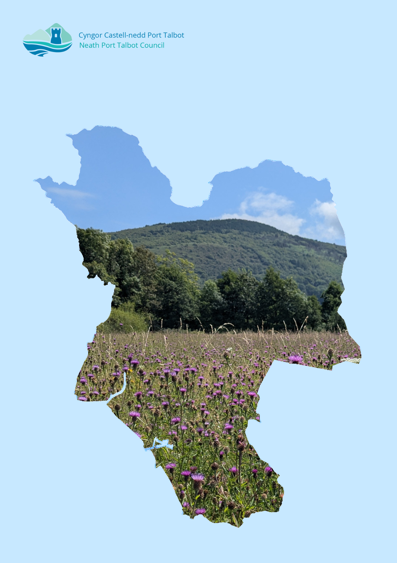

Neath Port Talbot Council

Biodiversity Duty Plan 2023-2025

Implementation Report

December 2025

Contents
Abbreviations and Acronyms 1
1. Introduction 1
1.1. Legislative Requirements 1
1.2. Neath Port Talbot (NPT) Biodiversity Duty Plan 2023-2025 Implementation Report 1
1.3. Programme for Reporting 2
2. Background 2
2.1. Context – Neath Port Talbot Council 2
3. Highlights, Key Outcomes and Issues 3
3.1. Key Biodiversity Actions 3
3.2. Key Enablers 6
3.3. Notable Barriers 7
4. Action Report 8
4.1. Nature Recovery Action Plan (NRAP) Objectives 8
4.2. NRAP Objective 1: Engage and support participation and understanding to embed biodiversity throughout decision making at all levels 8
4.3 NRAP Objective 2: Safeguard species and habitats of principal importance and improve their management 12
4.4 NRAP Objective 3: Increase the resilience of our natural environment by restoring degraded habitats and habitat creation 15
4.5 NRAP Objective 4: Tackle key pressures on species and habitats 17
4.6 NRAP Objective 5: Improve our evidence, understanding and monitoring 18
4.7 NRAP Objective 6: Put in place a framework of governance and support for delivery 20
5. Conclusion 22

Abbreviations and Acronyms
BDP: Biodiversity Duty Plan
C&W Team: NPT Council Countryside & Wildlife Team
ENRaW: Enabling Natural Resources and Well-being Scheme
GI: Green Infrastructure
IIA: Integrated Impact Assessment
LDP: Local Development Plan
LNR: Local Nature Reserve
LNP: Local Nature Partnership
NLHF: National Lottery Heritage Fund
NPT: Neath Port Talbot
NPTC: Neath Port Talbot Council
NRAP: Nature Recovery Action Plan
NRW: Natural Resources Wales
PSB: Public Service Board
OECM: Other Effective Conservation Measures
RLDP: Replacement Local Development Plan
S6: Section 6 Duty under the Environment (Wales) Act 2016
SINC: Sites of Importance for Nature Conservation
SPG: Supplementary Planning Guidance
SSSI: Special Site of Scientific Interest
SAB: SuDS Approving Body
SuDS: Sustainable Drainage System
WG: Welsh Government
WLGA: Welsh Local Government Association

Introduction

Legislative Requirements
The Environment (Wales) Act 2016 (the Act) introduced an enhanced Biodiversity and Resilience of Ecosystems Duty (the section 6 or S6 duty) for public authorities (including the Council), which must seek to maintain and enhance biodiversity in the exercise of their functions, so far as is consistent with the proper exercise of those functions, and in so doing promote the resilience of ecosystems.
To comply with the S6 duty the Council should embed the consideration of biodiversity and ecosystems into their early thinking and business planning, including any policies, plans, programmes and projects, as well as their day-to-day activities.
This duty is embedded in corporate planning and service delivery, influencing policies, projects, and land management decisions. The Council works closely with the Neath Port Talbot Local Nature Partnership to address biodiversity decline and implement actions aligned with the Nature Recovery Action Plan.

Neath Port Talbot (NPT) Biodiversity Duty Plan 2023-2025 Implementation Report

The third Biodiversity Duty Plan 2023-2026 was published in December 2023, following on from BDP 2020-2023, and adopting recommended changes as laid out in the BDP 2020-2023 Implementation Report.
BDP 2023-2026 outlines how NPTC intended to comply with the S6 duty, with targeted actions that would be undertaken by the Council to meet the requirements of the Act for the period of 2023-2026. It outlines what natural resources NPT has, why they are special and some of the activities already underway to protect them. It explains the legislative background; the mechanisms for delivery; detailed actions to be achieved and milestones for reporting.

Although this Biodiversity Duty Plan covers the period 2023–2026, we are reporting in 2025 by request of the Welsh Government, in order to align with the statutory reporting cycle required under the Environment (Wales) Act 2016. Therefore, although Year 8 (1st April 2025-31st March 2026) was included in the BDP 2023-2026, we will instead report on it in the next Implementation Report in 2028.
This BDP 2023-2025 Implementation Report provides an overview of highlights, key outcomes, issues presented and progress against actions during the first two years of delivery of the BDP 2023-2026.

Programme for Reporting

Under section 6 (7) of the Act, the Council must, before the end of 2019 and before the end of every third year thereafter, publish a report on what they have done to comply with the S6 duty.
For the Council to monitor the actions within the BDP in line with grant funding streams and to allow for political reporting, the monitoring timeline aligns with financial years. This implementation report is dated December 2025 as this is the date at which it was presented to Cabinet, however, the report monitors the actions from initial publication up to financial year end 2025– i.e. 1st April 2023 to 31st March 2025. The Implementation Report will be submitted to WG and placed on the Council’s website.
The Biodiversity Duty Plan will be reviewed in light of this report and published at the earliest possible opportunity in 2026. Accordingly, the Council will monitor the actions of the next BDP until 31st March 2028 and publish the next Implementation Report at the end of the next reporting period, by the end of 2028.
The S6 duty guidance states that the Council can amend the BDP at any time. If any circumstances arise that require changes, the BDP will be updated. The reasons for the changes will be documented within the 3-year implementation report and submitted to WG at the appropriate time.
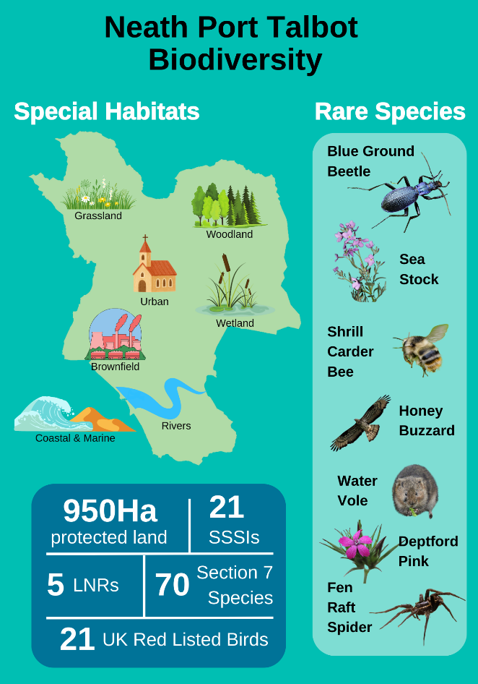

Background

Context – Neath Port Talbot Council

The County Borough of Neath Port Talbot (NPT) is located on the coast between the counties of Swansea and Bridgend. NPT also shares boundaries with Carmarthenshire, Powys, Rhondda Cynon Taf (RCT) and the Brecon Beacons National Park. The population is over 143,200 and the administrative area covers 44,217 hectares.
NPT has a wide variety of habitats and species, from marshy grassland in the valleys supporting Marsh Fritillary butterfly to ancient woodlands providing home to the rare Honey Buzzard and Blue Ground Beetle; and lowland wetlands and canals attracting fen raft spiders. Whilst the coastal dunes and saltmarsh border Swansea Bay, NPT’s upland peat bogs extend right across the plateau into Rhondda Cynon Taf. Brownfield land such as coal tips scattered throughout the county support rare plants and invertebrates.
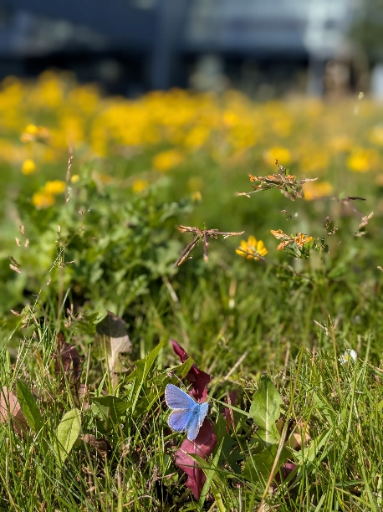
As a Local Authority, Neath Port Talbot Council has the ability and opportunity to influence the amount and extent of biodiversity within the County Borough through management of its land / assets, strategies, policies and project delivery. The Authority implements and enforces national policy and legislation, works in partnership with a wide variety of stakeholders and engages with the public to achieve wider benefits.
Figure 1. Common Blue butterfly and Bird's Foot Trefoil on the short flowering lawn in front of the Quays council offices
The Council is subject to the Well-being of Future Generations (Wales) Act 2015 and delivers its biodiversity commitments through the lens of sustainable development and well-being objectives. It is an active member of the Neath Port Talbot Public Services Board, contributing to the local Well-being Plan and aligning biodiversity actions with the Sustainable Management of Natural Resources (SMNR) principles and Area Statements produced by Natural Resources Wales. These frameworks ensure that biodiversity enhancement supports wider goals such as climate resilience, health and well-being, and community engagement.
Delivery of the S6 Duty and implementation of the BDP is the responsibility of the Council as a whole. As of 2017, the coordination and monitoring of the BDP has been embedded into a staff post. The Ecologist (Plans and Projects) of the C&W Team is lead officer for the BDP.

Highlights, Key Outcomes and Issues
This section sets out the positive outcomes that have been achieved to-date from the progress made on the Actions set out within the Report (Section 6). It also highlights key enablers and barriers that have or are continuing to influence action.

Key Biodiversity Actions

    - The Countryside & Wildlife Team (C&W Team) continue to provide an advisory service to enable the council to consider biodiversity in a wide range of functions. This includes through the development management process, as part of the SuDS (Sustainable Drainage Systems) Approving Body and for any other queries e.g. regarding land management. For example, the C&W Team have provided wording to Highways to include in Hedgerow Enforcement Notices to ensure that bird nesting is considered as an appropriate reason for homeowners to be given permission to delay cutting back hedges.

    - Service assessments to determine potential impacts of services on biodiversity and opportunities for best practice have been completed for all council service areas. All service areas have received recommendations for how to comply with the Biodiversity Duty. These will be regularly reviewed to ensure that service areas continue to comply. These service assessments had the added benefit of highlighting possible joint projects, for example, the Road Safety team regularly visit schools with their mascot ‘Henson the Hedgehog’. The C&W Team were able to produce and provide leaflets for the children to take home from school informing them ‘How to Help Henson at Home’. In this way, the Road Safety team are also raising awareness of and helping to tackle biodiversity issues.

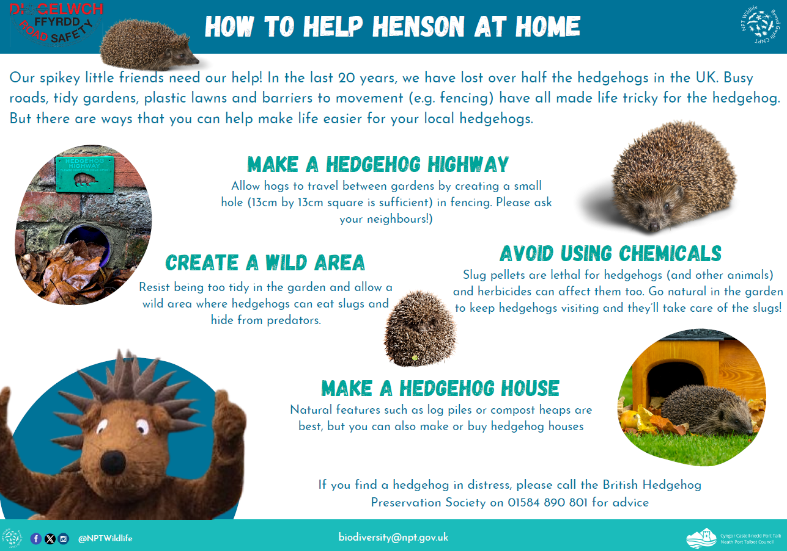
Figure 2. How to Help Henson at Home leaflet for Road Safety Teams to give to school children

    - The C&W Team have continued to provide a key service to other departments through consultancy. The Ecologists work closely with other departments from the start of project to completion, to ensure that works result in an enhancement for biodiversity, for example, undertaking bat surveys to inform refurbishment and repair projects at Margam Country Park.

    - The C&W Team raises awareness of biodiversity through a variety of methods including public walks, interpretation panels, leaflets, web pages, team newsletters, events, vlogs and social media.

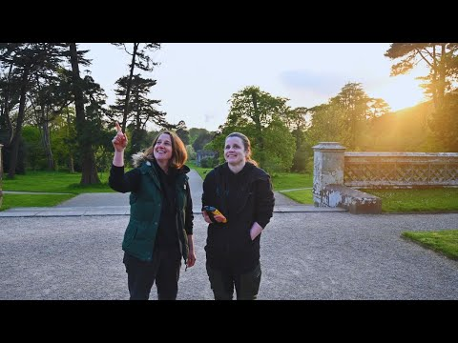
Figure 3. Vlog published on corporate channels about the Bats of Margam Park

- The C&W Team have facilitated biodiversity training for officers on a number of subjects including Planning Policy updates for Planning departments, Bats and Arboriculture training for tree workers and recognition of bat signs for Building Control officers. Regular training sessions are now programmed for officers, to increase understanding of the Biodiversity Duty, and to enable relevant staff members to recognise wildlife interest on site. Biodiversity is now also included in corporate mandatory training 'On Our Doorstep - An Introduction to Neath Port Talbot' which was introduced in 2024.

- The C&W Team have continued to collaborate, where appropriate, with other sections to aid in the development of strategies or plans that contribute towards biodiversity conservation or may impact on biodiversity. These included the Heritage and Culture Strategy, Arboriculture Management Plan, Place Making Plans and the Replacement Local Development Plan.

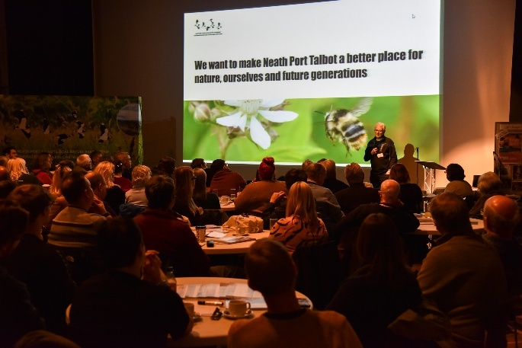
- The C&W Team has continued to provide the Secretariat for the NPT Local Nature Partnership. NPTC is supporting implementation of the Nature Recovery Action Plan (NRAP) on its own land and through support for other partners e.g. through securing funding for an LNP Grant Fund. The C&W Team organised a successful and very well attended launch event for the State of Nature and Nature Recovery Action Plan for NPT, along with follow-up events held at Margam Country Park over the following summers to further raise awareness.
Figure 4. Nature Unearthed, the launch of the State of Nature and Nature Recovery Action Plan for NPT, at the Gwyn Hall Neath February 2024

- Reviews of NPTC-owned and managed buildings and public spaces were undertaken to determine where there are opportunities for habitat enhancement alongside existing necessary functions/benefits. Funding has been secured to undertake some of these projects, such as wildflower planting, creating nature murals, installing bug hotels and bird box installation.

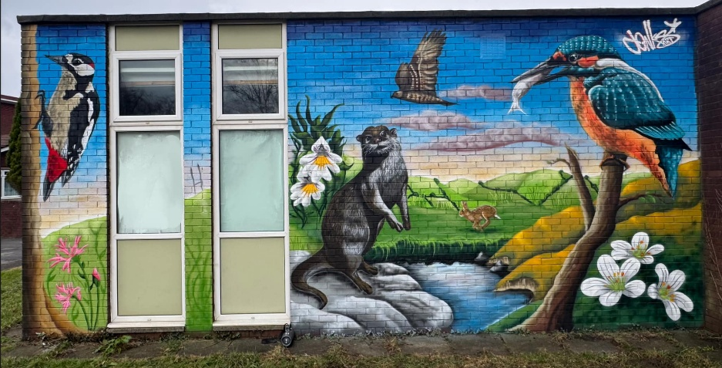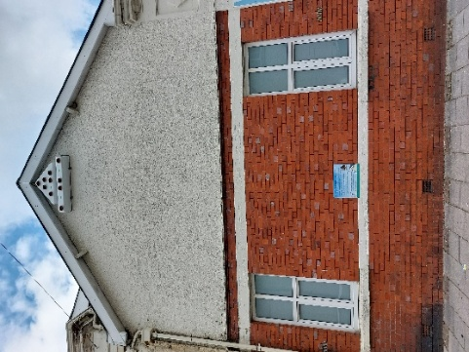
Figure 5. Left- local biodiversity mural at Glynneath Library, Right - swift boxes and interpretation installed at Pontardawe library

- The C&W Team has secured grant funding for a variety of other projects from a wide variety of funding streams. This has amounted to over £2million of funding for the period covered in this report. Case studies of some of these projects are pictured below:

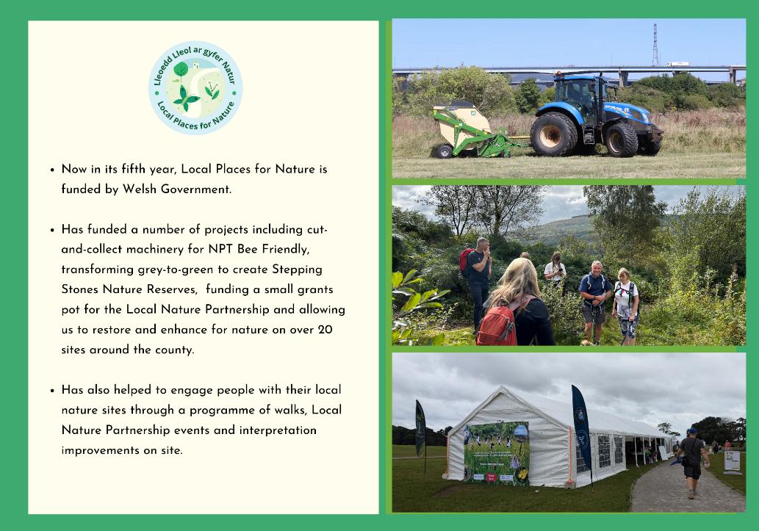
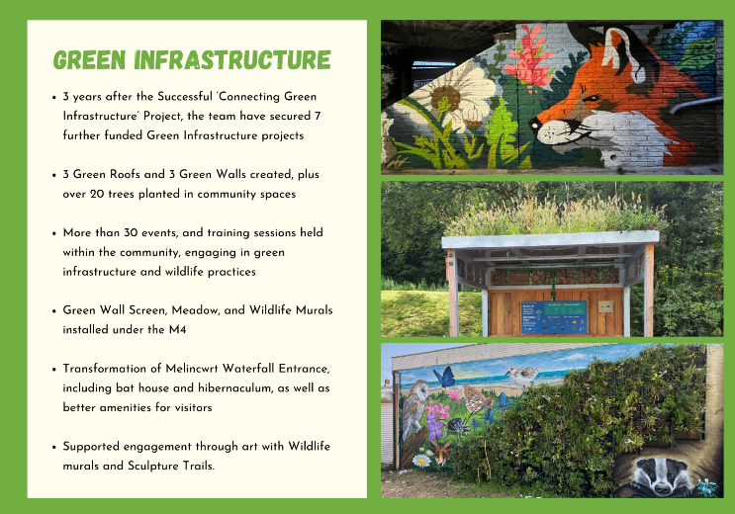

    - The C&W Team continues to work with other departments to manage sites for nature, such as the Local Nature Reserves and NPT Bee Friendly sites. There has been an overall increase in sites included in NPT Bee Friendly or being managed with external funding by 56.88 hectares. The Working with Nature project (funded by Welsh Government Local Places for Nature) has enabled restoration and enhancement works to be started on 25 nature sites around the county, which were previously suffering from lack of management.

Key Enablers

Good Internal Working Relationships
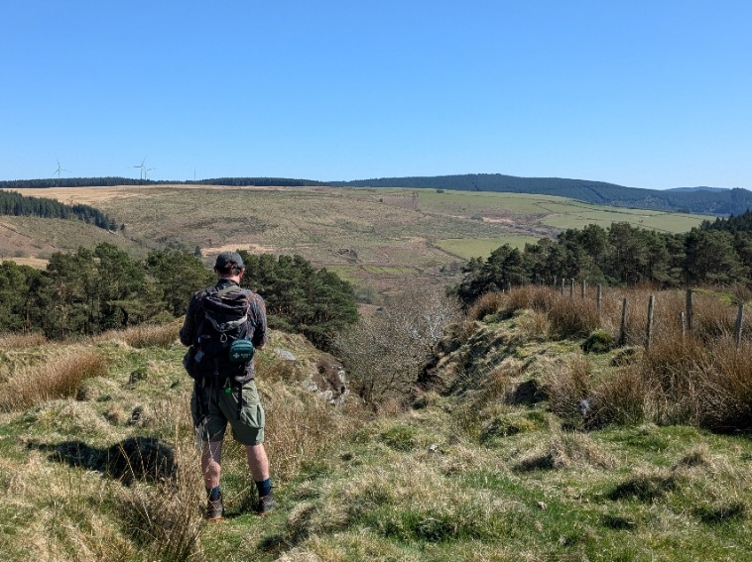
There are numerous examples of how good internal working relationships have led to achievements against the Biodiversity Duty. For example, Neighbourhood Services and the C&W Team work together to increase the area and extent of wildflower grassland (i.e. roadside verges and larger meadow areas which are managed to encourage wildflowers and pollinating insects) through the NPT Bee Friendly Scheme.

External Funding
A key enabler of the work of the Wildlife Team has been external funding. The Wildlife Team (not including staff undertaking a Countryside function or the Team Leader) only has 3 core full-time equivalent members of staff but supports an additional 8.76 full-time equivalent members of staff through project funding and 1.5 through other income generation. External funding greatly increases the capacity of the C&W Team to support action against the BDP.
Figure 6. C&W Team member looking from Cefn Morfudd towards Tonmawr

Notable Barriers

Capacity of the C&W Team
Although the team has increased in size through externally funded project staff, there has been increased pressure on core staff undertaking core functions e.g. from the development management process. The need to apply for project funding adds continual increased pressure on these staff. This presents a capacity issue for the C&W Team and is reflected in the Service Delivery Plan for the section. Additional funding generated through planning performance agreements and through the consultancy service has secured 1 additional temporary full-time staff member to support the team, however the short-term nature and inconsistency of the funding continue to undermine the long -term sustainability of the team.

Longevity of funding
As demonstrated above, external funding is a key enabler of action against the BDP. However, this funding is temporary, with the large majority of projects covering periods of a year or less. This represents a lack of security for the C&W Team and a risk of further loss of capacity if further external funding is not secured at the end of projects. This also has impacts upon the sustainability of project outcomes. A particular concern is the ability to provide consistency in Local Nature Reserve/green space management and support for volunteer groups and schools.

C&W Team Early Engagement
Although a number of service areas work closely with the C&W Team, there is still a lack of awareness within some service areas of the C&W Team and the BDP. This is evident in reviewing some of the past Integrated Impact Assessments (IIA) in Cabinet and Council Reports, that demonstrate limited engagement with the C&W Team in order to evidence the biodiversity section of the IIA. Another barrier to the Council meeting its biodiversity duty is a failure to involve the C&W Team from the start of projects. This can lead to project delays if surveys are required or problems if biodiversity impacts are identified too far down the line. This has highlighted the need for further training that will be overseen by the Corporate Governance Group.

Conflicting priorities
Commitment to our Biodiversity Duty is essential for the long-term well-being of our communities and natural environment. This can be challenging alongside other priorities such as delivering new homes, economic regeneration, and infrastructure, which often involve land use changes and development pressures. Even with strong mitigation and enhancement measures, these activities can create tensions that require careful planning and collaboration.

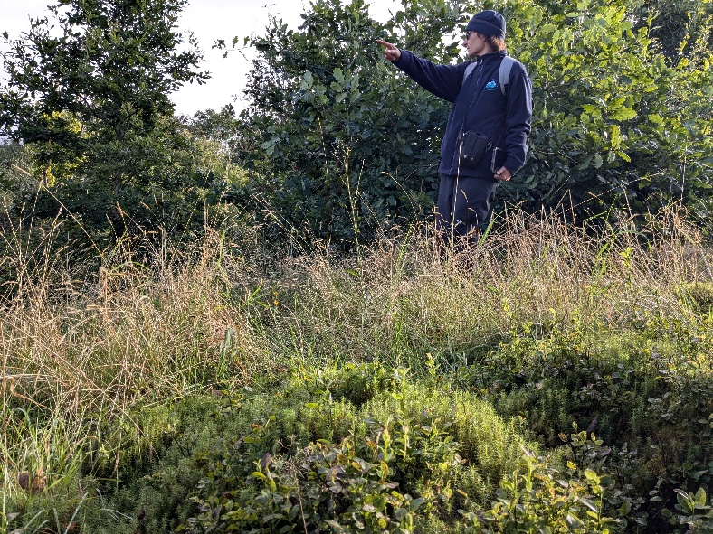
Figure 7. C&W Team officer undertaking a heathland survey

Action Report

Nature Recovery Action Plan (NRAP) Objectives

This section reports on actions in the Biodiversity Duty Plan 2023-2026, which were based on the objectives in the Nature Recovery Action Plan (NRAP) for Wales. The NRAP outlines how Wales will meet the commitments of the Convention on Biological Diversity, which is the key international agreement on biodiversity to which the UK Government is the signatory.
Although our Biodiversity Duty Plan covers the period 2023–2026, we are reporting in 2025 as requested by the Welsh Government, in order to align with the statutory reporting cycle required under the Environment (Wales) Act 2016. Therefore, although Year 8 was included in the BDP 2023-2026, we will instead report on this year in the next Implementation Report in 2028.
Progress against the milestones in the BDP 2023-2026 are given below.
Actions are categorised by Nature Recovery Action Plan for Wales objectives (shown below). Some actions deliver against a range of objectives, however, to avoid duplication, the actions are organised into the most appropriate NRAP objective with any additional relevant objectives (that they contribute to) listed in the final row of the table.
 | NRAP Objectives
1 | Engage and support participation and understanding to embed biodiversity throughout decision making at all levels
2 | Safeguard species and habitats of principal importance and improve their management
3 | Increase the resilience of our natural environment by restoring degraded habitats and habitat creation
4 | Tackle key pressures on species and habitats
5 | Improve our evidence, understanding and monitoring
6 | Put in place a framework of governance and support for delivery

NB. Year 3 = April 2020 – March 2021, Year 4 = April 2021 – March 2022 and Year 5 = April 2022 – March 2023, Year 6= April 2023-March 2024, Year 7 = April 2024 – March 2025.

NRAP Objective 1: Engage and support participation and understanding to embed biodiversity throughout decision making at all levels
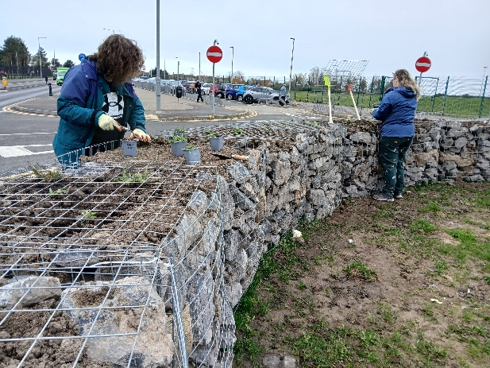
Figure 8. Officers from the C&W Team planting up 'Modular Based Biodiversity Units’ (wildflower gabion baskets) which will prevent dangerous parking outside a school, in conjunction with the Road Safety team
Biodiversity is embedded in corporate planning and service delivery, influencing policies, projects, and land management decisions. The Corporate Plan lists the BDP as a key strategy and plan, and key partnerships include NPT Local Nature Partnership, the Lost Peatlands Steering Group and the NPT Public Service Board – Climate and Nature Partnership. The sole function of programme 6 within the corporate transformation programme under the Corporate Plan is ‘Responding to Climate & Nature Emergency’. Biodiversity and ecosystem resilience is a key consideration in decision making, included in Integrated Impact Assessments for all decisions. Service assessments have outlined where there are opportunities for services to delivery biodiversity action in day-to-day work programmes or for problem solving e.g. working with the Road Safety team to install wildflower gabion baskets to prevent dangerous parking outside of a school, instead of simple bollards. Biodiversity is included in the corporate mandatory training ‘On our Doorstep- an Introduction to Neath Port Talbot’ and specific training for services is regularly provided, such as training to recognise signs of bat roosts and what to do if one is identified, for officers from Building Control. Sustainability and environmental considerations are now considered in all procurement exercises following the Procurement reform.

1.1 | BIODIVERSITY ADVISORY SERVICE
Action | The Council currently considers biodiversity in a wide range of functions, including through implementing the policies of the LDP when making decisions through the development management process and as part of the SuDS (Sustainable Drainage Systems) Approving Body.
Reporting mechanism | C&WT planning spreadsheet
Milestone year 6 | All advice recorded in the spreadsheet followed
Milestone year 7 | All advice recorded in the spreadsheet followed
Progress | The large majority of advice provided to other departments has been followed. In addition to planning advice, C&W Team continue to provide advice to other service areas e.g. working together with Neighbourhood Services to tackle issues such as invasive non-native plant species and biosecurity / providing ecological information for potential land sales to Estates. The C&W Team has sat on grant panels and/ or provided guidance for internal funds including the Regeneration Capital Fund, Community Facilities Improvement Fund and the Third Sector Grant. The C&W Team is also consulted on proposed events by the Special Events team and biodiversity duty information and questions are now included in the Events Registration Form to ensure that event organisers have applied due diligence for events with regards to impacts on biodiversity and sustainability.
NRAP Objectives | 1,6

1.2 | SERVICE ASSESSMENT
Action | Complete service assessment and provide reports with recommendations to each service. All services to follow recommendations as outlined in their reports.
Reporting mechanism | C&W Team to keep a spreadsheet recording action against recommendations. Internal Audit team to assist with collecting this information.
Milestone year 6 | Service assessments completed
Milestone year 7 | Action against recommendations taking place.
Progress | Service assessments are completed with recommendations for service areas as appropriate. Joint projects have been pursued such as collaborating with Passenger Transport Unit to display biodiversity information at bus stations. Where risks have been identified, the C&W Team are working with the relevant service area to alleviate this.
NRAP Objectives | 1

1.3 | C&WT EARLY ENGAGEMENT
Action | The C&WT are regularly consulted by other service areas and give appropriate advice and services.
Reporting mechanism | C&WT Consultancy Spreadsheet /STiR (time recording database)
Milestone year 6 | Retain internal consultancy function and continue to provide early advice to service areas throughout the Authority. All advice followed.
Milestone year 7 | Retain internal consultancy function and continue to provide early advice to service areas throughout the Authority. All advice followed.
Progress | Internal consultancy function is retained and used to full capacity by other services e.g. ecologists undertook bat surveys to inform a number of projects including school re-developments. There are still some issues with lack of early engagement with some departments. A briefing note for DMT on the services of the C&W Team has been developed to raise awareness of the need for departments to engage with Ecologists early.
NRAP Objectives | 1,2,3,4,5,6,

1.4 | DECISION MAKING PROCESS
Action | The Integrated Impact Assessment (IIA) that accompanies all committee reports includes an appropriately evidenced assessment of the impact on biodiversity in line with the Environment (Wales) Act 2016. Where necessary, training for staff and officers is undertaken to support this.
Reporting mechanism | Committee reports all containing a report on outcomes of the impact assessment. An annual IIA review is undertaken by C&W Team and reported back to relevant service areas, with follow-up training if necessary.
Milestone year 6 | All committee reports to contain an appropriately-evidenced report on outcomes of the impact assessment.
Milestone year 7 | All committee reports to contain an appropriately-evidenced report on outcomes of the impact assessment.
Progress | The C&W Team have been consulted on IIAs for a number of projects over this period including the Highways and Engineering Works Programme, the transfer of fleet to electric vehicles, the Neurodivergence Plan and land sales. Wider engagement with C&W Team regarding appropriately evidencing IIA’s could be improved. Awareness raising measures to be implemented.
NRAP Objectives | 1,2,3,4,5,6

1.5 | TRAINING
Action | Ensure that staff and Elected Members receive appropriate training and are aware of where to access further guidance.
Reporting mechanism | Attendance at training
Milestone year 6 | Deliver training
Milestone year 7 | Deliver training
Progress | A number of training sessions for staff and Elected Members have taken place including updates to planning policy with regards to ecology, annual Streetcare best practice training for biodiversity and the inclusion of a biodiversity section into corporate mandatory training 'On Our Doorstep - An Introduction to Neath Port Talbot'. Further training is planned, including an online Nature-wise training module to be put forward as key training on the corporate training programme.
NRAP Objectives | 1,6

1.6 | BIODIVERSITY SPG
Action | Implement the Biodiversity Supplementary Planning Guidance (SPG) in line with LDP policies and develop a mechanism for habitat banking to ensure we have compensation sites ready to go when needed.
Reporting mechanism | C&WT Planning spreadsheet
Milestone year 6 | Implement SPG
Milestone year 7 | Implement SPG
Progress | The current SPG is being implemented. It will be updated in light of PPW12, coordinated with the production of the Replacement Local Development Plan.
NRAP Objectives | 1,2,3,4,5,6

1.7 | WELL-BEING PROCESS
Action | Deliver and support others to deliver against ‘Recover, Reset, Renew’, the Council Corporate Plan and the Public Service Board’s Well-being Plan ‘Well-being Objective 3; To ensure our local environment, culture and heritage can be enjoyed by future generations’, as well as relevant actions under the other three Well-being Objectives.
Reporting mechanism | Via the Corporate Plan and PSB annual reports.
Milestone year 6 | As required by the Corporate Plan and PSB reporting mechanisms
Milestone year 7 | As required by the Corporate Plan and PSB reporting mechanisms
Progress | Report against Corporate Plan and Service Delivery Plan via the following KPIs:  - Biodiversity Action Plan - % of actions either completed or implementation in progress prior to the next reporting round – Target 80%. This target has been met each year.  - Area of biodiversity/ green space / nature reserves / green infrastructure within the council’s ownership to help address the climate and nature emergencies and help improve the health and well-being of our residents – Target Annual Increase. Increase of 9ha in year 6 and 47.85ha in year 7.  Quarterly Transformation Programme 6 reporting via:  - Narratives on projects and C&W Team work progress against a number of strategic priorities: We will have extended our work to help nature recover and the quality of and access to the natural environment will have improved, guided by our biodiversity action plan; More people in our community and wider partners have developed a greater sense of stewardship, actively working to manage and improve their local environment. All reported as on track.  - Performance Measures: Make progress towards the actions set out within the Biodiversity Duty Plan. Last reported as 39 of 40 actions progressed.
NRAP Objectives | 1,2,3,4,5,6

1.8 | NEW COUNCIL STRATEGIES
Action | C&WT to collaborate where appropriate with other sections to aid in the development of strategies or plans that contribute towards biodiversity conservation and respond to consultations and reviews of existing plans.
Reporting mechanism | BDP Reporting Spreadsheet
Milestone year 6 | N/A
Milestone year 7 | N/A
Progress | C&W Team have collaborated/ inputted to the following strategies:  1. Active Travel Delivery Plan  2. Corporate Asset Management Plan  3. Highways Asset Management Plan  4. Place Making Plans  5. Strandline Combing  6. Sustainable Procurement Policy  7. Heritage and Culture Strategy  8. Replacement Local Development Plan  9. Social Values Policy  10. Arboricultural Management Plan  11. Tree Inspection Policy  12. NPT Food Strategy  Two new biodiversity policies are in the process of being adopted by the council; preventing Honeybees and Artificial Grass
NRAP Objectives | 1,2,3,4,6

1.10 | SUDS (SUSTAINABLE DRAINAGE SYSTEMS) APPROVAL BODY (SAB)
Action | Maximise the biodiversity potential of SuDS in NPT.
Reporting mechanism | Through SAB processes
Milestone year 6 | Work with SAB team to determine the knowledge gaps and what is required to help maximise the biodiversity potential of SuDS in NPT.
Milestone year 7 | TBC
Progress | The C&W Team engage regularly with the SAB team and have progressed the production of an information pack on incorporating nature into the development of SuDS in the county.
NRAP Objectives | 1, 5, 6

1.11 | PROCUREMENT
Action | Include biodiversity/ sustainability impacts as a consideration in the procurement process, with appropriate weighting in tender evaluation.
Reporting mechanism | To be agreed with procurement.
Milestone year 6 | Work with Procurement team to determine appropriate considerations for biodiversity/ sustainability to include in the procurement process.
Milestone year 7 | Impacts on biodiversity / sustainability considered through the procurement process.
Progress | Procurement Reform has taken place and new Contract Procedure Rules and procedures have been updated accordingly, with significant improvements in considerations for environmental sustainability. The environment is now a key consideration in any procurement exercise. The C&W Team are still working closely with Corporate Procurement Team to further incorporate biodiversity considerations into the procurement processes.
NRAP Objectives | 1,6

1.11 | CURRENT ISSUES
Action | Keep policies and steering statements up to date in light of current issues.
Reporting mechanism | Through appropriate council processes
Milestone year 6 | Policies and steering statements adopted or updated as necessary
Milestone year 7 | Policies and steering statements adopted or updated as necessary
Progress | Two new biodiversity policies are in the process of being adopted by the council; preventing Honeybees and Artificial Grass. (Approved in the following period).
NRAP Objectives | 1, 5, 6

NRAP Objective 2: Safeguard species and habitats of principal importance and improve their management

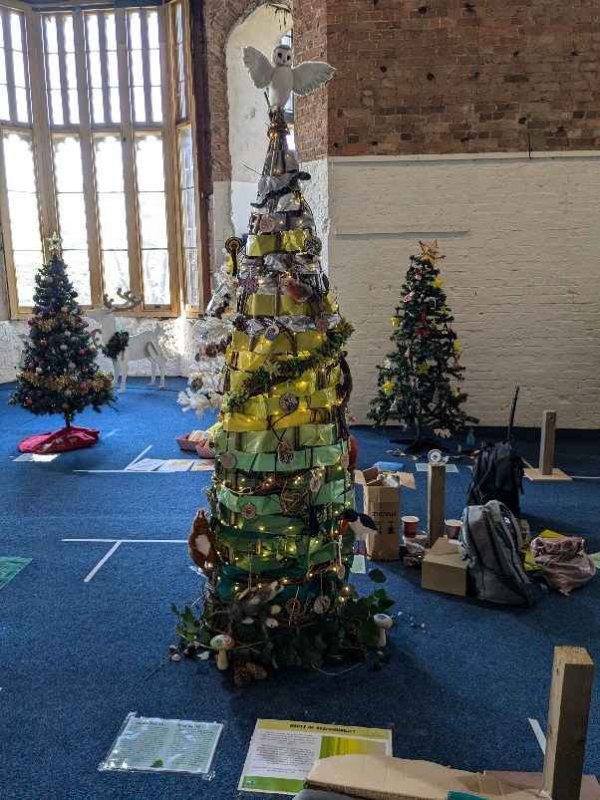
Sites that support special species and habitats are protected via designation or actively managed wherever permissions, capacity and budget allows. SINCs are actively surveyed, reviewed and designated. SINCs and S7 Habitats and Species are key considerations through the planning process. Potential or actual biodiversity constraints are now flagged through the Council’s Property Management System, indicating to other service areas whether a proposed project may have biodiversity implications and whether advice from the C&W Team should be sought. For example, a council-owned site with a SINC designation or a record for a S7 species would flag as Red on the system, prompting the officer to seek guidance from the C&W Team on the possible implications of their desired action and any required mitigation and enhancement. Through this process, potential sites to contribute to 30x30 are also being identified in readiness for the release of WG guidance on OECM’s.
Figure 9. The NPT LNP/ C&W Team Christmas Tree at the Community Christmas Tree Festival, Margam Country Park, 2024
NPTC supports NPT Local Nature Partnership in implementing the Nature Recovery Action Plan by actively delivering projects e.g. NPT Bee Friendly or supporting partners to do so e.g. through administering the NPT LNP Grant Fund or contributing to project planning such as attendance on the Woodland Trust Brynau Farm Stakeholder group. Awareness raising to safeguard habitats and species of importance is a key part of the remit of the C&W Team and this is done in a number of ways. External funding through the Local Places for Nature fund has allowed us to run over 70 nature walks on local nature sites during the timeframe of this report, with almost 500 unique participants. Nature social media posts are regularly posted on the NPT Wildlife social media streams, but also on the corporate channel and other council channels such as Gnoll Country Park. The C&W Team has attended other events to raise awareness of the nature of NPT, such as the Senedd Biodiversity Event and the Neath Green Gathering. NPT LNP in conjunction with the C&W Team is a regular contributor to the Margam Country Park Christmas Tree Festival, with a Christmas tree that raises awareness of the nature of NPT to a wider audience.
Lastly, the C&W Team is hugely successful in securing funding for biodiversity projects, with over £2million of external funding secured for the county during the period covered by this report.

2.1 | DEVELOPMENT MANAGEMENT PROCESS
Action | NPTC currently consider biodiversity (including species and habitats of principal importance, designated sites, sites of importance for nature conservation (SINC), habitats and species that meet the SINC criteria, and important natural features) through the development management process, in line with the Local Development Plan. Losses of protected/priority habitat/species (where known) are recorded.
Reporting mechanism | C&WT planning spreadsheet
Milestone year 6 | Achieve net benefit for biodiversity through the planning process.
Milestone year 7 | Achieve net benefit for biodiversity through the planning process.
Progress | Consistent achievement against this action.
NRAP Objectives | 1,2,3,4,5,6

2.2 | NPT NATURE PARTNERSHIP
Action | The Council will support the NPT Nature Partnership in implementing the NPT Nature Recovery Action Plan. The Action Plan is a key mechanism for species and habitat conservation in the County.
Reporting mechanism | Action to be recorded and reviewed annually in the first LNP meeting of the new year.
Milestone year 6 | Progress against relevant actions as outlined in the NRAP
Milestone year 7 | Progress against relevant actions as outlined in the NRAP
Progress | The C&W Team continues to support NPT Local Nature Partnership by undertaking Secretariat duties, enabling monitoring and review of the NRAP and administering a small grants fund on behalf of the LNP. NPTC is taking action against relevant Nature Recovery Action Plan actions e.g. NPT Bee Friendly directly and indirectly e.g. through the small grants pot.
NRAP Objectives | 1,2,3,4,5,6

2.3 | AWARENESS RAISING
Action | The C&WT raise awareness of biodiversity through a variety of methods; training, public engagement (walks/talks), interpretation panels, leaflets, web pages, social media.
Reporting mechanism | Project delivery and ongoing upkeep of the NPTC web pages and NPT Wildlife Facebook page
Milestone year 6 | 2 awareness raising projects per year and year on year increase in followers on the Facebook page
Milestone year 7 | 2 awareness raising projects per year and year on year increase in followers on the Facebook page
Progress | C&W Team have undertaken awareness raising in a number of ways:  - Press releases; regular press releases covering project activity  - Team newsletters; biannual team newsletter released e.g. December 2024  - Events; A number of events have been held, both small e.g. over 70 nature walks held through the Working with Nature project, with almost 500 individual participants, and larger ‘festival’-style events e.g. Nature Unearthed February 2024 and September 2024  - Attendance at other events; including Neath Green Week, the Green Gathering and the Christmas Tree Festival at Margam Country Park  - Vlogs; Margam Bat Vlog  - Leaflets; e.g. Help for hedgehogs leaflet for Road Safety team to take to schools, Margam Bats leaflet  - Interpretation; new interpretation installed at Working with Nature sites  NPT Wildlife Facebook page followers have increased by 400 (now 2.6k followers)
NRAP Objectives | 1,2,3,5

2.4 | BIODIVERSITY AUDIT
Action | Undertake a biodiversity audit on land within our ownership and control, to identify where we have protected/S7 habitats and species on our land. Priority will then be given to those areas / sites where priority Section 7 habitats / species have been identified which offer the greatest benefit to biodiversity, considering one of the following options:  1) The status quo – with no further action being taken.  2) Be brought into appropriate management for the benefit of biodiversity. This may be through:  The Authority and, where necessary, suitable revenue sources can be secured by way of external funding to support and manage the identified sites.  Lease to external parties.  NB Any notional financial loss to the Authority needs to be reported and agreed before any lease is granted.  3) Any future disposal of a site will include relevant information from the audit so that the purchaser / tenant can comply with the relevant requirements.  4) In advance of undertaking any works and / or any material changes in land use on sites owned and controlled by the Authority, it will take into consideration the findings of the audit, taking steps to conserve and where possible enhance the biodiversity value
Reporting mechanism | First report will be results of audit
Milestone year 6 | Assessment ongoing
Milestone year 7 | Advice provided as part of assessment followed
Progress | Biodiversity audit is ongoing to classify sites on a Red, Amber, Green basis with regards to biodiversity constraints. The information from these audits is incorporated into the property management systems and flagged with requirements e.g. ‘No net loss of SINC’ / ‘Speak to C&W Team to arrange bat / bird surveys’ etc. etc. The system is working well as evidenced by requests for further information from C&W Team as a result of biodiversity constraints being flagged on the Property Management System.
NRAP Objectives | 1,2,3,5

2.5 | NATIONAL GUIDANCE
Action | Implement any national/regional guidance on enhancing biodiversity and ecosystems resilience through the planning system. Any new guidance will be taken into account and integrated into the system.
Reporting mechanism | C&WT Planning spreadsheet
Milestone year 6 | All national/regional guidance to be integrated into the planning system within 3 months of its release
Milestone year 7 | All national/regional guidance to be integrated into the planning system within 3 months of its release
Progress | PPW12 Chapter 6 was integrated immediately on release.
NRAP Objectives | 1,2,3,4,5,6

2.6 | FUNDING
Action | Apply for funding as opportunities arise to continue to deliver for biodiversity, or as part of strategic, multi-functional projects delivering multiple benefits.
Reporting mechanism | As funding requirements
Milestone year 6 | As opportunities arise
Milestone year 7 | As opportunities arise
Progress | Over £2million of external funding secured by the C&W Team for biodiversity projects.  1. HLF Regreening PT - £206,377.50  2. Coastal Connections – Empowering our Coastal Communities (Capacity) - £108,036.30  3. Coastal Connections - Restoring Nature (Challenge) - £136,500.004.  4. Local Places for Nature Capital – Year 6 £380100, Year 7 £455,300  5. Local Places for Nature Revenue – Year 6 £72,000, Year 7 £72,000  6. Local Places for Nature Biodiversity Revenue- Year 6 £48,000, Year 7 £48,000  7. SPF Melincourt £40,070  8. Challenge fund King George V £5000  9. Lost Peatlands 2021-2025 £1.56 Millions funding but over £2.8Million total project value over 4 years  10. National Forest for Wales Landscape Pilot - £25906
NRAP Objectives | 1,2,3,4,5,6

2.7 | 30x30
Action | Examine the potential to increase the amount of protected or ‘other effective area based conservation measures (OECMs)’ land in NPT, in line with the 30x30 target and the Biodiversity Deep Dive recommendations. This can be completed for both NPTC land and for the county of NPT as a whole, working with the LNP.
Reporting mechanism | TBC (Welsh Government are yet to define how to measure other effective area-based conservation measures (OECMs))
Milestone year 6 | Complete biodiversity audit
Milestone year 7 | Use the information from the biodiversity audit to identify the maximum percentage of NPTC land holdings which have the potential to be protected for biodiversity or classified as OECMs i.e. not in other use etc.
Progress | Potential OECM sites are being identified through the biodiversity audit. We are awaiting full WG guidance on OECMs and how they will be classified.
NRAP Objectives | 1,2,3,4,5,6

NRAP Objective 3: Increase the resilience of our natural environment by restoring degraded habitats and habitat creation
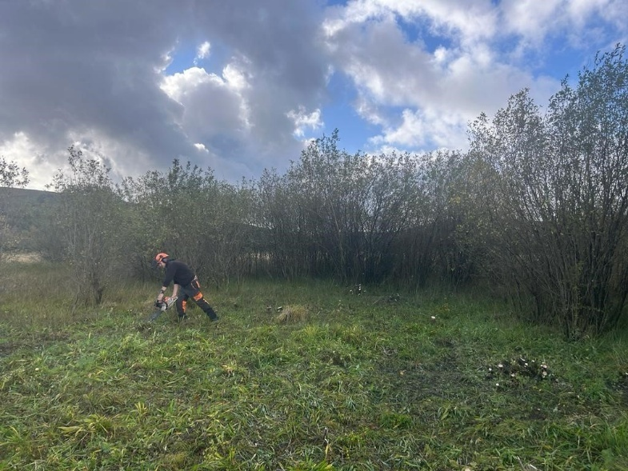
The C&W Team have secured over £2million of external funding for projects that restore and create habitats. For example, since 2023, the Welsh Government Local Places for Nature fund has allowed us to restore and enhance habitat at over 20 sites across the county, such as Maerdy Playing Fields, where we are removing scrub encroachment and undertaking cut-and-collect management to restore the S7 habitats (e.g. marshy grassland) to support the S7 species (e.g. Marsh Fritillary) the site supports. Area of land managed for biodiversity is increased year-on-year in accordance with the Corporate Plan, through adding sites to the NPT Bee Friendly scheme or securing external funding to manage SINCs. Opportunities to join up projects and sites to create resilient ecological networks are sought where possible e.g. the Lost Peatlands project, which restored 240 hectares of deep peat in NPT and neighbouring RCT. Habitat creation and restoration is also sought through the planning process.
Figure 10. Restoration of marshy grassland through removal of scrub encroachment at Maerdy Playing Fields, funded by WG LP4N

3.1 | CURRENT MANAGEMENT
Action | NPTC areas are being managed for biodiversity and to ensure their resilience.
Reporting mechanism | Extent of area under management reported through the Key Performance Indicators (KPI) within the Corporate Plan.
Milestone year 6 | Agree an amended KPI as part of the Corporate Plan.
Milestone year 7 | As set by the KPI
Progress | 1203 hectares of council land are designated and / or managed as biodiversity / green space / nature reserves / green infrastructure within the Council’s ownership to help address the climate and nature emergencies and help improve the health and well-being of our residents. This includes Sites of Importance for Nature Conservation, NPT Bee Friendly, Country Parks, Local Nature Reserves, Leased land that is managed for biodiversity by the Lessee and sites under management through externally funded projects e.g. Lost Peatlands. Some of these sites are only designated and are not in active management currently.
NRAP Objectives | 1,2,3,4,5,6

3.2 | HABITAT MANAGEMENT THROUGH DEVELOPMENT MANAGEMENT
Action | Through the development management process habitat management plans are put in place increasing the resilience of our natural environment and improving the management of S7 habitats
Reporting mechanism | C&WT Planning spreadsheet
Milestone year 6 | Appropriate assessments of ecosystems resilience submitted through the planning process and appropriate measures to deliver improvements taken
Milestone year 7 | Appropriate assessments of ecosystems resilience submitted through the planning process and appropriate measures to deliver improvements taken
Progress | Progressing as planned e.g. Electric car charging stations were installed at the Quays council offices with the loss of a small area of SINC, but the installation of ‘modular-based biodiversity units’ increased the overall surface area of habitat to mitigate for this loss and ensure ecosystem resilience.
NRAP Objectives | 1,2,3,4,5,6

3.3 | AREA STATEMENTS
Action | NPTC will assist NRW in implementing Area Statements as required.
Reporting mechanism | As required
Milestone year 6 | As appropriate
Milestone year 7 | As appropriate
Progress | Ecologist has attended Area Statement meetings with NRW as requested.
NRAP Objectives | 1,2,3,4,5,6

3.4 | GREEN INFRASTRUCTURE ASSESSMENT
Action | The Council will undertake a Green Infrastructure Assessment (GIA) in line with the requirements of Planning Policy Wales (PPW) for Neath Port Talbot.
Reporting mechanism | Planning & Environment Decisions Wales (PEDW) and Welsh Government approval as part of the evidence base that will underpin the LDP.
Milestone year 6 | Engagement, participation and contribution in partnership with the LDP Team to produce a GIA for the Authority.
Milestone year 7 | GIA complete but updated as necessary.
Progress | An approach has been agreed with the RLDP team and the strategic overarching biodiversity network assessment has been completed. The next stage is to undertake this at ward level.
NRAP Objectives | 3,4,5

3.5 | HABITAT CREATION ON BUILDINGS
Action | NPTC buildings are reviewed to determine where there are to continue the work in relation to habitat creation on council buildings, as appropriate for the use of the building. Opportunities are pursued where possible.
Reporting mechanism | Report on opportunities.
Milestone year 6 | Building review ongoing
Milestone year 7 | Building review ongoing
Progress | Building review has been completed and opportunities to undertake habitat enhancement on buildings are being pursued where possible e.g. swift boxes and a nature mural were installed on Pontardawe Library.
NRAP Objectives | 1,2,3,4,5,6

3.6 | REVIEW OF OPPORTUNITIES FOR NATURE IN PUBLIC SPACES AND PUBLIC REALM
Action | Review and assess opportunities to change and/or add features to public spaces and the public realm that deliver benefits for nature alongside existing necessary functions/benefits
Reporting mechanism | Report on opportunities.
Milestone year 6 | Review/assessment started
Milestone year 7 | Review/assessment ongoing.
Progress | Public spaces review completed and opportunities to undertake habitat enhancement are being pursued where possible e.g. bug hotels and associated wildflower planting have taken place in a number of parks and green roof bike shelters have been installed on Aberavon Seafront.
NRAP Objectives | 1,3,4,6

NRAP Objective 4: Tackle key pressures on species and habitats
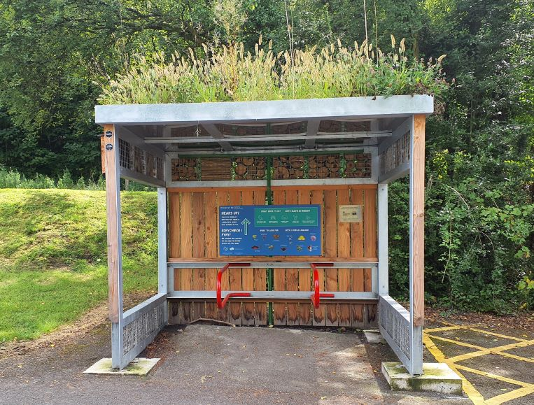
Figure 11. Green Roof Bike Shelter at Melincourt Car Park, funded by SPF
Key service areas are working together and with partners to tackle key pressures on species and habitats including INNS and climate change mitigation, and to pursue nature-based solutions such as tree planting and SUDS. A good example of this is a natural flood management scheme installed at Brynau Farm and Gnoll Country Park, led by NPTC Drainage team (with support from the C&W Team) working in conjunction with the Woodland Trust. This scheme included ponds and leaky barriers which now directly protects over 200 properties in the local area. Over the period covered in this report, the C&W Team has also utilised external funding to install biodiverse green roof bus stops and bike shelters at a number of locations across the county.
4.1 | INVASIVE NON-NATIVE SPECIES (INNS)
Action | A proactive approach is taken to dealing with INNS including Development Management Process and treatment on Council land.
Reporting mechanism | C&WT Planning spreadsheet and BDP Spreadsheet.
Milestone year 6 | As appropriate
Milestone year 7 | As appropriate
Progress | Relevant service areas have met internally to review our approach to tackling INNS. Japanese Knotweed on council land is being treated and monitored under a core programme with a budget, coordinated by Streetcare and Estates. Steps to prevent spread of INNS during day-to-day service delivery have been taken, such as the purchase of mobile wash-down facilities for Drainage and Streetcare teams for vehicles/equipment when undertaking culvert clearance or working in INNS-infested areas. Wording has been developed in conjunction with Legal teams for inclusion in Works contracts, to place onus on contractors to prevent the spread of INNS. Efforts to control other species such as American Skunk Cabbage, Himalayan Balsam and Rhododendron is focused on the sites which have biodiversity value to minimise damage to biodiversity. They are being controlled on nature sites through external funding e.g. Local Places for Nature. Country Parks undertake INNS control as capacity allows and works with Friends groups and external partners to do so e.g. Himalayan Balsam management at Gnoll Country Park by Friends of Gnoll Park. NPT Local Nature Partnership grant fund (administered by NPT Council) has provided funding to community groups to undertake INNS control on their own/ council-leased land e.g. Japanese Knotweed Control at Glantawe Riverside Park.
NRAP Objectives | 1,3,4,5,6

4.2 | AIR QUALITY
Action | The air quality implications of plans and projects are fully assessed for their potential effects on sensitive habitats and species through the HRA process
Reporting mechanism | C&WT Planning spreadsheet
Milestone year 6 | All development proposals assessed as appropriate
Milestone year 7 | All development proposals assessed as appropriate
Progress | All development proposals assessed as appropriate and HRAs are undertaken where required
NRAP Objectives | 1,2,3,4,5,6

4.3 | STATE OF NATURE IN NPT
Action | Support the Local Nature Partnership to review all of the local information and evidence and review the State of Nature of NPT in 2028.
Reporting mechanism | State of Nature in NPT reviewed and updated report on local pressures produced.
Milestone year 6 | No milestone until Year 10
Milestone year 7 | No milestone until Year 10
Progress | No milestone until Year 10
NRAP Objectives | 4,5

NRAP Objective 5: Improve our evidence, understanding and monitoring
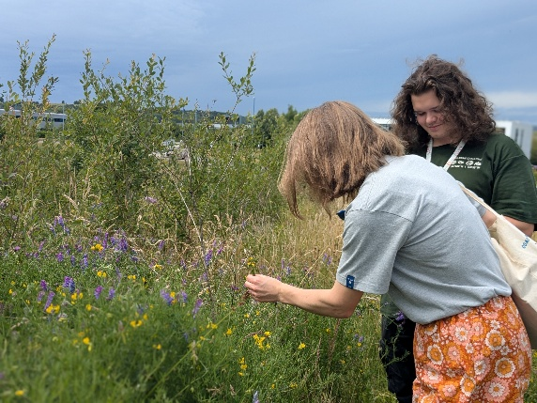
NPTC C&W Team actively surveys and records species and habitats across NPT and uses the data to inform future management of sites. Specialised species surveys are also facilitated through external funding e.g. NPTC applied to the LNP Grant Fund for funding to commission Long-eared Owl Surveys in the county, which can be used to inform habitat management for the species in the future. A Biodiversity Master Map is kept updated with key biodiversity information such as species surveys and habitat changes. Relevant planning applications are not accepted without a Biodiversity Records Centre search.
Figure 12. Undertaking SINC surveys
5.1 | DATA CAPTURE
Action | NPT uses a range of data capture tools and techniques. This has led to a large number of species records which are passed on to the Local Records Centre and, therefore, shared with the wider community.
Reporting mechanism | Metadata from MapMate
Milestone year 6 | Maintenance of the MapMate database and Biodiversity GIS layers.
Milestone year 7 | Maintenance of the MapMate database and Biodiversity GIS layers. If necessary, change to alternative database system.
Progress | The Biodiversity Master Map layers are up to date and continue to be updated. 1130 additional records have been added to the MapMate database by NPTC, synchronised with partners.
NRAP Objectives | 2,4,5

5.2 | SITES OF IMPORTANCE FOR NATURE CONSERVATION
Action | NPTC have a programme of identifying sites that qualify as Sites of Importance for Nature Conservation (SINC). This allows us to assess the quality of a site against national guidelines. Sites will be reviewed periodically through surveys and the development management process.  The GIS layer will be updated and shared with SEWBReC as required.
Reporting mechanism | Update GIS layer periodically and report updates to SEWBReC
Milestone year 6 | Update periodically through surveys and the development management process
Milestone year 7 | Update periodically through surveys and the development management process
Progress | 6 new SINCs have been surveyed and designated.
NRAP Objectives | 1,2,3,4,5,6

5.3 | SURVEYS
Action | NPTC provides secretariat for the NPT Nature Partnership which includes a number of specialist surveyors and SEWBReC. We utilise this expertise by organising surveys for targeted sites and species.
Reporting mechanism | Reports of surveys
Milestone year 6 | Work with the Local Nature Partnership to take forward specialist surveys where most appropriate
Milestone year 7 | Work with the Local Nature Partnership to take forward specialist surveys where most appropriate
Progress | A number of surveys have taken place during this period including consultancy surveys e.g. bat roost and activity surveys at Margam Park, and project surveys e.g. Lost Peatlands peatbog surveys. NPT Local Nature Partnership grant fund (administered by NPT Council) has provided funding for surveys for priority species including Long Eared Owl and fungal communities.
NRAP Objectives | 1,2,3,4,5,6

5.4 | RECORD CENTRE SEARCHES
Action | All planning applications containing biodiversity information must be accompanied by a SEWBReC search undertaken by/on behalf of the applicant, unless agreement is reached with the C&WT that sufficient justification exists to negate this need.
Reporting mechanism | C&WT Planning spreadsheet
Milestone year 6 | All biodiversity information contained in a planning application must be accompanied by a SEWBReC search, unless agreed otherwise
Milestone year 7 | All biodiversity information contained in a planning application must be accompanied by a SEWBReC search, unless agreed otherwise
Progress | All relevant planning applications are accompanied by a SEWBReC search. The C&W Team has also undertaken additional searches to inform Habitat Management Planning.
NRAP Objectives | 1,2,3,4,5,6

5.5 | BIODIVERSITY COMPENSATION SCHEME
Action | Implement the compensation scheme as set out in the Biodiversity SPG.
Reporting mechanism | C&WT Planning spreadsheet
Milestone year 6 | Implement SPG via the development management process
Milestone year 7 | Implement SPG via the development management process
Progress | The need for habitat banking has increased and a way forward for securing sites needs to be determined. However, relevant developments have been required to secure their own compensation sites.
NRAP Objectives | 1,2,3,4,5,6

5.6 | BIODIVERSITY PLAN EVIDENCE
Action | Evidence to be collected to ensure compliance with this plan.
Reporting mechanism | All reporting to be gathered and collated to report on this plan
Milestone year 6 | Ongoing
Milestone year 7 | Ongoing
Progress | Ongoing
NRAP Objectives | 1,2,3,4,5,6

NRAP Objective 6: Put in place a framework of governance and support for delivery
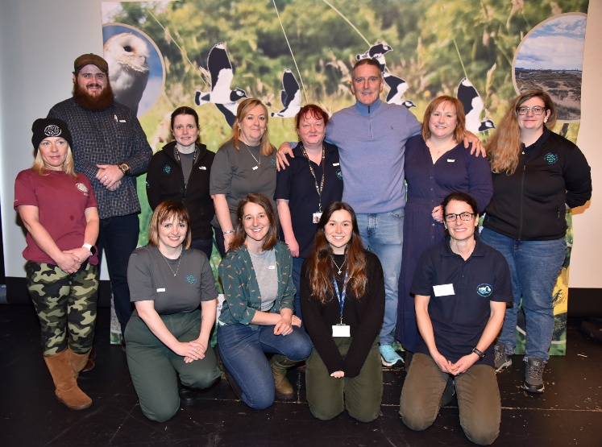
Figure 13. Officers from the C&W Team with Iolo Williams at the Nature Unearthed event, Feb 2024
Delivery of the S6 Duty and implementation of the BDP is the responsibility of the Council as a whole. This is supported by the C&W Team, with the coordination and monitoring of the BDP embedded into a staff post within the team. The same staff member provides the secretariat for NPT Local Nature Partnership, facilitating meetings and coordinating action against the NRAP. Partnership projects are regularly pursued, e.g. Coed Lleol are a key partner in the Lost Peatlands project, delivering health and wellbeing objectives alongside biodiversity objectives. The C&W Team are supported by elected members, including a Biodiversity Champion, as well as other Cllrs. with relevant portfolios e.g. climate change. Key schemes are continuing e.g. the NPT Bee Friendly scheme, and additional mechanisms for delivery are pursued where possible e.g. a Motion for the Ocean for NPT is currently in the process of being declared.

6.1 | C&W TEAM RESOURCES
Action | Maintain enough skills and capacity in the C&WT to co-ordinate the work needed to comply with the legislation and in response to increasing investment by WG and other funders.
Reporting mechanism | The duty report
Milestone year 6 | Maintain / increase current core staff levels and retain / employ additional project staff to deliver grant funded projects as and when funding becomes available.
Milestone year 7 | Maintain / increase current core staff levels and retain / employ additional project staff to deliver grant funded projects as and when funding becomes available.
Progress | Core staff levels have decreased in the period with the loss of the Woodland Officer in 2024. This has reduced the core staff levels to 2.5 core full-time equivalent members of staff (not including the team leader). Project/income generation reliant staff have been retained (an additional 10.26 full-time equivalent members of staff). During the period covered by this report, an additional project staff member has been employed using external funding – the Coastal and Marine Coordinator. The internship scheme has been utilised to secure a ‘Biodiversity Intern’ position with a student from Swansea University.  Although staff numbers have increased due to project staff, capacity remains an issue as demands on core staff have increased e.g. development planning. Predicted future habitat management targets from Welsh Government will increase pressure on the core team.
NRAP Objectives | 1,2,3,4,5,6

6.2 | NPT LOCAL NATURE PARTNERSHIP
Action | Continue to support the NPT Local Nature Partnership, providing the secretariat, steering the objectives and collating information on member activities through the C&WT.
Reporting mechanism | Partnership minutes
Milestone year 6 | Continue to provide secretariat for the NPT Local Nature Partnership
Milestone year 7 | Continue to provide secretariat for the NPT Local Nature Partnership
Progress | The Ecologist (Plans and Projects) in the C&W Team continues to provide the Secretariat for NPT LNP. The group continues to meet regularly. Member activities are collated through the Actions tracking spreadsheet during one of the first two meetings of each year.
NRAP Objectives | 6

6.3 | BIODIVERSITY CHAMPION
Action | A NPTC Councillor is appointed Biodiversity Champion and attends events/meetings as appropriate.
Reporting mechanism | Attendance at regular meetings
Milestone year 6 | Continued engagement as appropriate
Milestone year 7 | Continued engagement as appropriate
Progress | The C&W Team Leader provides regular briefings to the Biodiversity Champion and other Cllrs. with relevant portfolios. The Biodiversity Champion regularly attends LNP meetings and events.
NRAP Objectives | 1,6

6.4 | BIODIVERSITY CONTACT
Action | Each service area has a point of contact for biodiversity matters.
Reporting mechanism | Key Contacts spreadsheet
Milestone year 6 | Engagement as appropriate
Milestone year 7 | Engagement as appropriate
Progress | Behind schedule as an appropriate way of establishing this list has not been determined. Seeking to pick this up during service assessment reviews.
NRAP Objectives | 1,6

6.5 | NATURE RECOVERY ACTION PLAN
Action | Through the NPT Nature Recovery Action Plan, maximise opportunities to deliver priorities via volunteers and partners. NPTC delivers against any relevant actions in agreement with relevant departments.
Reporting mechanism | Delivery against actions to be reported to the LNP in first LNP meeting of the new year.
Milestone year 6 | Delivery against actions to be reported to the LNP in first LNP meeting of the new year.
Milestone year 7 | Delivery against actions to be reported to the LNP in first LNP meeting of the new year.
Progress | This has taken place during the first or second LNP meeting of each year and recorded on the Actions spreadsheet. Actions are updated as deemed appropriate by the LNP.
NRAP Objectives | 1,2,3,4,5,6

6.6 | NPT BEE FRIENDLY / NATURE CONSERVATION SITES SCHEME
Action | Implement the NPT Bee Friendly scheme, increasing sites included in the scheme each year. Review and update the Conservation Sites Scheme to include sites which are not managed under NPTBF.
Reporting mechanism | Hectarage of sites or kilometres of linear features reported through Corporate Reporting.
Milestone year 6 | Hectarage/ km of sites included in these schemes increases year on year
Milestone year 7 | Hectarage / km of sites included in these schemes increases year on year
Progress | There has been an overall increase in sites included in these schemes by 56.88 hectares. Large sites added to NPT Bee Friendly were the Gnoll Meadows and Baglan Energy Park. The Nature Conservation Sites Scheme still needs to be revisited to capture other sites into one scheme e.g. there are a number of sites being managed for nature and classified in different ways according to funding – these could be brought under one scheme.
NRAP Objectives | 1,2,5,6

6.7 | MOTION FOR THE OCEAN
Action | Investigate the Motion for the Ocean and potential deliverables for NPT.
Reporting mechanism | TBC
Milestone year 6 | Feasibility for Motion for the Ocean
Milestone year 7 | Start process of declaring a Motion for the Ocean if considered feasible
Progress | Motion for the Ocean has been drafted.
NRAP Objectives | 1,2,5,6

Conclusion

Neath Port Talbot Council has made substantial progress in delivering its Biodiversity Duty Plan. The C&W Team continues to provide an advisory and consultancy service for other departments and works with other service areas to restore and enhance for biodiversity. Biodiversity training has been expanded, including mandatory corporate modules, and biodiversity considerations are integrated into planning, procurement, and SuDS processes. Over £2 million in external funding has been secured for habitat restoration and enhancement projects, contributing to the management of over 1,200 hectares of green space, including 56.88 hectares under the NPT Bee Friendly scheme. Awareness raising has been strong through events, interpretation, and digital engagement, while biodiversity surveys and data capture continue to improve evidence-based decision-making. Governance structures remain robust, with core staff maintained and additional project roles funded. Overall, the Council is on track to meet legislative requirements and deliver wider well-being benefits for communities and nature. Through advisory services, training, collaborative projects, and habitat enhancements, our action against the Biodiversity Duty Plan has delivered outcomes that extend beyond nature conservation. These actions support community health and well-being by encouraging engagement with green spaces, foster social cohesion through partnerships and public events, and contribute to economic resilience by attracting significant external funding. By integrating biodiversity into planning, infrastructure, and education, we also advance the Well-being of Future Generations goals, ensuring that environmental, cultural, and social benefits are realised across Neath Port Talbot.

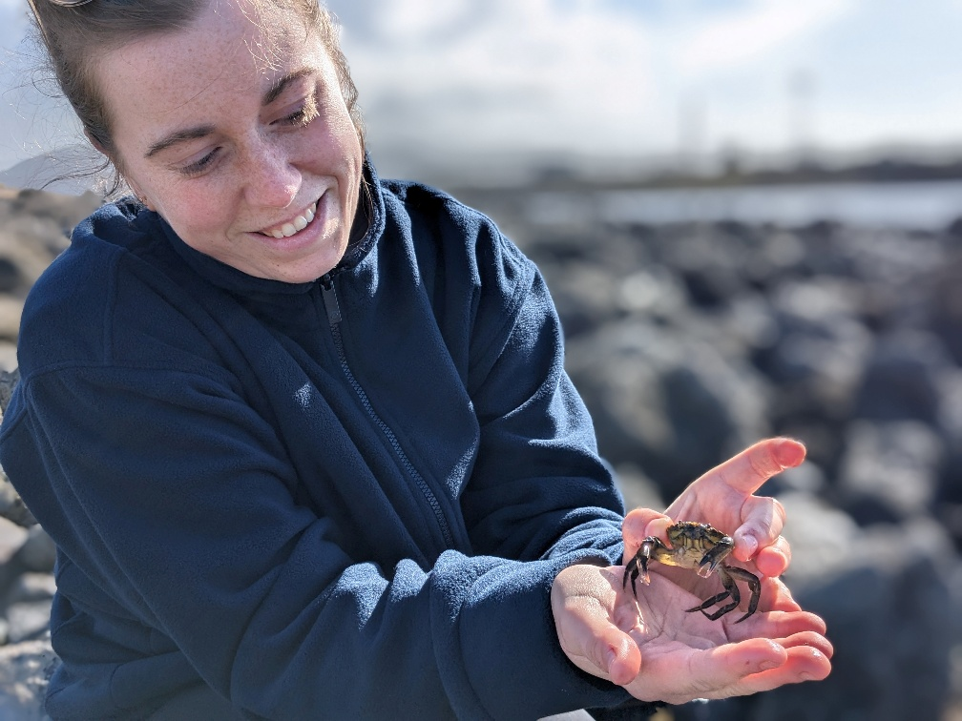
Figure 14. C&W Team officer rock pool survey at the Small Beach, Aberavon

Woodland Officer left and not replaced end of 2024 reducing core staff to 2.5 FTE
A model ‘Ocean Recovery Declaration’ – or ‘Motion for the Ocean’ – seeks to help local authorities play their part in realising a clean, healthy and productive ocean and all of the direct economic, health and wellbeing benefits it will bring. The world’s Ocean is a fundamental part of climate regulation and must be considered as part of an effective climate emergency response.

